**Dougherty Valley High School Chemistry**

Pre-Lab Assignment and Post-Lab Assignment

# ONLY BLACK OR BLUE PEN

**GENERAL GUIDELINES**

* All sections must be clearly labeled.
* Sections must be done in the order listed here.
* Headers must be filled out at the top of every page used in your lab notebook.
* This will be collected prior to the beginning of lab (except the data tables which are made before the lab, but on a separate page in your lab notebook so you can fill them out during lab).
* You may not participate in a lab without having it completed.
* Will sometimes be graded for completion and/or accuracy. Not all completed sections will necessarily be graded every time, one section might be chosen, or all might be chosen for grading.
* Professionalism matters – If I can’t read it, if it looks like you did it last minute walking to class, if it looks like you put no thought, effort, care, detail into your work, that will be reflected in your score.
* You must use adequate spacing between sections to keep your work clear and understandable. Do NOT try to save space. You have plenty of pages in your lab notebook. Clearly communicating your work matters more than saving a few pages in your lab notebook.

**PURPOSE OF THE EXPERIMENT**

1. State the general principle being studied
2. State any specific results to be obtained

**REAGENTS TABLE**

|  |  |  |  |  |  |  |  |
| --- | --- | --- | --- | --- | --- | --- | --- |
| **Name** | **Formula** | **Molecular Weight (g/mol)** | **Physicals Properties** | | | **State @ Room Temp (C)** | **Safety Concerns** |
| **B.P. (C)** | **M.P (C)** | **Density (g/cm3)** |
|  |  |  |  |  |  |  |  |
|  |  |  |  | **SAMPLE** |  |  |  |

1. Provide the above info for the state (s, l, g, aq) that is being used in the lab.
2. Note safety/cleanup points (if provided, all should be – BE DESCRIPTIVE)
3. Googling MSDS is how to do this! We don’t really use physical MSDS books anymore.

**MATERIALS**

1. 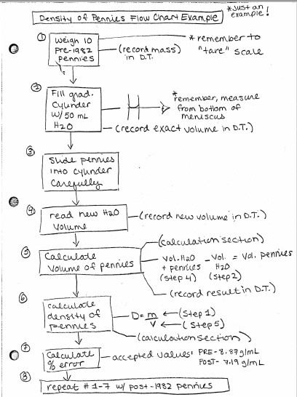List all needed chemicals, materials, and equipment in a bullet list.

**PROCEDURE**

1. Rewrite the procedure in your own words and in FLOW CHART STYLE!
2. Do not copy directly from lab handout!
3. Full sentences not needed.
4. Do not combine steps. Keep the original numbering system in the lab handout.   
   This is important in case we need to make changes before the lab, or if you   
   need help you can tell me what step you are on.
5. Included drawings of lab setups when applicable. Label the drawings with   
   equipment names.
6. Add reminders, equations, notes to yourself etc.
7. The intention of this section is to get you to *think about* the steps by putting   
   it in your own shortened version.
8. You should be able to do the lab with nothing but your notebook!

**PRE-LAB QUESTIONS**

1. Complete any listed pre-lab questions.
2. Number all questions.
3. Must show all work for calculations.
4. Do not recopy the question. Paraphrase it into your answers so a reader can infer what the question was.
5. Full sentence answers are not needed, but complete and detailed answers and thoughts are required!
6. Box any final numerical or short phrase like answers.

**DATA SECTION**

1. **Must be done on a NEW sheet of paper in your lab notebook! It cannot be on the same page as the rest of your pre-lab because you will be tearing out the carbon copy pages of your pre-lab and turning that in before you start the lab.**
2. Set up your data table(s) BEFORE the lab starts. This is part of your pre-lab assignment even though it is not turned in with the rest of the sections. It may be checked even though it is not turned in until after the lab.
3. Must include sections for QUANTATATIVE and QUALITATIVE data.
4. Make it large – does not have to be an entire page, but needs to be sufficiently large. You will be docked points for any work that is “squished,” as that is not professional work and hinders the reader’s ability to learn from it.
5. You must give your data table(s) a descriptive title. It should specifically mention any reaction(s) that is/are occurring as part of the title.
   1. Bad titles – Data Table, Table for My Lab, Table of Lab Numbers, Lab Data, etc.
   2. Better titles – Effect of Concentration on Absorbance, pH of Common Household Substances, etc.
6. You must have units in the headers of the columns/rows.
7. Your data collection should reflect the significant figures that are appropriate for each piece of equipment you are using. Remember that our equipment is inherently limited in precision!
8. Your qualitative observations must be descriptive and detailed. It is not sufficient to say “it changed colors,” or “it reacted.” Qualitative data is as important as quantitative data!

**CALCULATIONS SECTION**

1. Must show ANY calculation or manipulation of numbers done during and/or after the lab. If it is not a direct measurement, there should be evidence of it in the calculation section.
2. Sometimes results of calculations are put into your data tables. You still need to show the calc’s here!
3. Even “simple” calculations need to be shown. This includes subtracting, adding, metric conversions, etc.
4. Number and label all calculations. Make sure to give short label so people know what the calculation is.
5. Make sure you include units everywhere!

**POST LAB**

1. Post Lab Questions – in lab notebook.
   1. Number all questions.
   2. Do not recopy the question. Paraphrase in your answers so a reader can infer what the question was.
   3. Complete sentences not needed unless asked for. Complete thoughts and answers ARE needed!
2. Post Lab Two Pager – worksheet given to you.
   1. Summarizes what you learned.
   2. Imagine you are making a “cheat sheet” for a lab quiz! You may or may not be allowed to use these Two Pagers on Post Lab Quizzes. It will be announced at the start of the quiz if you can use it or not.
3. Formal Lab Report Sections
   1. Not always given. You will be told if/when to do one or more of these formal sections.
   2. Expectations will be given to you at the time. General expectations are on the Lab Guidelines Check List.
4. Post Lab Quiz
   1. Pop quizzes that can happen any time after a quiz.
   2. Will assess whether you actually *learned* from the lab. It is imperative that you do not just copy lab work from classmates. Lab questions may appear on pop quizzes, chapter quizzes, tests, finals etc.

The lab assignments and expectations can change at teacher’s discretion