Common Laboratory Equipment and Techniques
Safety Splash Goggles  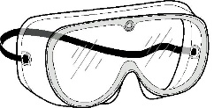 | Beaker  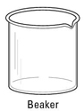 | Erlenmeyer Flask  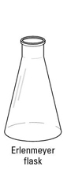 |  | Graduated Cylinder  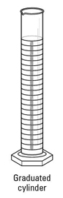
Distilled Water Wash Bottle  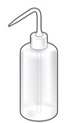 | Beaker Tongs  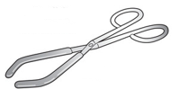 | Crucible Tongs  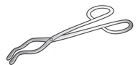 |  | Test Tube Tongs  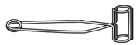
Hot Plate  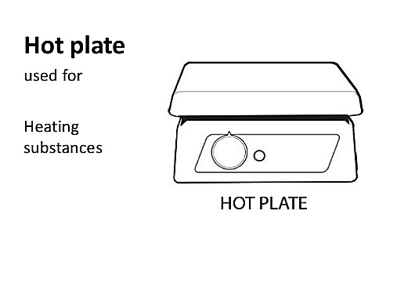 | Spatulas and Scoopulas  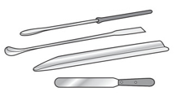 | Disposable Pipette  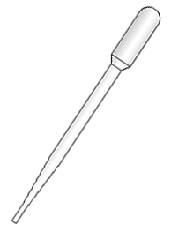 |  | Rubber Policeman  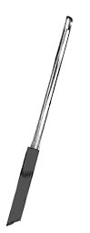
Forceps  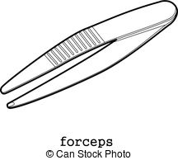 | Ring Stand  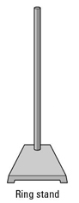 | Iron Support Ring  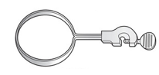 |  | Utility Clamp  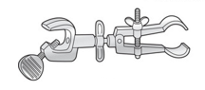
Wire Gauze with  Clay Center  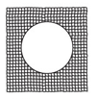 | Bunsen Burner  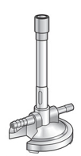 | Flint Striker  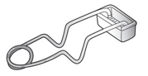 |  | Clay Triangle  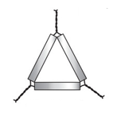  R-11
Crucible with Lid  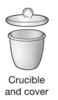 | Evaporating Dish  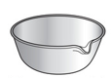 | Burette Clamp  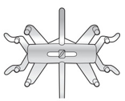 |  | Burette  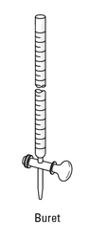
Filter Flask  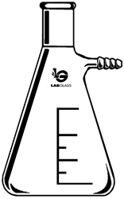 | Buchner Funnel  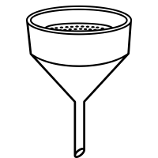 | Aspirator for Sink  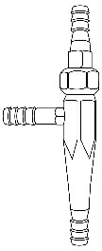 |  | Glass Funnel  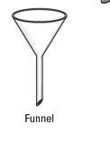
Test Tube Brush  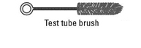 | Test Tubes  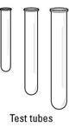 | Test Tube Rack  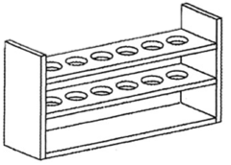 |  | Morter and Pestle  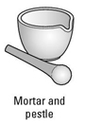
Volumetric Flask  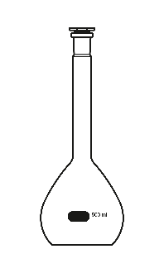 | Glass Watch Glass  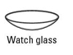 | Volumetric Pipette  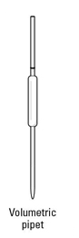 |  | Rubber Pipette Bulb  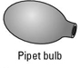
Rubber Stoppers  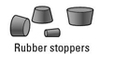 | 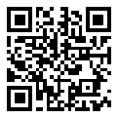  SCAN ME  Common Lab Techniques:  https://tinyurl.com/3eyn4faa |  | You will sometimes be asked to look at certain sections of this Common Lab Techniques PowerPoint as part of your “Pre-Lab” assignments. This will maximize our in class lab time and help ensure that you are safe in the lab.

