VSEPR
Valence Shell Electron Pair Repulsion

Steric  # | X | E | “generic”  Looking at shape of everything attached | “specific”  Only looking at shape of atoms
Electron Pairs | Bonded Pairs | Lone Pairs | Electron Geometry  (hybridization) | Molecular Geometry  (AXE Formula) | Bond Angles | 3-D example
2 | 1 | 1-3 | Linear  (sp) | Linear  (AXE, AXE₂, AXE₃) | 180 | 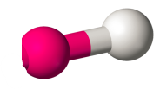
 | 2 | 0 |  | Linear  (AX₂) |  | 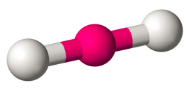
3 | 3 | 0 | Trigonal Planar  (sp²) | Trigonal  Planar  (AX₃) | 120 | 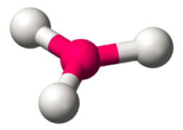
 | 2 | 1 |  | Bent  (AX₂E) | < 120 | 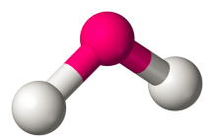
4 | 4 | 0 | Tetrahedral  (sp³) | Tetrahedral  (AX₄) | 109.5 | 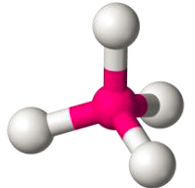
 | 3 | 1 |  | Trigonal Pyramidal  (AX₃E) | < 109.5 | 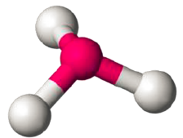
 | 2 | 2 |  | Bent  (AX₂E₂) | << 109.5 | 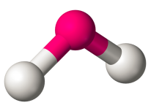

Continued on the back!
R-5
Steric  # | X | E | “generic”  Looking at shape of everything attached | “specific”  Only looking at shape of atoms | *it is unclear if d orbitals hybridize – currently we think they do not.
Electron Pairs | Bonded Pairs | Lone Pairs | Electron Geometry  (hybridization) | Molecular Geometry  (AXE Formula) | Bond Angles | 3-D example
5 | 5 | 0 | Trigonal Bipyramidal  (sp³d*) | Trigonal Bipyramidal  (AX₅) | 90  Axial  (above & below)  120  Equatorial  (in plane) | 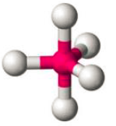
 | 4 | 1 |  | Seesaw  (AX₄E) | 90  120  180 | 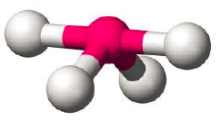
 | 3 | 2 |  | T-Shaped  (AX₃E₂) | 90  180 | 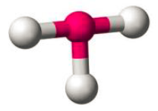
 | 2 | 3 |  | Linear  (AX₂E₃) | 180
6 | 6 | 0 | Octahedral  (sp³d²*) | Octahedral  (AX₆) | 90 | 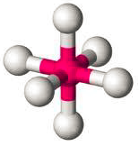
 | 5 | 1 |  | Square Pyramidal  (AX₅E) | 90  180 | 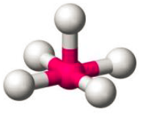
 | 4 | 2 |  | Square Planar  (AX₄E₂) | 90  180 | 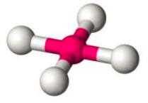
 | 3 | 3 |  | T-Shaped  (AX₃E₃) | 90  180
 | 2 | 4 |  | Linear  (AX₂E₄) | 180

