Reference Sheets for
Unit #0 –Review of Honors Chem

Honors Reference Sheets  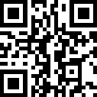  https://tinyurl.com/sba6td2k | Honors Notes  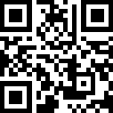  https://tinyurl.com/bddpaxne
Honors Study Materials  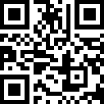  https://tinyurl.com/y726tn9x | Honors Worksheets  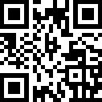  https://tinyurl.com/3ypurmkn

