**Dougherty Valley HS** • **AP Chemistry**

**Thermochemistry: Energy**

**A BLUFFER’S GUIDE**

*Inspired by Paul Groves*

1. The 1st Law of Thermodynamics -   
   The energy of the universe is constant.
2. Endothermic +qsytem -qsurroundings  
   Exothermic -qsystem +qsurroundings
3. Specific heat – the amount of energy it takes to raise 1g of a substance by 1°C  
   Molar heat – the amount of energy it takes to raise 1mol of a substance by 1°C
4. The larger the specific heat, the more energy it takes to raise the temperature. Will heat slower.
5. Q = mC∆T
6. Calorimetry:  
   Qsubstance 1 = - Qsubstance 2Tfinal substance 1 = Tfinal substance 2

Temp is in CELSIUS not Kelvins for this topic!

1 kJ = 1000 J 1 calorie = 4.184 J

1. Standard State = the form of the element that has ∆Hf°=0 and ∆Gf° = 0
   * Pure gas at 1atm pressure
   * Pure solid or liquid in most stable at 1atm and temp of interest (usually 25°C)
   * Substances with a 1M solution
2. 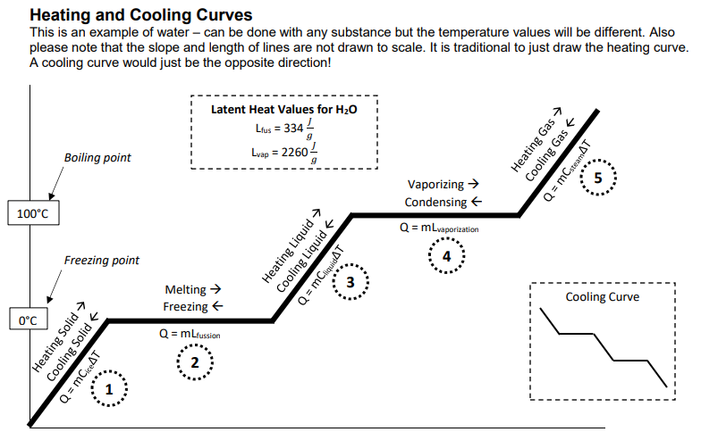Formation Reactions – the reaction of elements in their standard state to form one mole of a pure compound
   * Can have fractions as coefficients because making 1mol of the product.
   * C(s, graphite) + ½ O2(g) 🡪 CO(g)
3. Enthalpy change:  
   ∆𝑯° = 𝜮𝒏∆𝑯𝒇°(products) − 𝜮𝒏∆𝑯𝒇°(reactants)  
   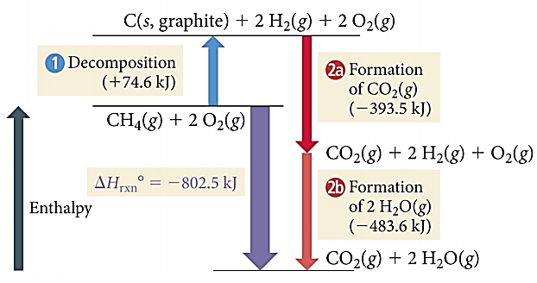
4. Bond Energy:  
   **ΣH(Bonds Broken) – ΣH(Bonds Formed)**  
     
   *“takes to break” and “free to form”  
    + -   
    endothermic exothermic*
5. Hess’s Law  
   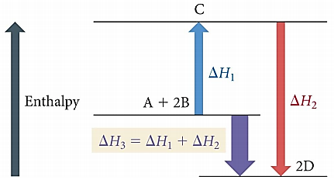
6. Relationship between modifying the chemical equation and the ∆Hrxn value
   * Multiplying a reaction by a number  
     = multiply ∆Hrxn by the same number
   * Reversing a reaction to go backwards  
     = flip the algebraic sign on ∆Hrxn
7. Example Hess’s Law Problem:  
     
   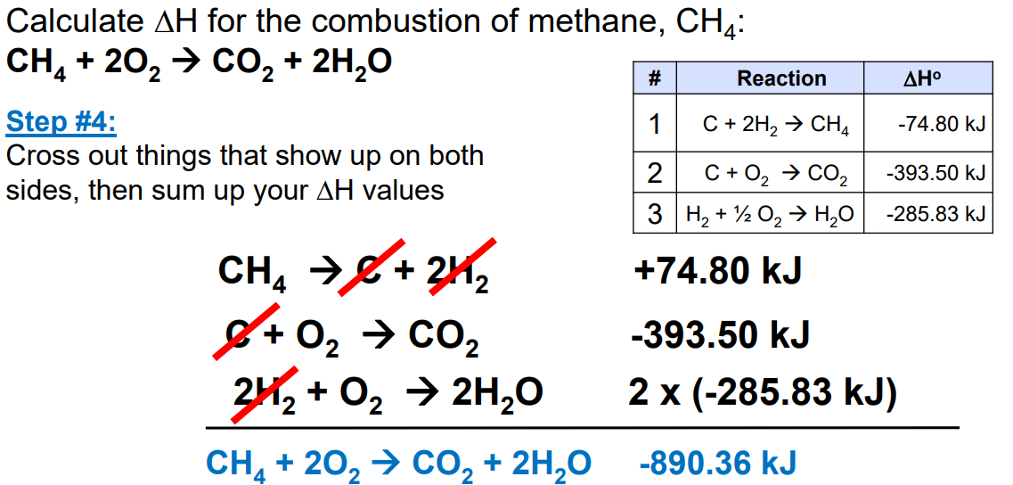

**R-17**