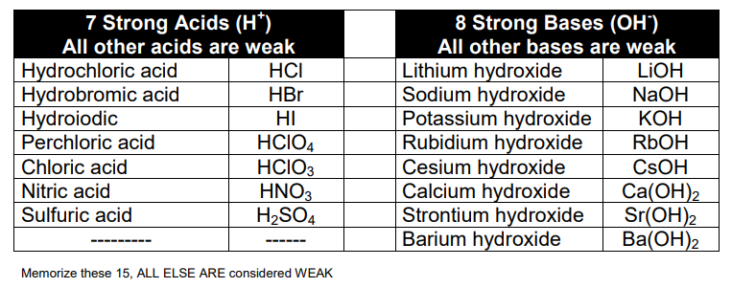Acids and bases reference sheet

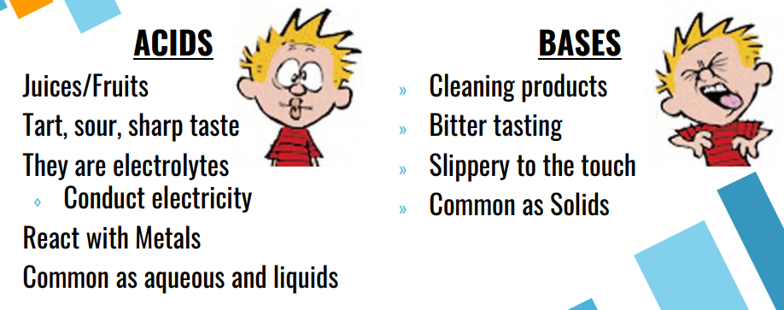

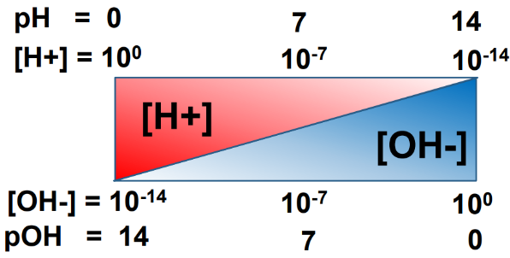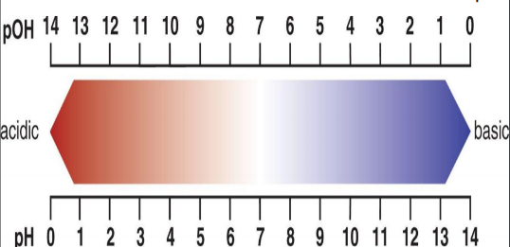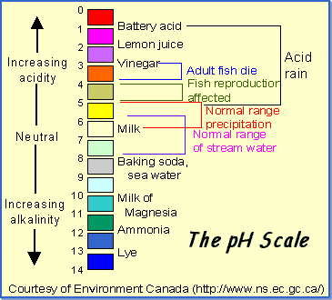  
  
  
  
  
  
  
  
 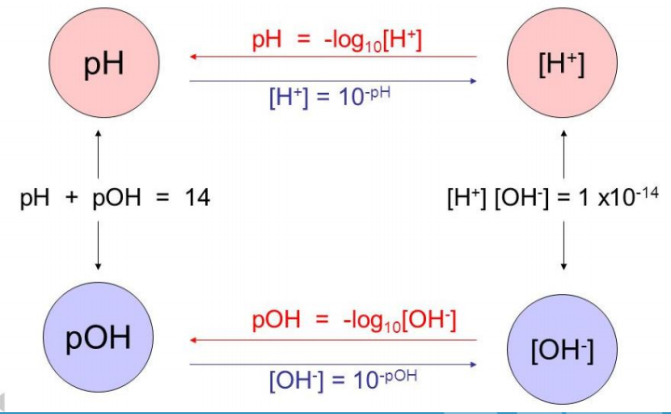

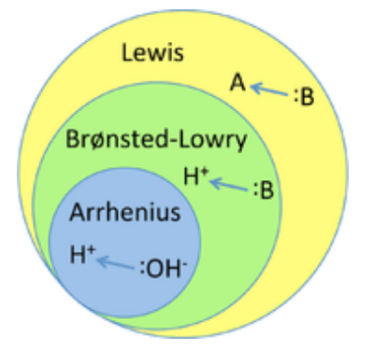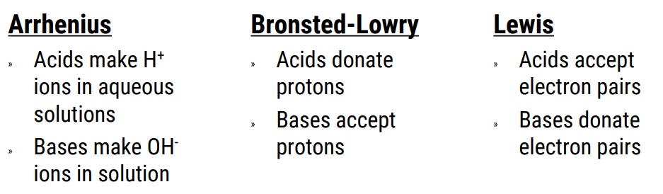

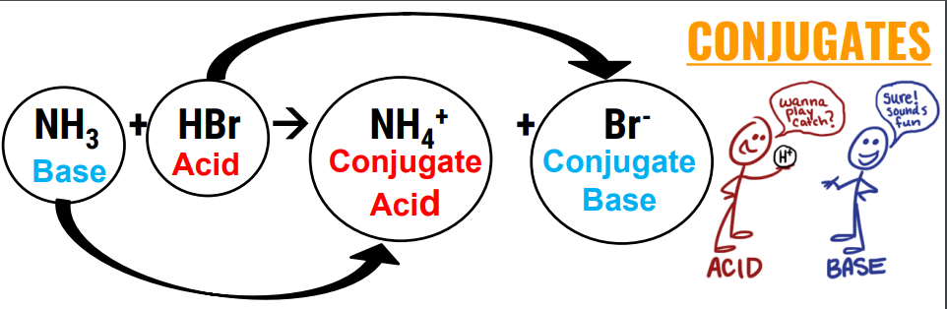

**R-38**

|  |  |  |  |
| --- | --- | --- | --- |
| **STRONG ACIDS** | | | |
| **Acid** | **Formula** | **Conj. Base** | **Ka** |
| Perchloric | HClO4 | ClO4- | Very large |
| Hydriodic | HI | I- | Very large |
| Hydrobromic | HBr | Br- | Very large |
| Hydrochloric | HCl | Cl- | Very large |
| Nitric | HNO3 | NO3- | Very large |
| Sulfuric | H2SO4 | HSO4- | Very large |
| Hydronium ion | H3O+ | H2O | 1.0 |

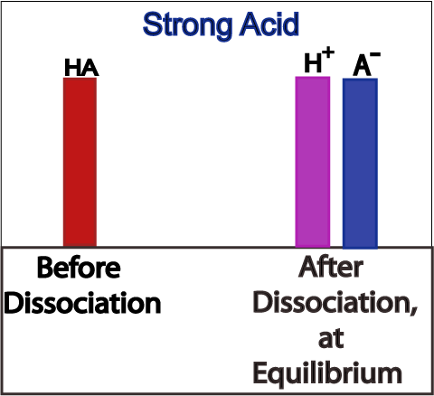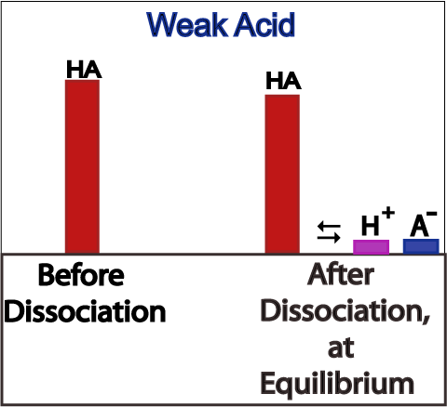

**You can convert back and forth from   
Ka to Kb using this equation:  
  
Kw = Ka x Kb**

**Strong Acid $\underset{→}{makes a }$ Weak Conj. Base**

**Large Ka Small Kb**

**Weak Acid $\underset{→}{makes a }$ Strong Conj. Base  
 Small Ka Large Kb**

**Strong Base $\underset{→}{makes a }$ Weak Conj. Acid**

**Large Kb Small Ka**

**Weak Base $\underset{→}{makes a }$ Strong Conj. Acid**

**Small Kb Large Ka**

|  |  |  |  |
| --- | --- | --- | --- |
| **COMMON WEAK ACIDS** | | | |
| **Acid** | **Formula** | **Conj.Base** | **Ka** |
| Iodic | HIO3 | IO3- | 1.7 x 10-1 |
| Oxalic | H2C2O4 | HC2O4- | 5.9 x 10-2 |
| Sulfurous | H2SO3 | HSO3- | 1.5 x 10-2 |
| Phosphoric | H3PO4 | H2PO4- | 7.5 x 10-3 |
| Citric | H3C6H5O7 | H2C6H5O7- | 7.1 x 10-4 |
| Nitrous | HNO2 | NO2- | 4.6 x 10-4 |
| Hydrofluoric | HF | F- | 3.5 x 10-4 |
| Formic | HCOOH | HCOO- | 1.8 x 10-4 |
| Benzoic | C6H5COOH | C6H5COO- | 6.5 x 10-5 |
| Acetic | CH3COOH | CH3COO- | 1.8 x 10-5 |
| Carbonic | H2CO3 | HCO3- | 4.3 x 10-7 |
| Hypochlorous | HClO | ClO- | 3.0 x 10-8 |
| Hydrocyanic | HCN | CN- | 4.9 x 10-10 |

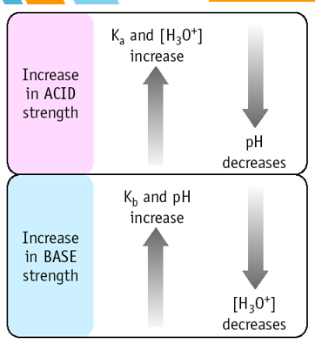

|  |  |  |  |
| --- | --- | --- | --- |
| **COMMON WEAK BASES** | | | |
| **Base** | **Formula** | **Conj. Acid** | **Kb** |
| Ammonia | NH3 | NH4+ | 1.8 x 10-5 |
| Methylamine | CH3NH2 | CH3NH3+ | 4.38 x 10-4 |
| Ethylamine | C2H5NH2 | C2H5NH3+ | 5.6 x 10-4 |
| Diethylamine | (C2H5)2NH | (C2H5)2NH2+ | 1.3 x 10-3 |
| Triethylamine | (C2H5)3N | (C2H5)3NH+ | 4.0 x 10-4 |
| Hydroxylamine | HONH2 | HONH3+ | 1.1 x 10-8 |
| Hydrazine | H2NNH2 | H2NNH3+ | 3.0 x 10-6 |
| Aniline | C6H5NH2 | C6H5NH3+ | 3.8 x 10-10 |
| Pyridine | C5H5N | C5H5NH+ | 1.7 x 10-9 |

Weak Acids and Bases Calculations

* Dissociation is a reversible reaction!
* So use Equilibrium Expressions, K values, and Ice Tables to find [ ]’s before doing pH type calculations
* Equilibrium Expression still $\frac{Products}{Reactants }$ which will be $\frac{[Dissociated Ions]}{[Undissociated Molecule]}$
* To find pH (or pOH) of something you first have to know the [H3O+] (or [OH-] )
  + For weak acids/bases you need to do the following steps to find those [ ]’s
    - Step 1 – ICE Table
    - Step 2 – Write a Ka expression (or Kb depending on the problem)
    - Step 3 – Solve for x using either quadratic or 5% rule
    - Step 4 – put x back into ICE Table to find the actual [ ] answers
    - Step 5 – use your [H3O+] (or [OH-] ) to find the pH (or pOH)

Monoprotic VS. PolyPROTIC – HOW MANY IONS COME OFF?

* Monoprotic acids/bases 🡪 only have one H+ or OH-
* Diprotic acids/bases 🡪 have two H+ or OH-
* Triprotic acids/bases 🡪 have three H+ or OH-

* Strong Bases
  + all OH- come off
    - Take that into account with your stoichiometry when finding the [OH-]
      * 1 M Ca(OH)2 = 2 M of OH- ions
* Strong Acids
  + The first H+ comes off and it would be a normal strong acid type pH calculation
    - No Ka value needed
    - No ICE Table needed.
  + The second/third/etc H+ might come off BUT
    - That would be a weak reaction and you would need:
      * Ka value for that second H+ coming off
      * Would need to do an ICE table
      * Then add the [H+] from the ICE Table calculation to the [H+] you found from the first H+ coming off.
  + Example: H2SO4 🡪 H+ + HSO4-Only assume one H+ comes off unless given Ka value for HSO4- 🡪 H+ + SO42-
* Weak Acids/Bases
  + For the given Ka or Kb value assume only one H+/OH- comes off.
  + You would need a second Ka or Kb value to do a second ICE Table for the second H+/OH- coming off, and then would need to add your [ ]’s from each ICE Table calculation.