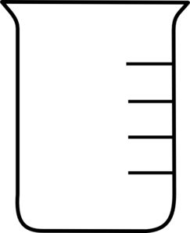**ACID BUFFER**

**Weak Acid + Matching Salt**

**HA + A–** 2.0 mol HA

2.0 mol A–



*Adding H+ to an Acid Buffer*

 **[HA] increased** 3.0 mol HA

**[A–] decreased** 1.0 mol A–

*Adding OH– to an Acid Buffer*

 **[HA] decreased** 1.0 mol HA

**[A–] increased** 3.0 mol A–

**BASE BUFFER**

**Weak BASE + Matching Salt**

**B + BH+** 2.0 mol B

2.0 mol BH+



*Adding H+ to a Base Buffer*

 **[B] decreased** 1.0 mol B

**[BH+] increased** 3.0 mol BH+

*Adding OH– to a Base Buffer*

 **[B] increased** 3.0 mol B

**[BH+] decreased** 1.0 mol BH+