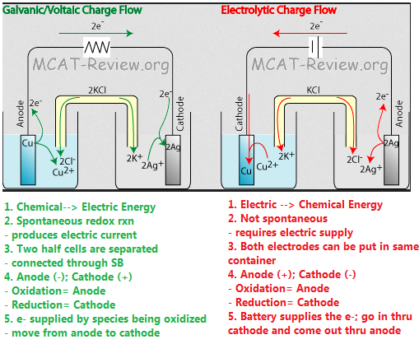

|  |  |
| --- | --- |
| **Galvanic/Voltaic** | **Electrolytic** |
| 1. Chemical → Electric energy | 1. Electric → Chemical energy |
| 1. Spontaneous redox reaction  - produces electric current | 1. Not spontaneous  - requires electric supply |
| 1. Two half cells are separated - connected through salt bridge | 1. Both electrodes can be put in same container |
| 1. Anode (-) Cathode (+) Oxidation = Anode Reduction = Cathode “An Ox, Red Cat” | 1. Anode (+) Cathode (-) Oxidation = Anode Reduction = Cathode Still “An Ox, Red Cat” you just change the   algebraic sign |
| 1. e- supplied by species being oxidized - move from anode to cathode | 1. Power source (ex. Battery) supplies the e-  - go in through the cathode and come out   through the anode |
| 1. ∆G < 0, K > 1 | 1. ∆G > 0, K < 1 |

**R-46**