**Dougherty Valley HS** • **AP Chemistry**

**Thermodynamics: Entropy and Free Energy**

**A BLUFFER’S GUIDE**

*Inspired by Paul Groves*

1. There are two driving forces for reactions. Reactions tend toward:

minimum **Enthalpy**, H (heat energy)

H , H<0, downhill   
maximum **Entropy**, S (randomness)

S +, S>0, uphill

1. Recognize whether S >0 or < 0. Entropy increases, S +, S > 0:
   * from solid to liquid to gas
   * fewer moles (g) to more moles (g)
   * simpler molecules to more complex molecules
   * smaller molecules to longer molecules
   * ionic solids with strong attractions to ionic solids with weaker attractions
   * separate solute & solvent to solutions
   * gas dissolved in water to escaped gas
2. Product or Reactant favored reactions depend on H, S, and absolute Temp

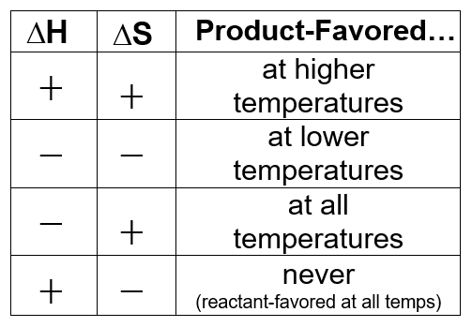

1. 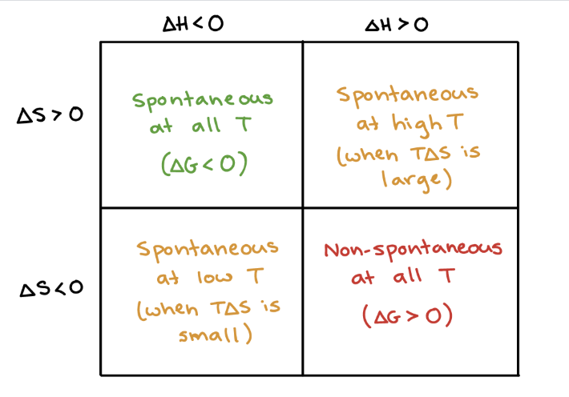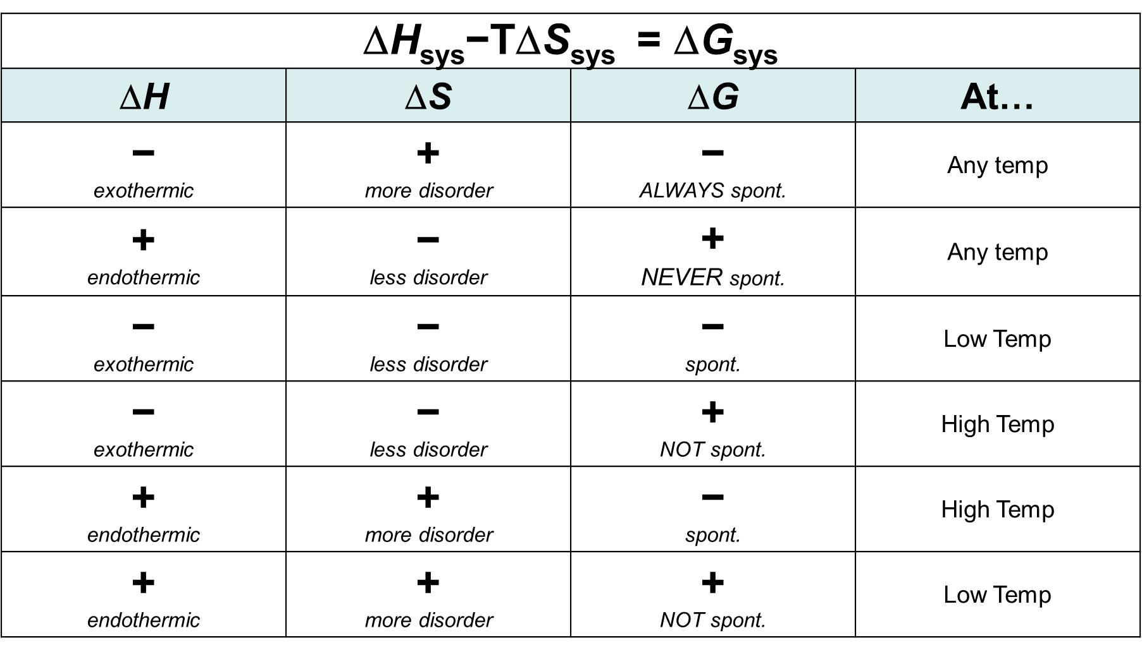
2. Many books use the term “spontaneous” for “product-favored.”

A spontaneous reaction does not necessarily mean a fast reaction.

The SPEED of a reaction is Kinetics...we are discussing whether a reaction CAN OCCUR which is Thermodynamics.

1. Gibbs Free Energy, G, puts the effects of

H, S, and Temperature together.

G = H - TS

G<0, G -, product-favored reaction

G>0, G +, reactant-favored reaction

G=0, reaction is at equilibrium

Note that H is usually in kJ/mol

S is usually in J/mol·K

**R-18**