Dougherty Valley • AP Chemistry [Keep for Reference]

Chemical Kinetics: Rates of Reaction

STUDY LIST From Paul Groves

Reaction Rates:

I can…

🞏 give the correct units to describe the rate of a reaction.

rate =  units = or mol⋅L-1⋅s-1

🞏 discuss the rate as the rate of **disappearance** of reactant or the rate of **appearance** of product Watch your signs because Δ[Reactants] = Δ[Products].

🞏 use **coefficients** to change one rate to another

Example reaction: 2A + 3B → 4C

** =  = **

🞏 list three ways to speed up a reaction

--increase the **concentration** of reactants

--increase the **temperature** of the reaction

--add a **catalyst**

🞏 determine the **average rate** of a reaction as well as the **instantaneous rate** of a reaction from a graph of [ ] vs. time.

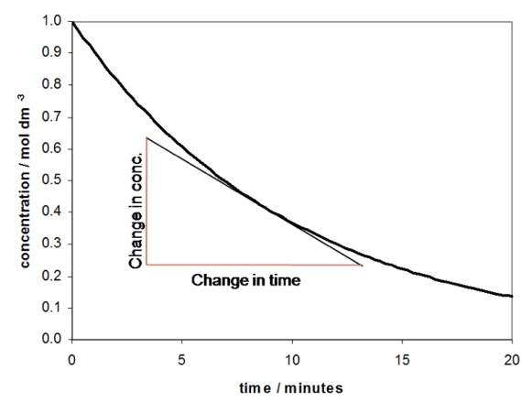

*This graph shows how to determine the instantaneous rate at 8 minutes. Take the slope of the tangent line at 8 min.*

🞏 describe a catalyst as a substance that speeds up a reaction without getting used up and cite examples of catalysts we have used in class (ester lab & elephant toothpaste demo).

KE & PE Diagrams:

🞏 draw the kinetic energy distribution for a sample of any reactants (as during the light stick activity).



🞏 sketch the change that occurs in the KE distribution if the reactants are warmed or cooled.

🞏 state that the only thing that moves the threshold energy is the addition of a catalyst. Temperature does not shift the threshold energy.

🞏 sketch the potential energy profile for a reaction showing the energy barrier between the reactants and products and show how the KE and PE graphs relate to each other.

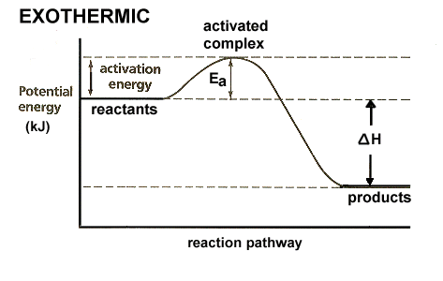

🞏 explain that a catalyst lowers the activation energy by changing the way the reaction occurs.

Half Life:

🞏 determine the half-life of a chemical from graphical data or information in a word problem.

🞏 use the integrated rate law to solve half-life problems involving in-between times.

* 
* the special case of half-life  
  ln(2) = 0.693 = kt½

Rate Laws:

🞏 write the rough rate law to show how the rate of a reaction depends on concentration.  
Ex: N2 + 3H2 ⭢ 2NH3  
Rate = k [N2]x[H2]y

🞏 determine the order of reaction with respect to a chemical using the method of initial rates by inspection.

🞏 determine orders of reactions using the mathematical method of initial rates.

🞏 solve for the specific rate constant, k, and determine the correct units.

Reaction Mechanisms:

🞏 explain that a reaction often occurs in several “elementary steps” that often involve only two particles at a time.

🞏 combine the elementary steps in a mechanism to identify the overall reaction, the intermediates, and a catalyst.

🞏 state that the slowest step in a mechanism is called the “rate determining step” and is linked to the rate law.

🞏 give an example of a chain reaction mechanism for H2 + Cl2 or for the destruction of ozone (O3) by stratospheric chlorine atoms.

🞏 label steps in a chain reaction mechanism as initiation, propagation, and termination steps.

Reaction Order--Graphical Method:

🞏 identify the integrated rate laws for zero, first, and second order reactions.

🞏 explain that the integrated rate laws can be set into the form “y = mx + b” which means that a graph indicate the order of reaction and the value of the rate constant, k.

🞏 state the straight-line graph that is identified with each reaction order.

🞏 use the slope of the straight-line graph to determine the value of k.

Arrhenius Equation:

🞏 use the Arrhenius equation to calculate the rate constant, k, using R = 8.31 J/mol K.

🞏 graphically or algebraically determine the activation energy, Ea, from rate or k data at different temperatures.

🞏 explain that a rate increase with temperature means that the rate constant, k, has increased proportionately.

🞏 explain that the slope of a graph of ln k vs. 1/T = -Ea/R.

Chain Reaction Mechanisms:

🞏 cite two examples of chain reaction mechanisms and label the elementary steps as initiation, propagation, and termination steps.

From the AP Exam:

