**Dougherty Valley HS** • **AP Chemistry**

**Atomic Structure and Periodicity: Patterns**

**A BLUFFER’S GUIDE**

*Inspired by Paul Groves*

1. c = v λ  
   c = speed of light = 3.00 x 108 m/s  
   v = frequency in hz, sec-1  
   λ = wavelength in meters
2. E = hv  
   E = energy in Joules, kgm2/s2  
   h = Planck’s constant 6.626 x 10-34 Js  
   v = frequency in hz, sec-1
3. Long wavelength   
   = low frequency  
   = low energy
4. Short wavelength  
   = high frequency  
   = high energy
5. de Broglie Equation

$λ=\frac{h}{mv}$ m = particle mass

1. Bohr Equation

$E={-2.178 x 10}^{-18}J\left(\frac{Z^{2}}{n^{2}}\right)$ Z = nuclear charge n = energy level

1. Energy change between two levels

$$-2.178 x {10}^{-18}J\left(\frac{Z^{2}}{n_{final}^{2}}-\frac{Z^{2}}{n_{initial}^{2}}\right)$$

*\*doesn’t usually show up on AP Exam*

1. Shielding – electrons are simultaneously attracted to the nucleus and repelled by each other.

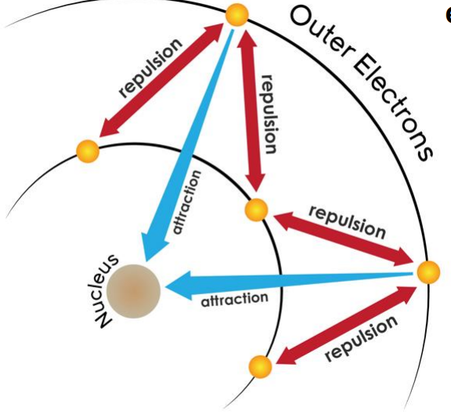

1. The repulsion results in less attractive force between outer electrons and the nucleus.  
     
   Outer electrons are shielded by the core, inner electrons. Outer electrons do not effectively screen for each other since they are in the same level.   
     
   Shielding causes outer electrons to not experience the full strength of the nuclear charge. The electrons would be more attracted to the nucleus if the electrons were not there!
2. Trend in shielding strength:  
    *most* s > p > d > f *least*
3. Effective nuclear charge – a net positive charge that is attracting a particular electron  
    Zeffective = Z – S  
   Z = nuclear charge (number of protons)  
   S = number of electrons in lower energy levels   
   *\*Note – this is oversimplified a lot!*
4. Penetration – when an e- spends time closer to the nucleus than its outer boundary.  
   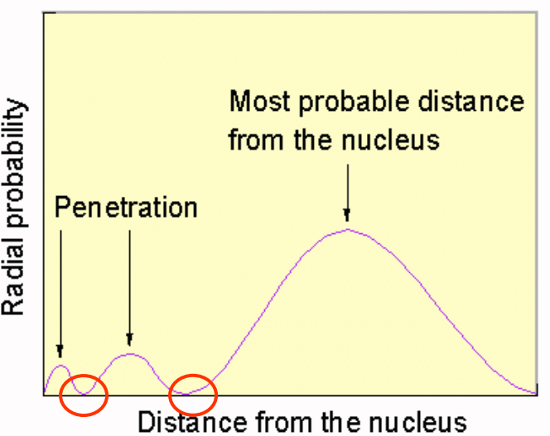  
   *\*nodes are areas with zero probability*  
     
   The closer the electron is to the nucleus, the more attraction it experiences.   
   The more e- penetrates = more attraction
5. Trend in penetration towards nucleus:  
    *most* s > p >> d > f *least*

**R-25**

1. Shielding and penetration explain a lot of things! Zeff, Ionization Energies, exceptions to patterns on periodic table etc
2. Summary of Periodic Trends:  
   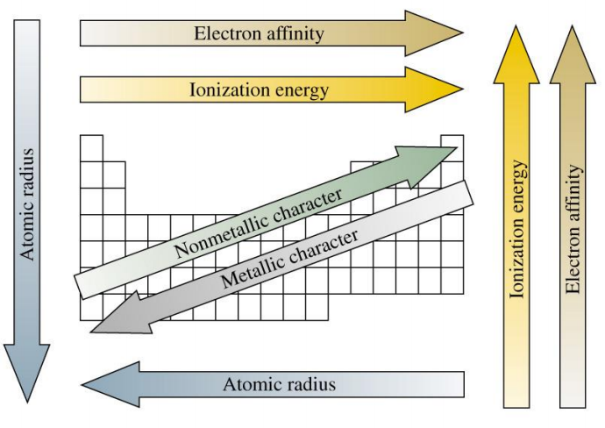
3. Careful with phrasing your answers!  
   Remember...AP Chem loves “columbic attraction” type explanations!
4. **Two elements in the same period?**

Discuss the fact that…

* Each element has valence electrons that are located in the same energy level.
* One atom has a greater number of protons (greater nuclear charge).
* More protons results in a stronger attraction between the nucleus and the valence e-’s
* Stronger columbic attraction between nucleus and valence e‑s results in a smaller atomic radius.
* That is what “Greater Effective Nuclear Charge” is trying to explain!

1. **Two elements in the same group?**

Discuss the fact that…

* Valence e-s are not located in the same energy levels, one has more principal energy levels.
* Valence e-s for one element are in a higher energy level than the valence e-s of the other element.
* The e-‘s in the higher energy level are (on average) located farther away from nucleus.
* Being further away from the nucleus results in a weaker attraction btwn the nucleus and valence e-s
* Weaker columbic attraction btwn nucleus and valence e-s results in a lager atomic radius.
* Increased e-s also results in more repulsions btwn   
  e-‘s resulting in a larger atomic radius
* That’s what “Increased Shielding” is trying to explain!

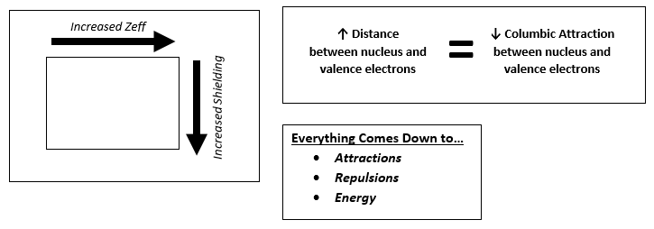

1. Ionic Radius Trend:  
   Cation < Neutral version of itself  
   Anion > Neutral version of itself  
   Cations < Anions  
     
   Isoelectric – same electron configuration  
   Larger (+) charge = smaller cation  
    protons pulling on fewer electrons  
   Larger (–) charge = larger anion  
    protons pulling on more e-
2. Irregularities in patterns  
   Extra repulsions of e-‘s in paired orbitals

* Makes it easier to remove an e-
  + Lower IE than expected

Moving to a p orbital (Mg 🡪 Al)

* p orbital does not penetrate as much as an s orbital does
* Less nuclear attraction
* Lower IE than expected

1. Large jump in IE shows when you begin removing core electrons:

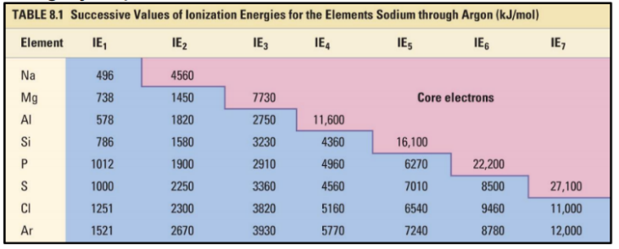

1. Electronegativity differences between bonded atoms results in a molecule being polar or nonpolar:
   * Pure covalent = EN difference of 0
   * Nonpolar covalent = EN diff. of 0.1 – 0.4
   * Polar covalent = EN diff. of 0.5 – 1.9
   * Ionic = EN diff. larger than or equal to 2.0

*\*ranges can vary, calculations rarely appear*

1. Magnetic properties are a result of how the electrons are arranged in orbitals
   * Paramagnetic – net magnetic field,  
     unpaired electrons in orbitals, weakly attracted by a magnet.
   * Diamagnetic – no net magnetic field,   
     all paired electrons in orbitals, weakly repelled by a magnet

1. Photoelectron Spectroscopy (PES)

