**Dougherty Valley HS** • **AP Chemistry**

**Bonding: Structure**

**A BLUFFER’S GUIDE**

*Inspired by Paul Groves*

1. Electronegativity differences between bonded atoms results in a molecule being polar or nonpolar: *\*ranges can vary*
   * Pure covalent = EN difference of 0
   * Nonpolar covalent = EN diff. of 0.1 – 0.4
   * Polar covalent = EN diff. of 0.5 – 1.9
   * Ionic = EN diff. larger than or equal to 2.0
2. Electronegativity difference is not the final determination of whether a substance is ionic or not. It must also conduct electricity in its molten state.
3. Coulomb’s Law 𝐹 ∝ $\frac{q_{1}q_{2}}{r^{2}}$  
   q = absolute value of charge on particles

r = distance between particles

1. Strongest ionic bond would be:  
   Large charge magnitude  
   Small ionic radius
2. Lattice Formation Energy  
   Five steps, example LiF  
    1. Turn solid Li into gas *Sublimation energy*  
    2. Break the F2(g) bond *Bond energy*  
    3. Ionize Li 🡪 Li+ *Ionization energy*   
    4. Add an electron to F🡪 F- *Electron affinity*  
    5. Form the ionic bond *Lattice energy*
3. ∆Hf for sodium chloride example:

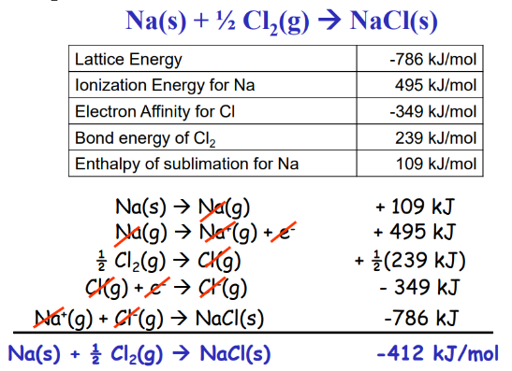

1. 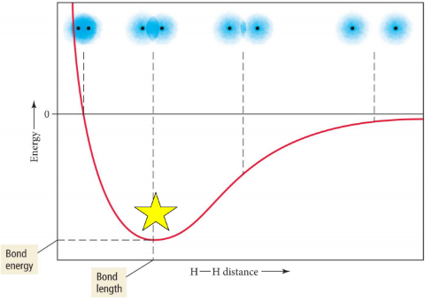Atoms are considered “bonded” when at lowest, most stable energy.
2. Bond length and energy   
   Bonds become shorter and stronger as “multiplicity increases”  
   Length: single **>** double **>** triple  
   Strength: single **<** double **<** triple
3. Bond Energy and Enthalpy  
   ∆H° = ΣDbonds broken – ΣDbonds formed  
   *“takes to break, free to form”*  
   Breaking bonds requires energy  
    Endothermic (+)  
   Forming bonds releases energy  
    Exothermic (-)
4. Resonance – when more than one valid Lewis Structure can be made for a molecule.
5. Resonance bonds:
   * Shorter and stronger than single bonds
   * Longer and weaker than double bonds

When resonance we see the bond lengths ending up identical and intermediate compared to the single or double bond order (*example: 1.5 vs 1 or 2*). We know this from experimental data!

1. Formal charge can help predict which resonance structure is more stable/common.
2. Formal Charge =   
    # valence electrons an atom should have  
   - # lone pairs on the atom  
   - ½ the # of bonded e- (only ½ b/c they are shared)

Guidelines:

* + - FC of 0 more stable
    - Negative FC should be on most electronegative atoms
    - 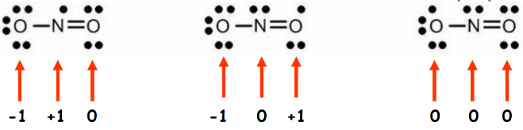Sum of all FC must equal the overall charge on the ion/molecule

**R-27**

1. Valence Shell Electron Pair Repulsion Model  
   VSEPR
   * The structure around a given atom is mostly determined by minimizing e- pair repulsions.
   * Allows us to predict the 3D structure and bond angles of molecules.
2. AXE Formulas can help you remember your geometries and bond angles

|  |  |  |
| --- | --- | --- |
| **Steric # X+E** | **Electron  Geometry** | **AXE  Formula** |
| 2 | Linear | AX2 |
| 3 | Trigonal Planar | AX3, AX2E |
| 4 | Tetrahedral | AX4, AX3E, AX2E2 |
| 5 | Trigonal Bipyramidal | AX5, AX4E, AX3E2, AX2E3 |
| 6 | Octahedral | AX6, AX5E, AX4E2 |

A = central atom  
X = atoms bonded to A  
E = nonbonding electron pairs on A

1. Octet “rule” – many atoms want to have 8 valence electrons.

Exceptions:

* + H and He can only have 2 max
  + Deficient Octets – B and Be
  + Expanded Octets – P, S and other elements with d orbitals (3rd period and below) can have more than 8.

1. Lewis Structures – show the valence electrons involved in bonding.
2. “Rules” for Drawing Lewis Structures:  
    1. Count and sum valence electrons  
    2. Place your atoms  
    3. Bond all atoms w/ a single bond  
    4. Give all atoms a full shell  
    5. Re-count the electrons you used  
    6. Used too few? Put extras on the central atom.   
    7. Used too many? Try double or triple bonds to fix.
3. Placement Suggestions:
   * Hydrogen always goes on the outside.
   * Least electronegative atom in the center
   * Symmetry is good
   * Think about Formal Charges
4. Polarity – unequal distribution of electron density. Results in partial positive regions and partial negative regions on the molecule.
   * Must have polar bonds
   * Asymmetrical shape
   * Bond dipole moment measured
5. 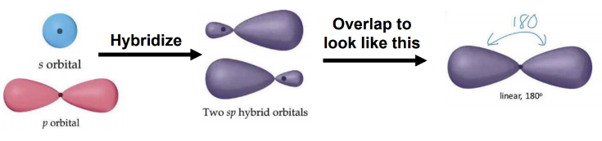Hybridization – the combining of two or more orbitals of similar energy into orbitals of equal energy and new shapes.   
     
     
     
     
   Explains bond angles and lengths better
   * Without hybridization some bonds would be longer/shorter than they are. Explains why CH4 has four equal bonds.
6. Which orbitals hybridize?
   * sp = 1 s orbital and 1 p orbital
   * sp2 = 1 s orbital and 2 p orbitals
   * sp3 = 1 s orbital and 3 p orbitals
   * No longer believed that d , f orbitals hybridize
7. Hybridization and AXE formulas
   * Steric #2 = sp
   * 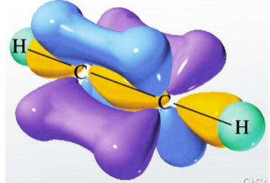Steric #3 = sp2
   * Steric #4 = sp3
8. Sigma (σ) and Pi (π)   
   bonds – describes how   
   the bonds are formed in   
   3D space, how the orbitals overlap.

Sigma Bonds – when orbitals of   
 two atoms line up along the axis directly   
 between the nuclei

* + Can be normal orbitals or hybrids
  + s-s, s-p, s-hybrid, p-hybrid, hybrid-hybrid, etc

Pi Bond – when the atomic orbitals of two atoms line up above and below the plane where the nuclei are.

* + Two unhybridized p orbitals are parallel to each other and the Pi bond forms above/ below or front/back the plane of the nuclei.

1. Sigma bonds are stronger than Pi bonds because the orbitals directly overlap between the nuclei. Because Pi bonds reach over/under they are further apart and less overlap, makes them weaker.
2. Single bond = 1 sigma   
   Double bond = 1 sigma, 1 pi  
   Triple bond = 1 sigma, 2 pi