**Basics of Gases and Kinetic Molecular Theory (KMT)**

**Kinetic Molecular Theory Assumptions**

1. Gases are “Ideal Gases” – meaning they do not interact with each other.
2. Gases consist of large numbers of tiny particles that are far apart relative to their size – the volume of each gas molecule is considered negligible, they are treated as point particles.
3. Gas particles undergo elastic collisions – meaning they do not lose energy when colliding.
4. Gas particles are in a constant, rapid, straight line motion – they possess kinetic energy (motion energy).
5. The average kinetic energy of the particles is proportional to temperature – T ↑, KE ↑
6. There is a distribution of speeds – some go faster than others – but overall there is an average kinetic energy of the sample.

**Gas Pressure**

* 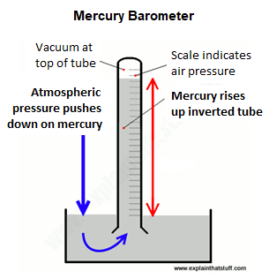Pressure – The force per unit area on a surface
$pressure= \frac{force}{area}$

* Gas particles exert force, and therefore pressure, on any surface with   
  which they collide.
* You can use various units for pressure. You may have to convert from   
  one to the other occasionally.
* Air pressure is classically found using a mercury barometer

|  |  |  |
| --- | --- | --- |
| **Unit** | **Symbol** | **Definition** |
| Pascal | Pa | SI unit for pressure $1 Pa=\frac{1N}{m^{2}}$ |
| Millimeter of mercury | mmHg | The amount of pressure that will support a 1 mm column of mercury in a barometer. Most barometers are no longer mercury based but they still use mmHg as their units. |
| Atmosphere | atm | Average atmospheric pressure at sea level and 0°C |
| Torr | torr | Torr is the same as mm Hg, just named after Evangelista Torricelli who discovered the concept of the barometer. |
| Pounds per square inch | psi | The pressure exerted when one pound of force is applied to a one square inch area. A common unit in “real life.” |

|  |  |
| --- | --- |
| **Conversions** | |
| 1 atm = | 1.01325 x 105 Pa |
| 101.325 kPa |
| 760 mmHg |
| 760 torr |
| 14.7 psi |

**Temperature Unit for Gas Laws**

* 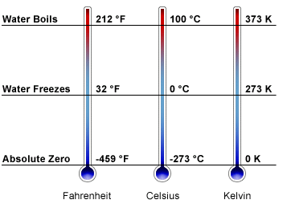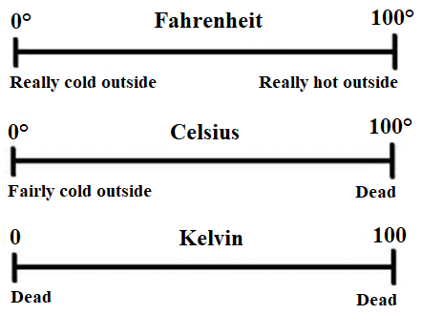Temperature is a measure of the   
  molecular movement.
* For gas law problems we want a   
  temperature of “0” to mean the   
  molecules are not moving.
* Kelvin is a unit for temperature that   
  is scaled so that at 0 K there is no   
  molecular movement.
* 0 Kelvin is called “Absolute Zero”

$K= ℃+273$

**Standard Conditions**

|  |  |
| --- | --- |
| **Standard Temperature** | 0°C = 273 K |
| **Standard Pressure** | 1 atm  **R-30** |

Many problems require that you use “standard conditions” for the given scenario. Rather than having to give you the temperature and pressure, they may just tell you to use “standard conditions” or that it is under “STP.” You can convert the pressure unit to whatever is convenient, but the temperature must be in Kelvins.

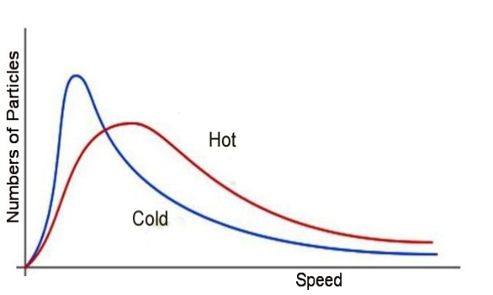**Kinetic Energy and Temperature**

$KE= \frac{1}{2}mv^{2}$

* A sample of gas will have molecules traveling at slightly   
  different speeds. We use the ***average***speed.
* The temperature is a measure of the average kinetic energy
* All gases at the same temperature have the same ***average*** KE
* Small molecules (small mass, *m*) have higher average speeds

**Properties of Gases**

|  |  |  |  |
| --- | --- | --- | --- |
| **Expansion** | **Fluidity** | **Low Density** | **Compressibility** |
| * Do not have a definite shape * Do not have a definite volume * Take the shape of their containers * Evenly distribute themselves within a container | * Gas particles easily flow past one another | * A gas has 1/1000th the density of the same substance in the liquid or solid state | * Can be compressed, * Decreases the distance between particles, and decreases the volume occupied by the gas |

**Factors Affecting Gas Pressure**

Amount of Gas

**↑** molecules = **↑** collisions with walls = **↑** pressure

**↓** molecules = **↓** collisions with walls = **↓** pressure

Volume

**↑** volume = **↑** surface area = **↓** collisions *per unit of surface area* = **↓** pressure

**↓** volume = **↓** surface area = **↑** collisions *per unit of surface area* = **↑** pressure

Temperature

**↑** temperature = **↑** molecule speed = **↑** frequency and force of collisions = **↑** pressure

**↓** temperature = **↓** molecule speed = **↓** frequency and force of collisions = **↓** pressure

**Ideal Gases vs. Real Gases**

|  |  |
| --- | --- |
| **Likely to behave  nearly ideally** | **Likely to NOT behave ideally** |
| Gases at high temperature and low pressure | Gases at low temperature and high pressure |
| Small non-polar gas molecules | Large, polar gas molecules |

* Ideal Gas – An imaginary gas that perfectly fits all the assumptions of the kinetic molecular theory
* Real Gases – A gas that does not behave completely according to the assumptions of the kinetic molecular theory. They occupy space and exert attractive and/or repulsive forces on one another

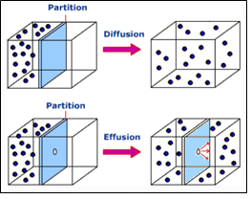**Diffusion and Effusion**

* Diffusion
  + Spontaneous mixing of particles from two (or more) substances
  + Caused by their random motion
  + Rate of diffusion is dependent upon:
    - Speed of particles
    - Attractive/repulsive forces between the particles
* Effusion
  + Process by which particles under pressure pass through a tiny opening
  + Rate of effusion is dependent upon:
    - Speed of particles (small molecules have   
      greater speed than large molecules at the same temperature, so they effuse more rapidly)