Dougherty Valley HS • AP Chemistry
Gases and Their Properties
A BLUFFER’S GUIDE
Inspired by Paul Groves

- General properties of gases:
  - Do not have definite shape or volume.
  - Take the shape of their container.
  - Evenly distribute with a container.
  - Are fluid, they flow past each other.
  - Have low density – 1/1000th the density of a liquid/solid.
  - Can be compressed due to the low density – lots of space between particles so you can compress them closer.

- Gas pressure is caused by the collision of gas particles with the walls of a container.

- Pressure can be measured in various units and you can convert between the different units. Common Units:
- 1 atm = 760 mmHg = 760 torr =
14.7 psi = 101.325 kPa

- “Standard Temperature and Pressure” is:
- 1atm, 273 K
- At STP the volume of 1 mole of gas will be 22.4 L, regardless of which gas it is.

- Pressure can be measured using a barometer or a manometer.

- Kinetic Molecular Theory describes the behavior of “Ideal” gases.
  - Gas particles do not interact with each other – there are no attractive or repulsive forces.
  - Gases consist of large numbers of tiny particles that are far apart relative to their size – the volume of each gas molecule is considered negligible, they are treated as point particles.
  - Gas particles undergo elastic collisions – meaning they do not lose energy when colliding.
  - Gas particles are in a constant, rapid, straight line motion – they possess kinetic energy.
  - The average kinetic energy of the particles is proportional to temperature in Kelvin T ↑, KE ↑
  - There is a distribution of speeds – some go faster than others – but overall there is an average kinetic energy of the sample.

- It is common to simplify behaviors of gases into “Ideal Gases” versus “Real Gases” to simplify the concepts and calculations.
  - Real gases have attractions and repulsions between particles, and the particles take up space meaning they have a volume, they are not point particles.

- Real Gases will behave closer to Ideal Gases when they:
  - Are at high temperature – so they are moving too fast to interact much with other particles.
  - Are at a low pressure – so they are far apart so they don’t interact much with other particles.
  - Are small, non-polar gas molecules – so they don’t interact much with other particles.

- When performing gas law calculations, temperature must be measured in Kelvin.
  - Kelvin is an “absolute” scale – meaning at zero degrees Kelvin, there is no molecular motion.
  - K = °C + 273

- A sample of gas will have molecules traveling and a variety of speeds. We use the average speed.
  - All gases at the same temperature have the same average kinetic energy
  - KE = ½ mv² KE_{avg} = ³/₂RT
  - Smaller mass particles will have higher average speeds.
  - Maxwell-Boltzmann distribution graphs are often used when dealing with changing temperatures of gases.
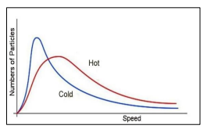
R-29

- There are several different gas laws that can be derived to represent the relationship between different variables.
  - Boyle’s Law

Charles’s Law
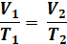

  - Gay-Lussac’s Law
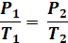

  - Avogadro’s Law
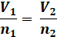

  - Combined Gas Law
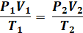

  - Ideal Gas Law
R = 0.0821 L•atm/mol•K,
= 8.31 L•kPa/mol•K
= 62.4 L•mmHg/mol•K

  - Dalton’s Law of Partial Pressures

  - Mole Fraction
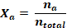

- It is important to be able to recognize, sketch, and explain graphs of some of the gas laws. Key features can be found on the various graphs, such as extrapolated lines to determine absolute zero, the volume not reaching zero because in real life gas particles take up space and can never get to a zero volume, etc.
  - Boyle’s Law Charles’s Law
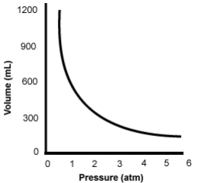 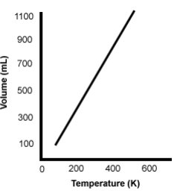
  - Gay-Lussac’s Law Avogadro’s Law
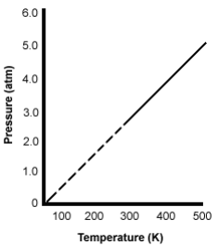 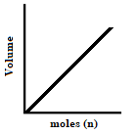

- When graphing gas laws, or looking at the mathematical equations, you can determine if there is a direct or indirect relationship between the different variables.
- Boyle’s Law = Indirect
- Charles’s Law = Direct
- Gay-Lussac’s Law = Direct
- Avogadro’s Law = Direct

- Derivations of the Ideal Gas Law can be used to find things such as:
Density Molar Mass
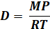 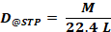 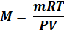
- Stoichiometry problems can be performed for questions involving gases. Normal conversion factors can be used, but sometimes gas specific calculations can be added to the problems. Commonly used:
  - Molar Volume: 1 mol = 22.4L
  - Density: D = g/mL, D = MP/RT
  - Ideal Gas Law: PV = nRT
- A common lab technique is collecting gas over water. When using this lab technique the vapor pressure of the water needs to be subtracted from the total pressure since water molecules are contributing to the total pressure. The vapor pressure of water will be different at different temperatures so the value is looked up on a chart based on the temperature of the water.
  - P_{dry gas} = P_{total} – P_{H2O}

- Gasses exhibit:
  - Diffusion
    - Spontaneous mixing of particles of two or more substances.
    - Caused by random motion.
    - Rate of diffusion dependent on:
      - Speed of particles
      - Attractive/repulsive forces between the particles
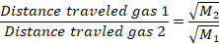
  - Effusion
    - Particles under pressure pass through a tiny opening.
    - Rate of effusion is dependent on:
      - Speed of particles
