IMFs Visually |  | IntRA versus IntER
 |  | 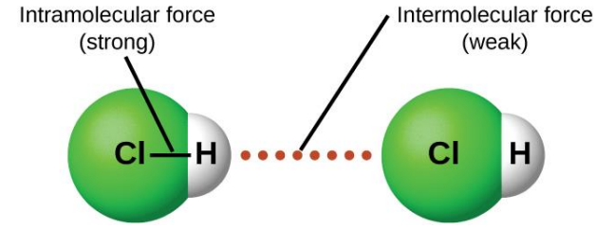
Intermolecular Forces
London Dispersion Force | 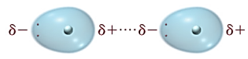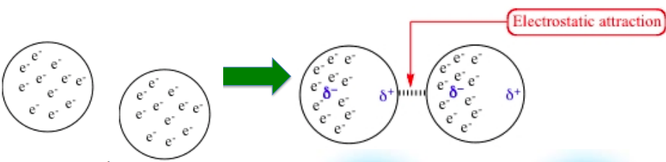
Dipole-Dipole | 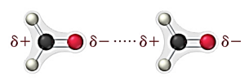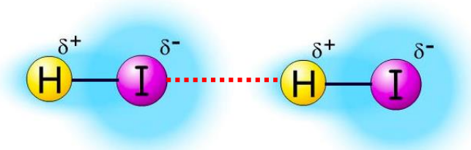
Hydrogen Bonding | 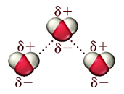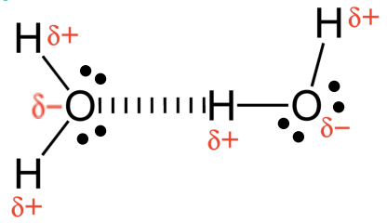
Ion-Dipole Force | 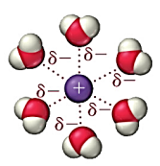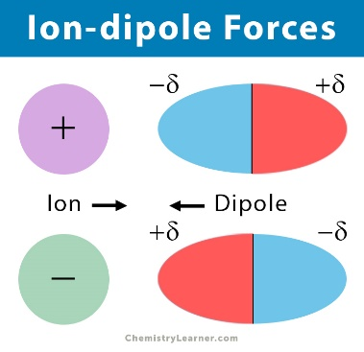
Ion Induced Dipole | 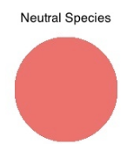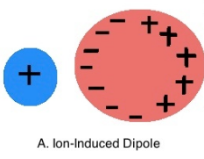
Dipole Induced Dipole | 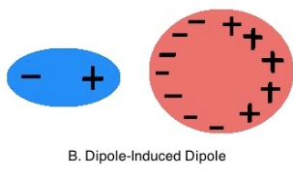
R-34
Bulk Solids
Ionic Lattice | 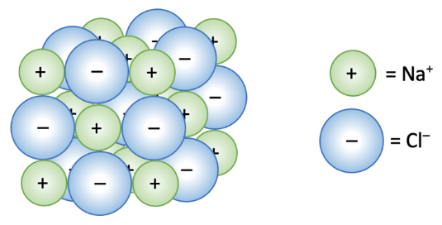
Metallic Bond | 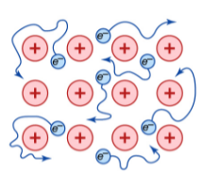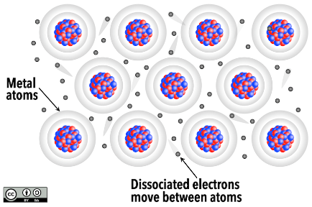
Network Covalent | 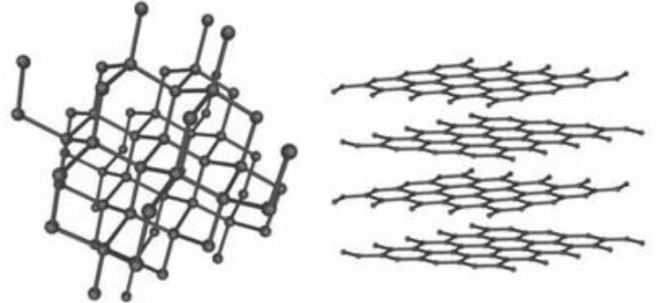

Videos About Vapor Pressure
- Explaining Boiling - https://youtu.be/Ag4lLUXKuSM

- Vapor Pressure, IMFs and Boiling Point - https://youtu.be/iZqsQhZ1CAs

- Crash Course, Partial Pressures and Vapor Pressure - https://youtu.be/JbqtqCunYzA

