Dougherty Valley HS • AP Chemistry
IMF’s, Liquids, & Solids
A BLUFFER’S GUIDE
Inspired by Paul Groves

- IntRAmolecular = forces holding atoms together...the “bonds”
  - Broken during chemical reactions

- IntERmolecular = forces holding molecules near other molecules
  - Broken during phase changes, pulling molecules away from each other but not pulling the bonded atoms apart! We do not break intRAmolecular bonds during a phase change.

- We will be classifying substances into:
  - Covalent (molecular)
    - London dispersion forces
    - Dipole-Dipole
    - Hydrogen bond
  - Bulk Solids
    - Metallic
      - “sea of electrons,” “free flowing electrons,” “mobile carriers” etc
      - Electrons detached and flow freely throughout the material
    - Ionic
    - Network covalent
      - Covalent bonded substance that has so many intER and intRa bonds that it is much stronger than expected
      - Common network covalents:
        - Carbon as Diamond and
Carbon as Graphite
        - WC, SiC
        - Si, SiO₂, SiO₄
        - (any others you come across!)
  - Some new to you IMFs:
    - Ion-Dipole
      - Interaction between an ion and a polar molecule
    - Ion Induced Dipole
      - When an ion causes a dipole to form in a non-polar molecule
    - Dipole Induced Dipole
      - When a polar molecule causes a dipole to form in a non-polar molecule

- To determine what type of IMF is present
  - Determine if it is ionic, covalent or metallic
  - If covalent – determine if it is:
    - Non-polar = London Forces
      - Temporary dipole due to the unequal distribution of electrons.
      - Everything has London Forces!
      - Weak compared to other forces BUT if you have enough cumulative forces it can result in higher properties than expected.
      - Increases with increased “polarizability of electron cloud” and surface area.
    - Polar = Dipole-Dipole
      - Permanent polarity due to the structure of the molecule
      - Increases with increased difference in electro negativities between atoms.
      - Bond dipoles do not cancel out, resulting in a “net dipole” for the molecule
    - Polar AND “H-NOF:” = H-bonding
      - Stronger than a typical dipole-dipole interaction.
      - Must meet the criteria of a hydrogen bonded to a highly electronegative element
(N, O, or F) with a lone pair.
      - Important examples: DNA, protein folding, water

- As the amount of IMFs increases
- Properties increase
  - Boiling point increases
  - Melting point increases
  - Viscosity increases
  - Surface tension increases
- Deviates more from “ideal” behavior

- Miscibility is based on IMFs
  - Polar things mix with polar things
  - Nonpolar things mix with nonpolar things

R-33

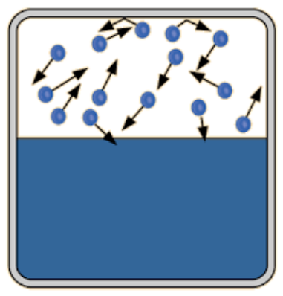
- Vapor Pressure
  - Vapor pressure is based on the dynamic between the liquid and the vapor above the liquid’s surface, when measured in a closed container.
  - Temperature is the only variable that changes the vapor pressure, not the quantity of liquid, the pressure above the liquid, or the volume of the container. Vapor-Liquid dynamics are an equilibrium situation. Example:
    - If you increase the volume of the container, the pressure inside will decrease.
    - When the pressure decreases, there are fewer vapor molecules per volume so the rate of condensation will slow down.
    - So for a period of time the rate of vaporization will be higher than the rate of condensation.
    - This will increase the amount of vapor in the container.
    - Eventually enough vapor is made so the rate of vaporization and rate of condensation are equal again.
    - Equilibrium is restablished!
    - Vapor pressure is now back to what it was before! Changing the container volume did not affect the vapor pressure value.
  - The lower the IMFs, the higher the vapor pressure above the liquid will be. The liquid is more “volatile”
    - The molecules are not being held into the liquid phase as much. More are in the vapor phase
  - The higher the IMFs, the lower the vapor pressure above the liquid will be. The liquid is less “volatile”
    - The molecules are being held in the liquid phase! Less are in the vapor phase.
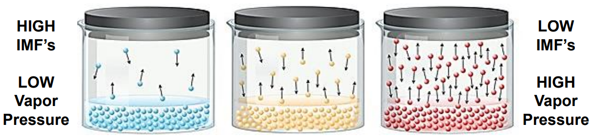
  - Boiling occurs when the vapor pressure matches the pressure above the container.
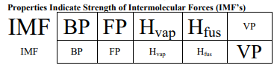
    - You can make things boil by either heating the temperature so the vapor pressure increases, OR by lowering the pressure above the liquid so that it matches the vapor pressure.
    - “Normal Boiling Point” is the temperature at which a liquid will boil when at sea level, 1atm.

- Phase Changes
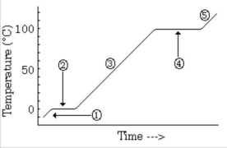
  - s ↔ l = melting, freezing
  - l ↔ g = vaporizing, condensing
  - During heating/cooling, there is a change to the kinetic energy (temperature is changing)
  - During phase changes, there is a change to the potential energy (particles are changing position, closer or further apart, NO temperature change!)
  - To calculate energy change involved:
    - During a heating/cooling segment
∆H = mC∆T
    - During a phase change
∆H_{fus} = mL_{fus}
∆H_{vap} = mL_{vap}

