Name: Period: Seat#:
S-7
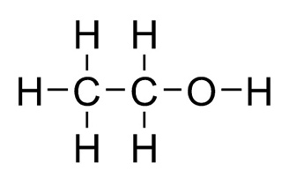 | Ethyl alcohol, molar mass = 46.08 g/mol

The heat of fusion of ethyl alcohol, ΔH_{fus}, is 4.98 kJ/mol.
The heat of vaporization of ethyl alcohol alcohol, ΔH_{vap}, is 39.40 kJ/mol.

Phase Change Equations
Write an equation for alcohol vaporizing. Include the energy value.

Change on the Particulate Level
If alcohol molecules looked like , draw a before and after picture of alcohol vaporizing.

Before (liquid) |  | After (gas)
 | →

Calculations
How much heat is needed to boil 10.0 grams of ethyl alcohol? (Show work as a single line equation.)

How much heat is released when 25.0 grams of liquid ethyl alcohol freezes?
(Show work as a single line equation.)

