**Name: Period: Seat#:**

**S-9**

Try these problems. If you can DO them, check the box (🗹). If you CANNOT do them, write some notes TO YOURSELF about what you need to study to succeed at these problems.

***The specific heat of water is 4.18 J/g·°C. The molar mass of C3H8 = 44.09 g/mol.***

🞎 **Calculating Enthalpy (ΔH) from Data:**

A 3.00 gram sample of propane, C­3H8, is burned and warms 100. g of water from 20.0°C to 100.0°C. What is the ΔH of combustion for C3H8? _____________ What is the sign of the ΔH? ____

🞎 **Heating Curves**

Consider the following heating curve of ice at -30 °C to steam at 130 °C.

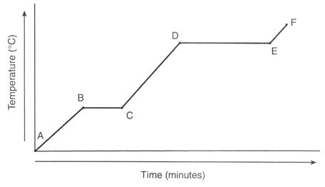

a) Label the graph with “solid”, “liquid”, and “gas”

b) In which segment is ***boiling of the water*** occurring? _____ (AB, BC, etc.)

c) Where on this curve would you use the formula, q = mCΔT? _____________________

d) Describe what is happening to the H2O as you move from point B to point D.

______________________________________________________________

e) ΔHfus would be used as the H2O goes from Point ___ to Point ___