Dougherty Valley • AP Chemistry [Keep for Reference]

18 • Acid-Base Reactions

STUDY LIST From Paul Groves

STRONG ACID-STRONG BASE NEUTRALIZATION

I can:

🞎 write the equation for the neutralization of a strong acid and strong base.

🞎 state that the pH at the equivalence point = 7.

🞎 calculate the pH of the initial acid or base solution.

🞎 calculate the pH of any combination of acid and base before and after the equivalence point.

🞎 state that a titration is the volumetric analysis of an acid of unknown concentration by adding a base of known concentration.

🞎 sketch the shape of a strong acid-strong base titration curve.

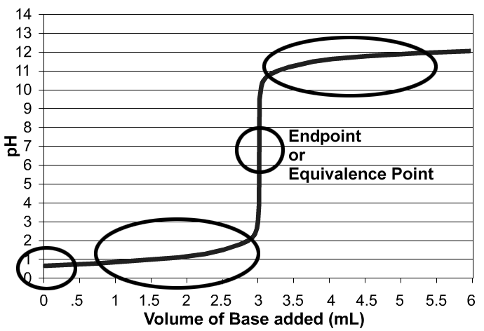

ACID-BASE NEUTRALIZATIONS INVOLVING WEAK ACIDS & BASES

🞎 write the equation for the neutralization of any acid and any base.

🞎 predict the general pH of a strong or weak acid neutralized by a strong or weak base:   
• strong acid + strong base ________  
• weak acid + strong base ________  
• strong acid + weak base ________

🞎 explain that the pH at the equivalence point depends on the conjugate base or the conjugate acid formed from the reactants.

🞎 identify the conjugate acid of a weak base or the conjugate base of a weak acid in a neutralization.

🞎 calculate the volume of acid needed to neutralize a base and the volume of base needed to neutralize an acid using the formula: VH+ MH+ = VOH- MOH- or a line equation.

🞎 calculate the concentration of the conjugate base or conjugate acid and the pH at the endpoint of a titration.

🞎 explain that weak acids and strong acids require the same amount of base to be neutralized because the weak acids will dissociate during neutralization.

BUFFERS

I can:

🞎 describe how a pH buffer behaves when small amounts of acid or base are added.

🞎 explain why a buffer works (buffering capacity) based on the presence of the weak acid (H+ donor) and conjugate base (H+ acceptor). I can show mathematically that diluting the buffer does not change the pH of the buffer; but it reduces its buffering capacity.

🞎 calculate the pH of the best buffer you can make from a given acid and its conjugate base given Ka’s of weak acids (or Kb’s of weak bases)

🞎 choose the acid / conjugate base needed to get a buffer of specified pH. (Given Ka’s of acids.)

🞎 choose pairs of substances that will make a buffer:

--weak acid & its conjugate base --weak base & its conjugate acid

or

--weak base & ***some*** strong acid --weak acid & ***some*** strong base

🞎 calculate the pH of a buffer using the ICE box or the Henderson-Hasselbach equation.

TITRATION CURVES

🞎 determine the equivalence point (end point) of the titration by looking at a titration curve.

🞎 determine the pKa of the weak acid being titrated by looking at a titration curve.

🞎 do the eight calculations that will allow me to sketch the pH curve for a weak acid or weak base.

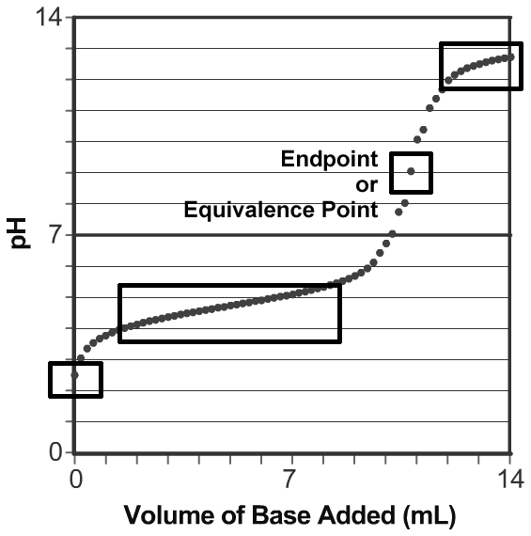

* pH of the weak acid solution initially
* amount of based needed for titration
* concentration of conjugate base at endpoint
* pH of the solution at the endpoint
* pH halfway to the equivalence point (e.p.)
* pH a little *before* halfway to the e.p.
* pH a little *after* halfway to the e.p.
* pH after all of the acid has been neutralized

🞎 translate all of my knowledge and skills from a weak acid titration to a weak base titration.

DIPROTIC ACIDS

ACID-BASE INDICATORS

LAB: TITRATIONS