Dougherty Valley • AP Chemistry

**S-84b**

18 • Acid-Base Reactions

STUDY LIST From Paul Groves

STRONG ACID-STRONG BASE NEUTRALIZATION

I can:

🞎 write the equation for the neutralization of a strong acid and strong base.

🞎 state that the pH at the equivalence point = 7.

🞎 calculate the pH of the initial acid or base solution.

🞎 calculate the pH of any combination of acid and base before and after the equivalence point.

🞎 state that a titration is the volumetric analysis of an acid of unknown concentration by adding a base of known concentration.

🞎 sketch the shape of a strong acid-strong base titration curve.

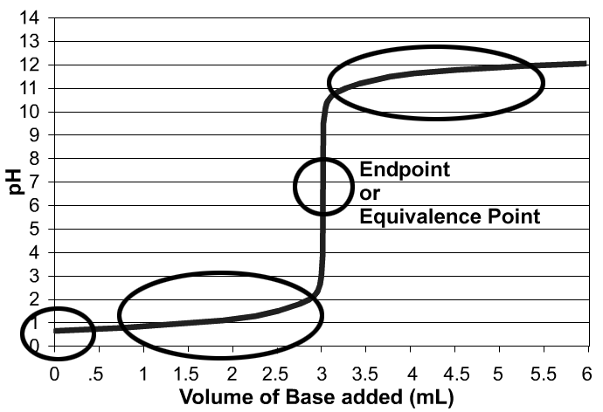

ACID-BASE NEUTRALIZATIONS INVOLVING WEAK ACIDS & BASES

🞎 write the equation for the neutralization of any acid and any base.

🞎 predict the general pH of a strong or weak acid neutralized by a strong or weak base:   
• strong acid + strong base ________  
• weak acid + strong base ________  
• strong acid + weak base ________

🞎 explain that the pH at the equivalence point depends on the conjugate base or the conjugate acid formed from the reactants.

🞎 identify the conjugate acid of a weak base or the conjugate base of a weak acid in a neutralization.

🞎 calculate the volume of acid needed to neutralize a base and the volume of base needed to neutralize an acid using the formula: VH+ MH+ = VOH- MOH- or a line equation.

🞎 calculate the concentration of the conjugate base or conjugate acid and the pH at the endpoint of a titration.

🞎 explain that weak acids and strong acids require the same amount of base to be neutralized because the weak acids will dissociate during neutralization.

BUFFERS

I can:

🞎 describe how a pH buffer behaves when small amounts of acid or base are added.

🞎 explain why a buffer works (buffering capacity) based on the presence of the weak acid (H+ donor) and conjugate base (H+ acceptor). I can show mathematically that diluting the buffer does not change the pH of the buffer; but it reduces its buffering capacity.

🞎 calculate the pH of the best buffer you can make from a given acid and its conjugate base given Ka’s of weak acids (or Kb’s of weak bases)

🞎 choose the acid / conjugate base needed to get a buffer of specified pH. (Given Ka’s of acids.)

🞎 choose pairs of substances that will make a buffer:

--weak acid & its conjugate base --weak base & its conjugate acid

or

--weak base & ***some*** strong acid --weak acid & ***some*** strong base

🞎 calculate the pH of a buffer using the ICE box or the Henderson-Hasselbach equation.

TITRATION CURVES

🞎 determine the equivalence point (end point) of the titration by looking at a titration curve.

🞎 determine the pKa of the weak acid being titrated by looking at a titration curve.

🞎 do the 8 calculations that will allow me to sketch the pH curve for a weak acid or weak base.

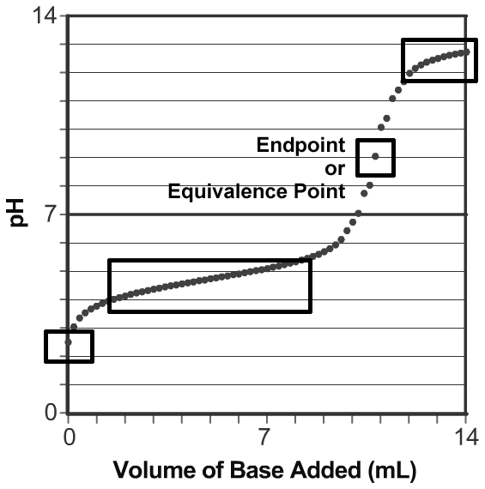

* pH of the weak acid solution initially
* amount of based needed for titration
* concentration of conjugate base at endpoint
* pH of the solution at the endpoint
* pH halfway to the equivalence point (e.p.)
* pH a little *before* halfway to the e.p.
* pH a little *after* halfway to the e.p.
* pH after all of the acid has been neutralized

🞎 translate all of my knowledge and skills from a weak acid titration to a weak base titration.

DIPROTIC ACIDS

🞎 remember that often the first hydrogen ionizes completely, and has a very large Ka1 value.

🞎 be able to use an ICE table for the second ionization because it is typically a weak acid reaction, small Ka2 value.

🞎 use the starting H+ concentration from the first ionization as the initial [H+] for the ICE table being used for the second ionization.

🞎 the more dilute the acid is, the more the second dissociation will contribute towards the pH.

🞎 remember - sometimes teachers do not cover how to do diprotic calculations so you may see problems where they ignore the 2nd ionization, or they tell the students to remove both hydrogens completely.

ACID-BASE INDICATORS

🞎 know the definition of an indicator

🞎 know the key properties of a good indicator

* easily detected color change
* rapid color change
* indicator molecule must not react with the substance being titrated
* pK value that is +/- 1 pH unit of the expected equivalence point pH.

LAB: TITRATIONS

🞎 know the effect of some common titration lab errors.

🞎 be able to do the calculations mentioned in the Titration Curves section of this document when given lab data.

TITRATION SIMULATION

Another teacher posted this simulation and said that their students found it helpful. Not required, but thought I would share it with you in case it is helpful to you also! <https://tinyurl.com/4k6x6bz5>

