South Pasadena • AP Chemistry Name ___________________________________
Period ___ Date ___/___/___
18 • Acids, Bases, & Buffers
STATION 1: INITIAL pH
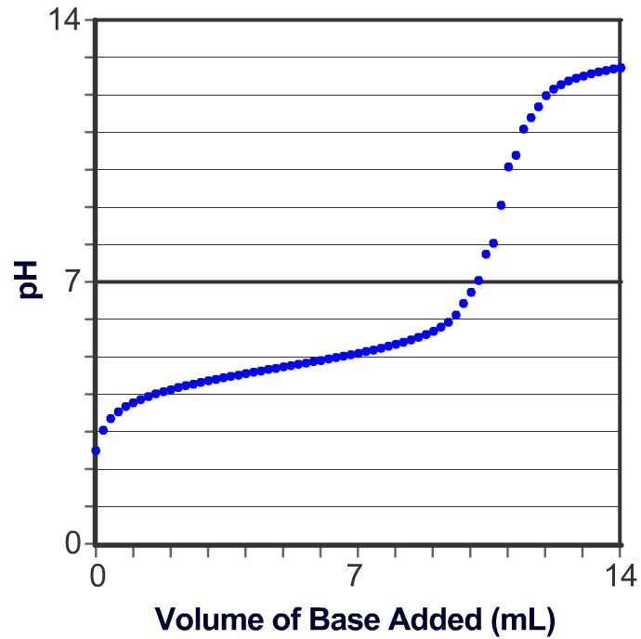 | In this Review, we will walk ourselves through the calculations needed to sketch the Titration Curve for a weak acid titrated with a strong base.  Acetic acid, is often abbreviated as HAc.. K_{a} acetic acid = 1.8x10⁻⁵  SHOW YOUR WORK FOR EACH STEP.

What is the pH of a 0.15 M solution of HAc?

Plot this point on your Titration Curve (Station 9).

18 • Acids, Bases, & Buffers
STATION 2: VM = VM
The acid is titrated with a 0.10 M solution of KOH.
Calculate the volume of base needed to neutralize a 10. mL sample of the 0.15 M HAc.

Note that this is the volume of base at the equivalence point on your titration curve.
18 • Acids, Bases, & Buffers
STATION 3: EQUIVALENCE POINT CHEMICALS
a) Write the balanced net equation for the neutralization of HAc by KOH:

b) What chemicals are in the flask at the endpoint (equivalence point) of this titration?

c) How many moles of HAc are in the 10. mL of 0.15 M HAc that you used for the titration?

d) How many moles of Ac⁻ are in the flask at the equivalence point?

e) What is the total volume of solution (in Liters) at the equivalence point?

f) What is the concentration of Ac⁻ at the equivalence point? [Ac⁻] =

18 • Acids, Bases, & Buffers
STATION 4: pH AT EQUIVALENCE POINT
Calculate the pH of a solution with the [Ac⁻] from Station 3. K_{a} of HAc = 1.8 x 10⁻⁵

Plot the pH at the equivalence point on your titration curve using the info from Stations 2 and 4.
18 • Acids, Bases, & Buffers
STATION 5: HALF-WAY TO EQUIVALENCE POINT

a) What volume of base is half-way to the equivalence point? _____ mL

b) What do you know about the pH half-way to the equivalence point? pH = _____

c) What is the pH half-way to the equivalence point? ________

d) Plot this third point on your titration curve (Station 9).

18 • Acids, Bases, & Buffers
STATION 6: BEFORE HALF-WAY
When 6.5 mL of KOH has been added to the solution:

a) How many moles of HAc are in 10. mL of 0.15 M HAc?

b) How many moles of OH- are in 6.5 mL of 0.10 M KOH?

c) What is the total volume (in Liters)?

d) Fill in this NEUTRALLIZATION chart using Molarities
HAc | + OH⁻ | → H₂O(l) | + Ac⁻

e) Fill in this EQUILIBRIUM chart:
HAc | + H₂O(l) |  H₃O⁺ | + Ac⁻

f) Write the equilibrium expression for HAc.
Substitute the equilibrium values into the expression and compute the [H₃O⁺] concentration and pH.

18 • Acids, Bases, & Buffers
STATION 7: AFTER HALF-WAY
When 8.5 mL of KOH has been added to the solution:

a) How many moles of HAc are in 10. mL of 0.15 M HAc?

b) How many moles of OH- are in 8.5 mL of 0.10 M KOH?

c) What is the total volume (in Liters)?

d) Fill in this NEUTRALIZATION chart using Molarities
HAc | + OH⁻ | → H₂O(l) | + Ac⁻

e) Fill in this EQUILIBRIUM chart:
HAc | + H₂O(l) |  H₃O⁺ | + Ac⁻

f) Write the equilibrium expression for HAc.
Substitute the equilibrium values into the expression and compute the [H₃O⁺] concentration and pH.

18 • Acids, Bases, & Buffers
STATION 8: AFTER THE EQUIVALENCE POINT
When 20. mL of KOH have been added to the solution:

a) How many moles of HAc are in 10. mL of 0.15 M HAc?

b) How many moles of OH⁻ are in 20. mL of 0.10 M KOH?

c) How many moles of excess OH⁻ are in solution?

d) What is the total volume (in Liters)?

e) What is the concentration of OH-, the pOH, and the pH of the solution?

18 • Acids, Bases, & Buffers
STATION 9: SKETCH THE TITRATION CURVE
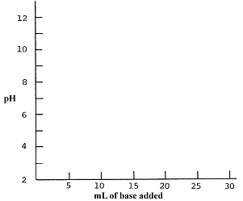

FYI: Formulas from the AP Exam:
