**Dougherty Valley HS AP Chemistry**

**S-78**

**Acid Base Equilibrium**

**Quick Check #3**

**Name: Date: Period: Seat #:**

🞎 **Diprotic Acids**

Sulfurous acid, H2SO3, is a diprotic acid. Write the step-wise dissociation equations for H2SO3.

|  |  |
| --- | --- |
|  | Ka1 = 1.5 x 10-5 |
|  | Ka2 = 1.0 x 10-7 |

🞎 **~~Lewis Acids and Bases~~**

Consider the following picture. The Lewis acid is ____________. The Lewis base is ___________.

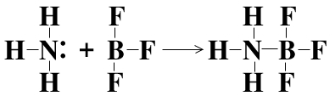

Consider the equation: H+ + OH ⭢ H2O. The Lewis acid is _______. The Lewis base is ______.

🞎 **Strengths of Acids**

Consider the acids: HClO2, HBrO2, HIO2. Rank them from weakest to strongest.

|  |  |  |  |  |
| --- | --- | --- | --- | --- |
| Weakest |  |  |  | Strongest |

Justification:

Consider the acids: HBrO, HBrO2, HBrO3. Rank them from weakest to strongest.

|  |  |  |  |  |
| --- | --- | --- | --- | --- |
| Weakest |  |  |  | Strongest |

Justification:

Consider the acids: HCl, HBr, HI. Rank them from weakest to strongest.

|  |  |  |  |  |
| --- | --- | --- | --- | --- |
| Weakest |  |  |  | Strongest |

Justification:

🞎 **Diprotic Acid Calculations**

What is the [SO32-] in a 0.150 M solution of H2SO3? ___________

Calculate the pH of a 0.150 M solution of H2SO3.