Dougherty Valley • AP Chemistry

**S-92**

Electrochem: Application of Thermodynamics

**STUDY LIST From Paul Groves**

General Terms

I can…

* Determine the oxidation number of any element.
* State that oxidation number is the charge an atom would have if all of the shared electrons were assigned to the more electronegative atom.
* Identify for any element in a reaction whether it is gaining or losing electrons (LeO GeR).
* Explain that when oxidation occurs, reduction must also occur (RedOx).
* Correctly apply the terms oxidizing agent and reducing agent to a redox reaction.
* State that there are two big topics in electrochemistry, (1) **Electrolysis**—in which electricity (moving electrons) causes chemical change, and (2) **Electrochemical Cells**—in which chemical changes cause a flow of electrons (electricity).

Electrolysis

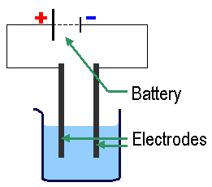

I can…

* State that during electrolysis, electricity applied to a solution causes ions to migrate to the electrodes.
* State that an electrode is the part of the conductor that touches the solution.
* State that reduction always occurs at the cathode (red cat).
* State that oxidation always occurs at the anode (an ox).
* Write equations for the reactions that occur at the electrodes when water undergoes electrolysis (memorize how to derive these).  
  () cathode: 2 H2O(l) + 2 e → H2(g) + 2 OH  
  (+) anode: 2 H2O(l) → O2(g) + 4 H+ + 4 e 
* Explain that during the electrolysis of an ionic solution, either the + ion can be reduced or water can be reduced. In the same way, either the – ion can be oxidized or water can be oxidized.
* Use a reduction potential chart to determine which of two substances is more likely to be reduced or oxidized.
* State that electrical current is measured in Coulombs and 1 Coulomb = 1 amp·1 sec.
* State that 1 Faraday (**F**) = 1 mole of electrons = 96,500 Coulombs.
* Use the Faraday, amps and seconds to quantify electrolysis problems.

Electrochemical Cells

(Voltaic Cells & Galvanic Cells)

I can…

* State that oxidization always occurs at the anode and reduction always occurs at the cathode.
* Draw a simple electrochemical cell:

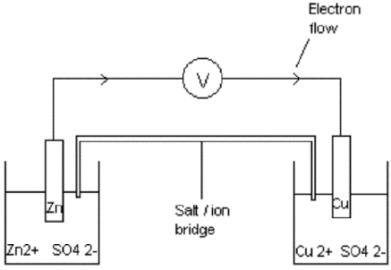

* Use the reduction potential chart to determine which chemical is the anode (smaller E°) and which chemical is the cathode (larger E°).
* State that standard conditions are 25°C, solutions are 1 M, and gases are 1 atm.
* Calculate the voltage of a standard cell as the difference in the two E° values. (not like Hess)
* State that the anode is the () electrode because the chemicals are being oxidized (losing e’s).
* State that for non-standard cells, changes that drive the reaction forward increase the voltage.  
  (The Nernst equation allows you to calculate this voltage for a non-standard cell.)