South Pasadena • AP Chemistry Name __________________________ Period___
21 • Electron Transfer Reactions
STATION 1 – CELL NOTATION

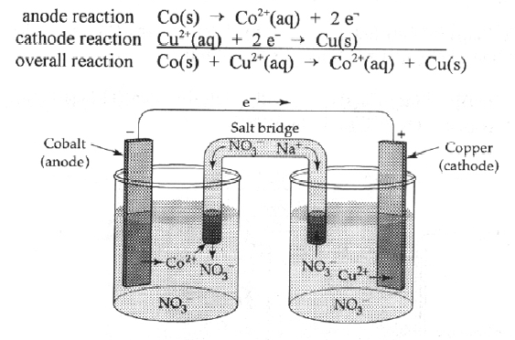
The “cell notation” for this electrochemical cell is Co(s) | Co²⁺ || Cu²⁺ | Cu(s)
Use the above information to answer the following questions:

1. The left portion of the cell notation represents the _________ (anode / cathode).
2. The “||” represents the ______________ (anode / cathode / salt bridge)
3. Write the cell notation for Cl₂(g) + Zn(s) → 2 Cl⁻ + Zn²⁺ _____ | _____ || _____ | _____
4. Write the cell notation for 2Ag(s) + Pt²⁺ → Pt(s) + 2Ag⁺ _____ | _____ || _____ | _____

21 • Electron Transfer Reactions
STATION 2 – E VALUES
Standard Reduction Potentials (volts)  Ag⁺(aq) + e⁻ → Ag(s) +0.80  I₂(s) + 2e⁻ → 2I⁻(aq) +0.535  Cu²⁺(aq) + 2e⁻ → Cu(s) +0.337  Sn⁴⁺(aq) + 2e⁻ → Sn²⁺(aq) +0.15  Sn²⁺(aq) + 2e⁻ → Sn(s) -0.14  Cd²⁺(aq) + 2e⁻ → Cd(s) -0.40  Zn²⁺(aq) + 2e⁻ → Zn(s) -0.763  2H₂O(l) + 2e⁻ → H₂(g) + 2OH⁻(aq) -0.828  Al³⁺(aq) + 3e⁻ → Al(s) -1.66 | 1. A cell is made from Sn in 1.0 M Sn(NO₃)₂ and Al in 1.0 M Al(NO₃)₃. The E° of the cell is ______ volts.  2. A cell is made from Sn in 1.0 M Sn(NO₃)₂ and Cd in 1.0 M Cd(NO₃)₂. The E° of the cell is ______ volts.  3. A cell is made from Ag in 1.0 M AgNO₃ and Cu in 1.0 M Cu(NO₃)₂. The E° of the cell is ______ volts.  4. A cell is made from Zn in 1.0 M Zn(NO₃)₂ and Ag in 1.0 M AgNO₃. The E° of the cell is ______ volts.

21 • Electron Transfer Reactions
STATION 3 – NERNST EQUATION
Standard Reduction Potentials (volts)  Sn²⁺(aq) + 2e⁻ → Sn(s) -0.14  Al³⁺(aq) + 3e⁻ → Al(s) -1.66  E_{cell} = E° − $\frac{\text{RT}}{\text{nF}}$ln Q  look at your equation sheet for R and F.  “n” is the moles of electrons gained or lost in a redox reaction. | 1. Fe(s) + Cu²⁺(aq) → Fe²⁺(aq) + Cu(s) E° = +0.78 V  a) What is n? ______ moles  b) If [Cu²⁺] = 0.10 M and [Fe²⁺] = 1.5 M,  Q = $\frac{[ ]}{[ ]}$=  c) Calculate the E_{cell}.
2. A cell is made from Sn in .25 M Sn(NO₃)₂ and Al in 0.25 M Al(NO₃)₃ at 25°C.
a) The E° of the cell is ______ volts.
b) The reaction at the anode is: _______________________
c) The reaction at the cathode is: _______________________
d) The overall reaction is: ____________________________________
e) The value of n is ______ moles.
f) Q = $\frac{[ ]}{[ ]}$=
g) Calculate the E_{cell}.

21 • Electron Transfer Reactions
STATION 4 – BALANCING REDOX EQ’S(ACIDIC)
Balance the following equations in acidic solution:

Cr₂O₇⁻²(aq) + C₂O₄⁻²(aq) → Cr⁺³(aq) + CO₂(g)

MnO₄⁻(aq) + SO₂(g) → SO₄⁻²(aq) + Mn⁺²(aq)

21 • Electron Transfer Reactions
STATION 5 – BALANCING REDOX EQ’S (BASIC)
Balance the following equations in basic solution:

Mn⁺²(aq) + ClO₃⁻(aq) → MnO₂(s) + ClO₂(g)

Cl₂(g) → Cl⁻(aq) + ClO₃⁻(aq)

21 • Electron Transfer Reactions
STATION 6 – ELECTROLYSIS
How long will it take to electroplate each of the following with a current of 100.0 A?

1.0 g of Al(s) from aqueous Al⁺³.

1.0 g of Ni(s) from aqueous Ni⁺².

21 • Electron Transfer Reactions
STATION 7 – REACTIVITY
Consider the following half-reactions and E° values:
Ag⁺(aq) + e⁻ → Ag(s) E° = 0.80 V
Cu⁺²(aq) + 2e⁻ → Cu(s) E° = 0.34 V
Pb⁺²(aq) + 2e⁻ → Pb(s) E° = -0.13 V

1. Which of these metals or ions is the strongest oxidizing agent? ____
2. Which is the strongest reducing agent? _____

Predict whether each of the following reactions will occur as written:
3. Cu²⁺ + Pb° → Pb²⁺ + Cu° ______
4. Pb²⁺ + 2Ag° → 2Ag⁺ + Pb° ______
5. 2Ag⁺ + Pb²⁺ → 2Ag° + Pb° ______

21 • Electron Transfer Reactions
STATION 8 – SKETCH A CELL
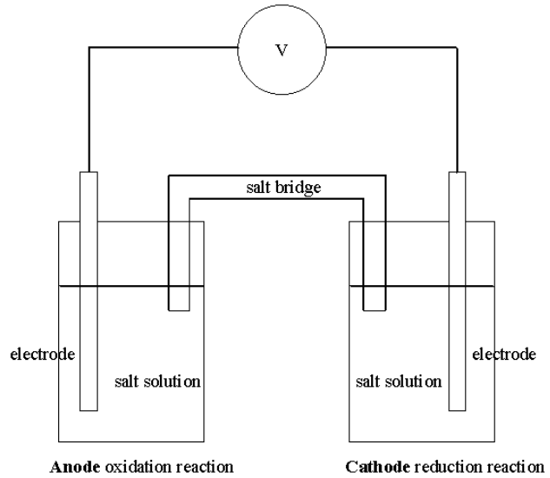 | Consider these half-reactions & E° values:  Ag⁺(aq) + e⁻ → Ag(s) E° = 0.80 V  Cu⁺²(aq) + 2e⁻ → Cu(s) E° = 0.34 V  Pb⁺²(aq) + 2e⁻ → Pb(s) E° = -0.13 V  Which two metals and 1.0 M solutions would give the greatest voltage? ___ ___  Label:  - the anode reaction  - the cathode reaction  - the overall reaction  - the metals used for each electrode  - the ions in solution  - the expected voltage  - the direction of flow of electrons  - the flow of ions in the salt bridge  - the charge on each electrode (+ or −)  - ions you might use in the salt bridge  - the observed changes in the electrodes

