Dougherty Valley HS AP Chemistry
S-88
Electrochemistry
Quick Check #1
Name: Date: Period: Seat #:
Electrolysis Reactions

Use your Reduction Potential Chart to determine the reaction at the anode, reaction at the cathode, and the overall reaction during the electrolysis of a solution of copper(II) chloride.

Electrolysis Stoichiometry
A current of 2.50 amps is passed through a solution of Ni(NO₃)₂ for 2.00 hours.
What mass of Ni metal is deposited?

Electrochemical Cell
Sketch the cell made from Au in a 1.0 M solution of gold(III) nitrate and Zn in a 1.0 M solution
of Zn(II) sulfate.
Au³⁺ + 3e⁻ → Au(s) +1.50
Zn²⁺(aq) + 2e⁻ → Zn(s) -0.763

Anode Reaction | Sketch the Cell | Cathode Reaction
 | 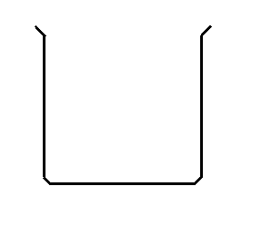
 | Overall Reaction & E° (volts)

