Dougherty Valley HS AP Chemistry
QUICK CHECK #1a
Acid Base Equilibrium Review

Name: Date: Period: Seat #:
Balancing Redox Equations
An acidified solution of potassium dichromate is added to a solution of iron(II) sulfate.

Aluminum metal is added to a strongly basic solution of sodium hydroxide forming bubbles of
hydrogen gas and the complex ion, Al(OH)₄⁻.

Electrolysis Reactions

Use your Reduction Potential Chart to determine the reaction at the anode, reaction at the cathode, and the overall reaction during the electrolysis of a solution of copper(II) chloride.

Electrolysis Stoichiometry
A current of 2.50 amps is passed through a solution of Ni(NO₃)₂ for 2.00 hours.
What mass of Ni metal is deposited?

Predicting Spontaneous (Product-Favored) Reactions
State whether each reaction below is product-favored or not. Use your reduction potential chart.
____ Br₂ + 2Cl⁻ → Cl₂ + 2Br⁻
____ Cu²⁺ + 2I⁻ → I₂ + Cu
____ 2Au³⁺ + 3Zn → 3Zn²⁺ + 2Au

Electrochemical Cell
Sketch the cell made from Au in a 1.0 M solution of gold(III) nitrate and Zn in a 1.0 M solution
of Zn(II) sulfate.
Au³⁺ + 3e⁻ → Au(s) +1.50
Zn²⁺(aq) + 2e⁻ → Zn(s) -0.763

Anode Reaction | Sketch the Cell | Cathode Reaction
 | 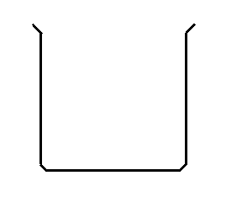
 | Overall Reaction & E° (volts)

Non-Standard Electrochemical Cell
Calculate the voltage of the above cell if the [Au³⁺] = 5.00 M and [Zn²⁺] = 0.100 M.

Alkali Metal in Water
Write the balanced chemical equation for the reaction of potassium metal dropped into water.

Oxidation-Reduction of Alkali Metals in Water
Which element in the chemical equation above, was oxidized and which element was reduced?
____________ was oxidized and was the ______________agent
____________ was reduced and was the ______________agent

Electrolysis of Water
Write the balanced chemical equation for the electrolysis (or decomposition) of water.

What are the two half-reactions for this overall reaction, showing the reduction and the oxidation?

