A | 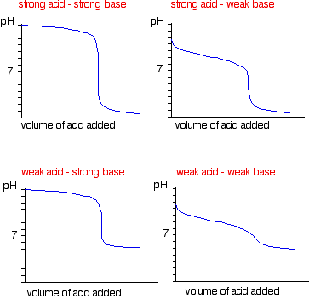 | B | 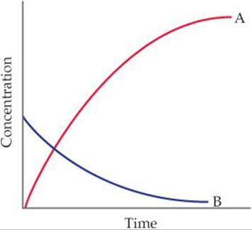
C | 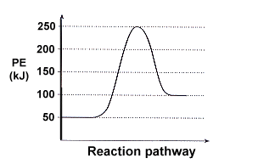 | D | 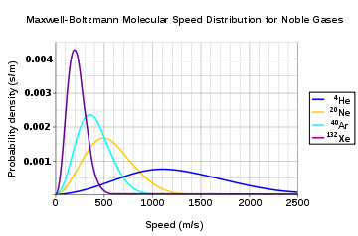
E | 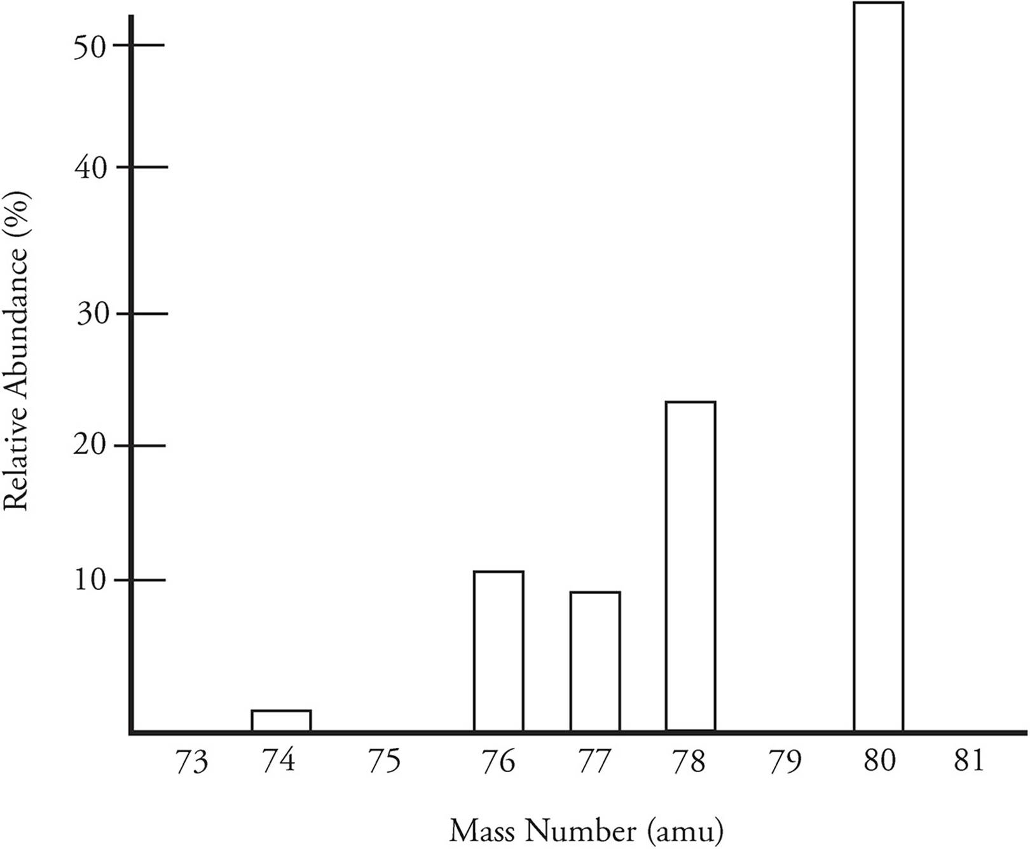 | F | 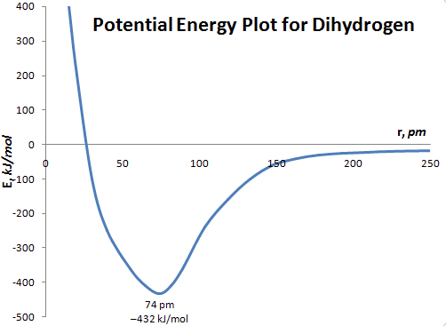
G | 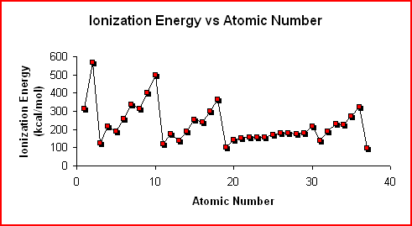 | H | 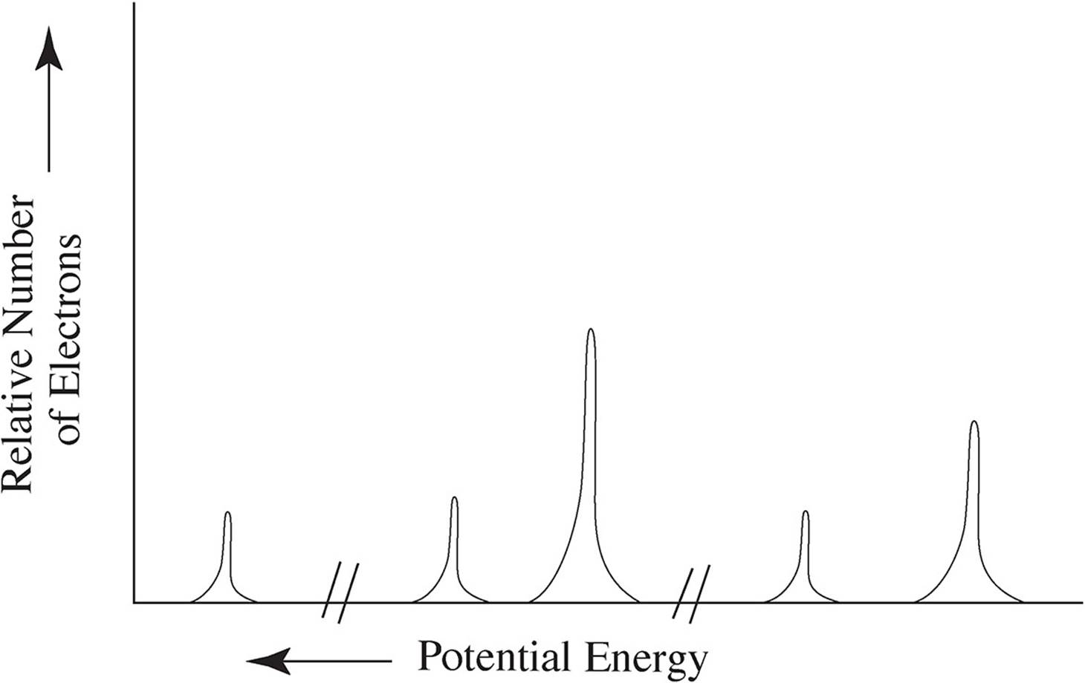
I | 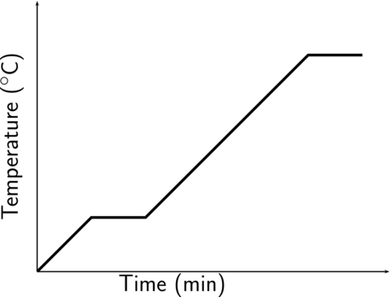 | J | 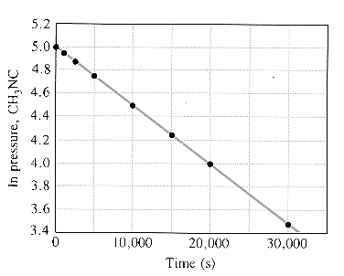

NAME:____________________________________________________________________________
18C12D8 Graph Analysis Review Activity
- Match each graph with its name.
Letter | Name
 | Maxwell Boltzmann Distribution of particle speeds
 | Heating Curve
 | Concentration vs Time graph for first order reaction ([X] vs .t )for a 1st order reaction X→ products)
 | Internuclear Separation Energy Graph (Bond energy)
 | Reaction Potential Energy Diagram (Energy profile)
 | Mass Spectrum
 | First Ionization Energy of Elements Graph
 | Photoelectron Spectrum
 | Natural Log of Concentration vs time (ln[X] vs .t )for a 1st order reaction X→ products
 | Titration Curve

2. Label the axes of each graph with variables and likely units.
3. Cut the graphs apart. Tape each graph with the question that it would likely be found with. Then explain how you could answer the question using the graph.
QUESTION: What is the enthalpy of reaction for this process? | Tape graph here
Explain how to answer the question using the graph.

QUESTION: How many valence electrons does this species have? | Tape graph here
Explain how to answer the question using the graph.

QUESTION: What is the equivalence point volume for the reaction? | Tape graph here
Explain how to answer the question using the graph.

QUESTION: What is the average rate of the reaction over the period 0 to 20 seconds? | Tape graph here
Explain how to answer the question using the graph.

QUESTION: What is the boiling point of this species? | Tape graph here
Explain how to answer the question using the graph.

QUESTION: What is the approximate average atomic mass of this element? | Tape graph here
Explain how to answer the question using the graph.

QUESTION: What is the value of the rate constant for this process? | Tape graph here
Explain how to answer the question using the graph.

QUESTION: Which curve represents the gas at the highest temperature? | Tape graph here
Explain how to answer the question using the graph.

QUESTION: What is the bond energy for this species? | Tape graph here
Explain how to answer the question using the graph.

QUESTION: Identify two neighboring elements in the same period that are an exception to the overall trend observed for that period and using principles of atomic structure and Coulomb’s Law, explain the reason for this exception | Tape graph here
Explain how to answer the question using the graph.
4. Draw each graph on the grid provided, label the axes, then explain how it differs from the example graph.
Draw a titration curve for a weak acid analyte and a strong base titrant.   | How is the graph you drew different from the example graph?

Draw a reaction potential energy diagram for an exothermic process. | How is the graph you drew different from the example graph?

Draw a photoelectron spectrum for nitrogen. | How is the graph you drew different from the example graph?

