**Answer Key: AP Chemistry Experimental Evidence Review**

For each of the following scenarios, review the objectives of the laboratory team, the data collected, and use your knowledge of chemistry to analyze the results and make conclusions.

\**Note: These scenarios are not to be performed in the lab. Safety precautions have not been included.*

|  |
| --- |
| Digital balance (0.1 g) |
| Beakers, various sizes |
| Goggles |
| Volumetric flasks, various sizes (0.5 mL) |
| Gloves |
| Triple Beam Balance (0.01 g) |
| Graduated cylinders (1 mL) |
| Metal scoop |
| Bathroom Scale (1 g) |

**Scenario #1: Using Spectroscopy to Quantify Color**

1. Description: You are given a bottle of chromium(III) nitrate and asked to prepare 100 mL of a 0.20-M solution of the compound. Given the lab equipment listed in the table with the sensitivity of the instrument in parenthesis, describe the process for preparing the sample.

0.100 L x 0.20 mol/L x 238.03 g/mol = 4.76 g Cr(NO3)3

Procedure: put on goggles and gloves, weigh out 4.76 g of chromium(III) nitrate with the triple beam balance and dissolve in water in a 50-mL beaker, with stirring. Transfer the solution to a 100-mL volumetric flask. Add water so the bottom of the meniscus is even with the fill line and shake 13 times. Place the flask on a flat surface and check to make sure the meniscus is still even with the fill line. If it’s below, add drops of water until it is even.

1. When the solution is analyzed in a spectrophotometer, the data below was obtained.

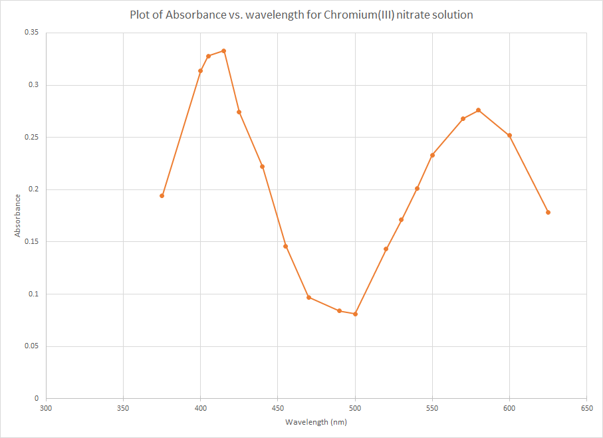

1. What do the peaks at approximately 400 nm and 580 nm represent? Justify your response

The peaks represent the wavelengths of light that are most absorbed by the sample.

1. Would the solution of Cr(NO3)3 be colored? Justify your response.

Since the wavelengths absorbed are within the visible range, the solution would be colored.

**Scenario #2: Analysis of an Alloy with Spectroscopy**

1. Description: A chemist is tasked with determining the copper content of a sample of brass. If the content of the copper is above 95%, the brass is considered “Gilding Brass” and it can be used for coins. If it is less than 95% copper, it cannot be used for coins. The other metal alloyed with the copper is zinc. Describe a reaction, or process of reactions, that you can use to separate the alloy.

The brass could be reacted with nitric acid to ionize both the copper and the zinc. The reaction would produce copper(II) nitrate, which is blue colored and would be able to be detected by a visible light range spectrometer.

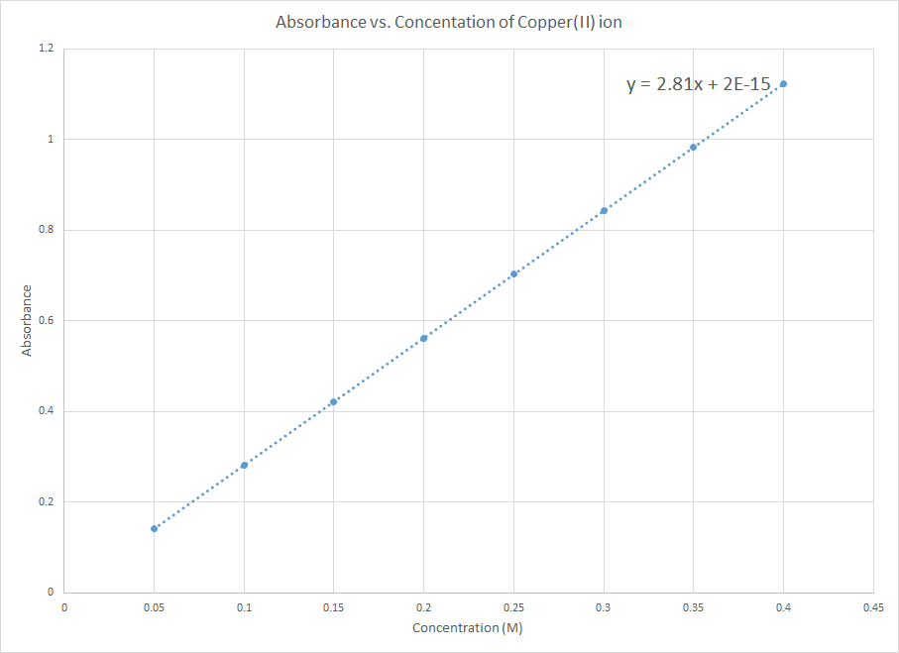

1. Above is a graph of the absorbance of the blue copper(II) ion in solution, made with various concentrations of copper(II) ion. If a 0.5-gram sample of the alloy was dissolved in 100 mL of solution and the absorbance read 0.204, what is the purity of the copper in the brass? Justify your response with calculations.

0.204 = 2.81x + 2x10-15 x=0.0726 M Cu2+

|  |  |  |  |  |
| --- | --- | --- | --- | --- |
| 0.100 L | 0.726 mol Cu | 63.55 g | = | 0.461 g Cu |
|  | L | mol |

|  |  |  |  |
| --- | --- | --- | --- |
| 0.461 g Cu | x | 100 | = 92% Cu |
| 0.500 g sample |

**Scenario #3: Stoichiometry and Predictive Precipitation**

1. Description: Below is a simulated graph of the titration of a sample of water that is suspected to be “hard water”. The water sample was titrated with 0.10-M sodium carbonate.

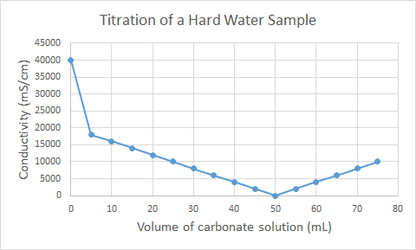

1. What ion makes the water hard?

Calcium

1. Write a net ionic equation for the reaction of sodium carbonate with the hard water sample.

Ca2+(aq) + CO32-(aq) 🡺 CaCO3(s)

1. Describe why the titration curve has the shape that it does. Why does the theoretical conductivity go to zero and then rise again?

As the reaction proceeds, the conductivity decreases as calcium and carbonate ions are removed from the solution. Once all of the calcium and carbonate are precipitated, additional spectator ions are added to the solution, which increases the concentration of ions in solution and increases conductivity.

1. The titration curve does not represent reality. Describe one difference between an actual conductivity titration and the ideal situation shown above.

Calcium is not the only ion in water that would precipitate with carbonate, the conductivity would not really go to zero, as other ions would be present in the water, etc.

|  |
| --- |
| beakers, various sizes |
| graduated cylinders |
| PPE |
| Erlenmeyer flasks |
| volumetric flasks |
| glass stir rods |
| 100-mL burets |
| phenolphthalein |
| bromothymol blue |
| phenol red |
| DI wash bottle |
| pH meter |

**Scenario #4: Determination of acid concentration by titration**

1. Description: A student conducts a titration reaction to determine the concentration of an unknown, weak monoprotic acid. The student wants to use a standard sodium hydroxide solution. The available equipment is listed in the table.
2. Describe the process that the student would take to make 100 mL of the standard (0.10 M) sodium hydroxide solution. Include calculations.

|  |  |  |  |  |
| --- | --- | --- | --- | --- |
| 0.100 L | 0.10 mol | 40.00 g | = | 0.40 grams NaOH |
|  | L | mol |

Student would put on PPE and weigh 0.40 grams of NaOH and dissolve in some water in a beaker, while stirring. Then the solution would be transferred to a 100-mL volumetric flask and water added so the bottom of the meniscus is even with the fill line. Shake the flask 13 times to mix. Place the flask on a flat surface to check that the meniscus is even with the fill line. If not, add water drop-by-drop so it’s even.

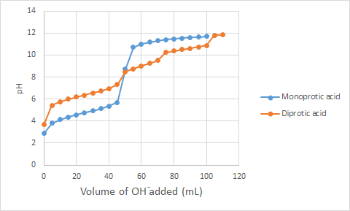

1. The blue line on the graph above represents the titration of 50.0 mL of the mystery weak acid with the standard sodium hydroxide solution. According to the data from the graph, what would you estimate the concentration of the unknown acid to be? Justify your response with an explanation or calculation.

Since the volume of NaOH added to neutralize the acid is the same as the volume of the mystery, monoprotic acid--50 mL--the acid must have the same concentration as the base – 0.1M.

1. The orange line on the graph above represents a different weak acid. Based on the data in the graph, describe the differences in the chemical composition and Ka values of the two different acids (represented in blue and orange on the graph).

The orange line represents a diprotic acid (two dissociating hydrogen ions) because there are two points in the graph where the pH changes rapidly at the endpoint of the dissociation of each hydrogen ion; it would have the chemical formula H2A. To determine the pKas of the acids, look at the pH at the half equivalent point (volume at equivalent point divided by 2 – pH at that point). The pKa for the monoprotic acid is ≈5 and the diprotic acid is >6 and ≈11 (for the second hydrogen, look at the volume of base between the first and second equivalent points, divide that volume by two and add that to the volume for the first equivalent point – so 45 mL to 75 mL = 30 mL/2 = 15 mL; 45 mL + 15 mL = 60 mL, pH ≈11).

1. Another student suggests using an indicator that has a pH range from 9.3-10.5. How would the data found by using this indicator differ from the data gathered when using a titration curve?

The indicator that you choose should have a pKa value near the pH of the titration’s endpoint. The first titration has a pKa of ≈5, which is not in the indicator’s range. The diprotic acid has pKa values of >6 and ≈11. Its first endpoint is also out of the indicator’s range and the second endpoint is close to being out of range. A different indicator should be selected.

**Scenario #5: Components of a Mixture**

1. Description: Paper chromatography is a method of separation that involves a moving phase (the mobile phase, or solvent) and a stationary phase (the paper, in this case). A student sets up a chromatogram to determine the identity of an unknown ink by spotting two known inks next to the unknown ink and running the paper chromatography with water as the mobile phase. The resulting, dried chromatogram is shown below.

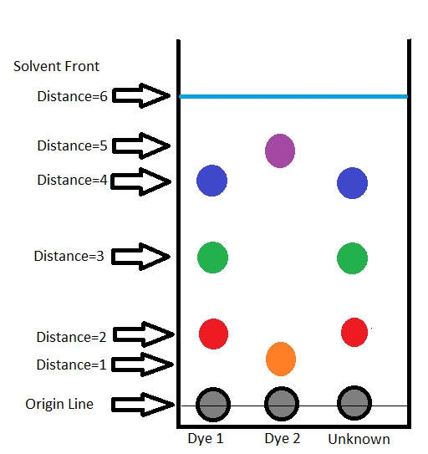

1. In the chromatogram above, the Rf values for the orange spot is ⅙, while the purple is ⅚. What does that tell you about the difference between the molecules of the orange and purple spots, in terms of affinity for the stationary and mobile phases?

The molecules that make up the orange spot, with a lower Rf value, has a higher affinity for the stationary phase than the molecules that make up the purple spot; the molecules that make up the purple spot have a stronger affinity for the mobile phase than do the molecules that make up the orange spot.

1. The student makes the conclusion that the unknown dye is the same as dye 1, because the spots look the same. Describe how the student could be more precise with his/her conclusion, based on the data.

The student could describe the identity of the unknown in terms of its molecular make up compared to Dye #1--the dyes have a matching set of Rf values for each spot.

**Scenario #6: Ionic, Covalent, and Metallic Bonding**

1. Description: A student conducts an experiment to determine some of the properties of ionic, covalent, and metallic substances. The student looks at the crystal structure, melting points, solubility, and conductivity of the substances. The results are shown in the table below.

|  |  |  |  |
| --- | --- | --- | --- |
|  | **Ionic Compound** | **Covalent Compound** | **Metallic element** |
| **Crystal Structure** | Crystal structure is an ordered crystal | Crystal structure is an amorphous solid | No crystal structure is evident; the surface is shiny |
| **Melting Point** | 801 0C | 186 0C | 1538 0C |
| **Solubility** | Very soluble in water | Slightly soluble in water | Insoluble in water |
| **Conductivity** | Solid does not conduct electricity, but dissolved solution does conduct. | Neither the solid nor the solution conducts electricity. | Solid conducts electricity. |

1. Describe the intramolecular forces (bonding) in each of the following:
   1. ionic compound Ionic compounds are held together by electrostatic forces of oppositely charged particles.
   2. covalent compound Covalent compounds are held together by strong covalent bonds, which involves sharing of electrons between atoms in the molecule.
   3. metal Metals are held together by the electrostatic attraction of delocalized valence electrons, shared among atoms of a metal sample, and the positively charged cations.
2. Describe how intramolecular forces relate to the structure and melting points of each of the substances.

Ionic compounds have a definite composition and rigid crystal structure, due to the set charge of the cation and anion that make up the ionic compound. Ionic compounds have a high melting point, since a lot of energy is required to overcome the electrostatic attraction within the crystal lattice.

Covalent compounds vary in structure, depending on the strength of the intermolecular forces, but they tend to have less rigid structure than ionic compounds. Due to the weaker attraction among molecules in a covalent compound, they have lower melting points.

Metals have a crystal structure, but varying melting points, depending on the size of the atoms. In general, larger atoms have lower melting points due to weakened attractions, but many anomalies exist especially atoms will electrons in the d-orbitals.

1. What two things must be true for a substance to conduct electricity? Describe how each substance that is able to conduct electricity fulfills those requirements from the particle-level viewpoint.

To conduct electricity, charged particles need to be able to move around. Solid ionic compounds consist of charged particles, but they are fixed in position and thus do not conduct electricity. But when ioninc compounds are dissolved, the charged particles disperse in the water, allowing a flow of electrons/conductivity.

Covalent compounds cannot conduct because they have no charged particles; they are neutral.

Metals are composed of cations and delocalized electrons that are free to move, so metals readily conduct electricity.

**Scenario #7: Formula for a hydrated crystal**

1. Description: A student conducts an experiment to determine the amount of water in a hydrated crystal of magnesium sulfate (Epsom salts). The results of the experiment are shown in the table below:

|  |  |
| --- | --- |
| Mass of Crucible | 10.3 g |
| Mass of Crucible + hydrated magnesium sulfate | 15.3 g |
| Mass of Crucible + product after 1st heating | 12.8 g |
| Mass of Crucible + product after 2nd heating | 12.7 g |
| Mass of Crucible + product after 3rd heating | 12.7 g |

1. According to the data, calculate the number of water molecules in the hydrated magnesium sulfate.

Mass of MgSO4**.**xH2O = 15.3 g – 10.3 g = 5.0 g MgSO4**.**xH2O

Mass of MgSO4 = 12.7 g – 10.3 g = 2.4 g MgSO4

Mass of water = 5.0 g – 2.4 g = 2.6 g H2O

|  |  |  |  |  |  |  |  |
| --- | --- | --- | --- | --- | --- | --- | --- |
| 15.3 g-12.7 g=2.6 g water | | | | 12.7 g-10.3 g = 2.4 g MgSO4 | | | |
| 2.6 g | 1 mol | = | 0.14 mol H2O | 2.4 g | 1 mol | = | 0.020 mol MgSO4 |
|  | 18.02 g |  | 120.38 g |
|  |  |  |  |  |  |  |  |
|  |  |  |  |  |  |  |  |
| 0.14 mol H2O | | = | 7 H2O= MgSO4 .7 H2O(s) | | | | |
| 0.020 mol MgSO4 | | 1 MgSO4 |  |  |  |  |

1. Write a chemical equation for the reaction performed in the experiment.

MgSO4 .7 H2O(s) 🡺 MgSO4(s) + 7 H2O(g)

1. Why was the product heated three times? What is shown in the mass of the product?

It is heated three times to make sure that all of the water is gone. When the mass is constant, it shows that all of the water has been drive off.

1. Calculate the percent error for the data in this experiment, knowing that the number of water molecules in Epsom salts is 7.

|  |  |
| --- | --- |
| |7 – 7| | X 100 = 0% error |
| 7 |

**Scenario #8: Redox Titration**

1. Description: A student is given the task of determining the mass of iron in a solid sample of ferrous ammonium sulfate. The molar mass of the ferrous ammonium sulfate (Fe(NH4)2(SO4)2●6H2O) is 392.2 g/mol. A 1.235-gram sample of the solid was titrated with a 0.0205-M solution of potassium permanganate and it took 26.01 mL of the solution to reach the endpoint. The net ionic equation for the reaction is shown below.

MnO4-(aq) + 5 Fe2+(aq) + 8 H+(aq) ⇒ 5 Fe3+(aq) + Mn2+(aq) + 4 H2O(l)

(pink) (colorless)

1. In the titration described above, what color is observed at the endpoint of the titration?

As you titrate with the potassium permanganate, the solution turns pink and then the pink disappears and it reacts. At the endpoint of the titration, the solution will be a dull pink from the slight excess of permanganate ions added.

1. Write the half-reactions for the reduction and the oxidation.
   1. Reduction: Mn+7(aq) + 5e- 🡺 Mn2+(aq)
   2. Oxidation: 5Fe2+(aq) 🡺 5Fe3+(aq) + 5e-
2. Using the data provided above, calculate the mass percent of iron in the ferrous ammonium sulfate sample.

|  |  |  |  |  |  |  |
| --- | --- | --- | --- | --- | --- | --- |
| 26.01 mL KMnO4 | | 1 L | | 0.0205 mol KMnO4 | | = 5.33x10-4 mol KMnO4 |
|  | | 1000 mL | | 1 L | |
|  | |  | |  | |  |
| 5.33x10-4 mol KMnO4 | | 5 mol Fe+2 | | 55.85 g Fe+2 | | = 0.149 g Fe+2 |
|  | | 1 mol KMnO4 | | 1 mol Fe+2 | |
|  | |  | |  | |  |
| 0.149 g Fe2+ | x 100 | = 12.1% Fe2+ in sample | |  | |
| 1.235 g sample |  | |

1. Calculate the percent yield of the reaction.

Mass of Fe2+ = 55.85 Mass of Fe(NH4)2(SO4)2●6H2O = 392.2 g/mol

|  |  |  |  |  |
| --- | --- | --- | --- | --- |
| 55.85 | = 14.2% Fe2+ |  | 12.1% | x 100 = 85.2% Yield |
| 392.2 |  | 14.2% |

**Scenario #9: Separation of Mixtures**

1. Description: A student is given a mixture of ammonium chloride salt, sodium chloride salt, and silicon dioxide (sand). The student is asked to separate the mixture and purify the sand. The procedures used are shown below.

|  |
| --- |
| 1. The student takes the mixture to the fume hood and heats the mixture, where the student notices a smell of window cleaner as the mixture is heated. |
| 1. Once the remaining mixture is cooled, the student adds water to the mixture, stirs, and decants the solution. |
| 1. The student rinses the sand with water two more times. |
| 1. Once the sand is rinsed, the student heats it and observes steam that leaves a white residue on the side of the container. |

1. In step 1 of the process, the mixture is heated. Which component was removed by this process? Justify your response.

NH4Cl(s) 🡺 NH3(g) + HCl(g)

The student smells the ammonia gas that is being produced.

1. In step 2 of the process, water is added to the mixture. Would that step have worked to remove more than one component of the mixture? Justify your response in terms of the solute-solvent interactions.

In step 2, water dissolves the sodium chloride, but it would also dissolve ammonium chloride since both salts are soluble in water. Since the student wasn’t asked to purify the sodium chloride, it’s suitable for excess water to be added in this step to ensure both salts are completely dissolved and separated from the sand.

1. In the last step, a white residue is noted on the side of the container. Hypothesize the identity of the white residue and describe an experiment or test you would perform to confirm your hypothesis.

The residue is most likely remaining salt, either sodium chloride or ammonium chloride. The salt could be scraped and flame tested to see if the yellow flame of sodium were present.

1. Describe why the sand was rinsed three times, then dried. Would it make a difference if tap water or deionized water were used?

The sand is rinsed three times to make sure that all of the salt is extracted from the sand. If tap water were used, then additional salts could contaminate the sand, since there are typically minerals dissolved in tap water, so deionized water is the better choice to rinse with.

**Scenario #10: Factors that affect the rate of a reaction**

1. Description: A student designs an experiment to determine the factors that affect the rate of a reaction. The reaction is conducted at 25 0C, in a 1-L flask. The student collects the following data from the reaction of calcium carbonate and hydrochloric acid:

|  |  |  |  |  |  |
| --- | --- | --- | --- | --- | --- |
| **Trial** | **Form of CaCO3** | **Mass of CaCO3** | **[HCl] M** | **Volume of HCl** | **Initial Pressure of CO2 gas** |
| **1** | chips | 1.0 g | 1.0 M | 10.0 mL | 0.15atm. |
| **2** | chips | 2.0 g | 1.0 M | 20.0 mL | 0.15atm |
| **3** | powder | 2.0 g | 1.0 M | 20.0 mL | 0.22atm |
| **4** | powder | 3.0 g | 2.0 M | 30.0 mL | 0.30atm |

1. Write the net ionic equation for the reaction between the calcium carbonate and hydrochloric acid.

2H+(aq) + CO32-(aq) 🡺 H2O(l) + CO2(g)

1. According to the data above, what conclusions can be made about the effect of particle size on the rate of a reaction?

Between experiment 2 and 3, the only factor that changed was the form of the calcium carbonate. This factor resulted in the initial pressure of the carbon dioxide gas to increase when the calcium carbonate was in powder form. The evidence supports that as particle size decreases, the reaction rate increases.

1. Between experiment 1 and experiment 2, the mass of the calcium carbonate was changed, but the initial rate of the reaction did not. Describe why, in terms of changing concentrations of reactants and products.

Since the concentration of a solid does not change, adding more does not affect the rate of the reaction.

1. Between experiment 3 and 4 the pressure of the CO2 gas changed. Can that change be contributed to a specific change in one parameter of the reactants? Justify your response.

No. Since both the concentration and volume of the HCl was changed between the trials you cannot draw any conclusions**.**

**Scenario #11: Determining Rate Law**

1. 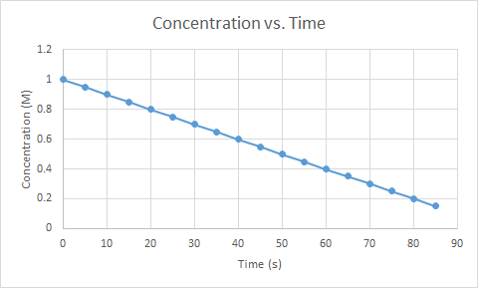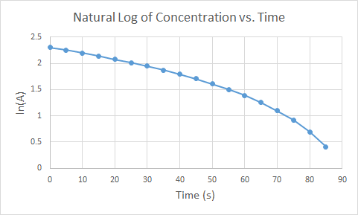Description: A student conducts an experiment to determine the rate law for a reaction with respect to a certain reactant. Below are graphs of the resulting data plotted in three ways. One is with concentration of reactant vs. time, the second with the natural log of the reactant concentration vs. time and the third with the inverse of the reactant concentration vs. time. The generic form for the reaction is:

**A + B ⇔ C**

|  |
| --- |
|  |

1. According to the data above, what is the order of the reaction with respect to A? Justify your response.

Zero order, since the graph of concentration vs time is linear. Rate = k[A]0

1. Can the reaction order of B be inferred from the data above? Why or why not?

No. The concentration of B is not graphed so we cannot determine the reaction order of B.

1. Calculate the half-life of the reaction, with respect to reactant A, based on the data in the graphs.

[A] = [A]0 – kt

t1/2 = [A]0/2k (where k = -slope) slope = .2-1/80-0 = -.01

1.0 M/2(.01) = 50 s_

[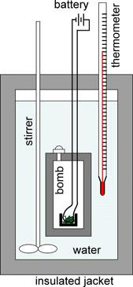](https://commons.wikimedia.org/wiki/File:ChemicalPrinciplesFig2-4.jpg)**Scenario #12: Enthalpy and Calorimetry**

1. Description: In many organisms, glucose is oxidized to carbon dioxide and water, as represented by the following equation:

**C6H12O6(s) + 6 O2(g) → 6 CO2(g) + 6 H2O(l)**

A student conducts an experiment in a bomb calorimeter, where a 2.50 g sample of glucose and an excess of O2(g) were burned. After the reaction proceeded to completion, the total heat released by the reaction was calculated to be 37.5 kJ. The molar mass of glucose is 180.18 g/mol.

1. Calculate the value of ΔH°, in kJ/mol, for the combustion of glucose.

Image: Wikimedia commons CC-BY-3.0

Attribution: [Dickerson, Gray and Haight](https://commons.wikimedia.org/wiki/File:ChemicalPrinciplesFig2-4.jpg)

|  |  |  |  |  |
| --- | --- | --- | --- | --- |
| 37.5 kJ | 180.18 g glucose | = 2703 | kJ | released |
| 2.50 g glucose | 1 mol glucose | mol |

ΔH° = -2703 kJ/mol

1. The literature value for the combustion of glucose is -2800 kJ/mol. Calculate the percent error in the experiment.

|  |  |
| --- | --- |
| (-2703) – (-2800) | x 100 = 3.5% Error |
| -2800 |

1. Was the measured amount of heat generated by the reaction too high, too low, or correct? Discuss a possible source of this error in terms of heat flow.

The measured amount of heat generated by the reaction was too low. Heat was probably absorbed by the calorimeter, stirrer, or thermometer and that would result in a lower measured amount of heat released from the reaction.

**Scenario #13: Le Châtelier's Principle**

1. Description: A system at equilibrium can be thought of like kids balanced on a seesaw on the playground. The reactants and products have reached a steady state concentration such that balance between reactants and products has been reached. Refer to the illustration below.

|  |
| --- |
|  |

When a system at equilibrium is stressed, or placed out of balance, Le Chatelier’s Principle states that equilibrium will shift to reduce the effect of that stress, or to restore balance. Refer to the series of illustrations below.

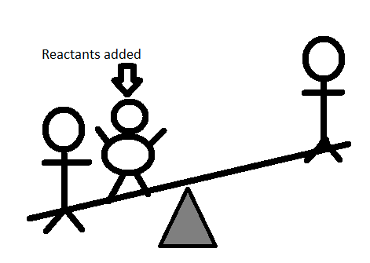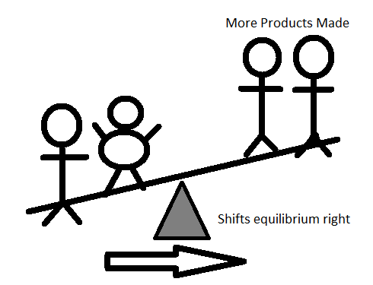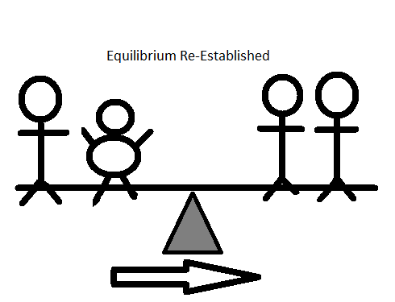

In the first image in the series above, reactants are added to the system, which unbalances the seesaw. In the second image, equilibrium shifts to produce more products, which in the third image, restores equilibrium with a new amount of reactants and products, but the same equilibrium. Use this illustration to answer the questions below.

1. If equilibrium shifts to the right when additional reactants are added to a system, how does equilibrium shift when additional products are added to a system at equilibrium?

The system will shift left, to produce more reactants by consuming products.

1. If a reaction is exothermic, is heat a reactant or product in the reaction?

Heat is released in an exothermic reaction, so heat is a product.

1. Since a catalyst affects the speed of a reaction only, would adding a catalyst change equilibrium? Justify your response.

No. A catalyst affects the rate of both the forward and reverse reactions, so equilibrium would be achieved faster, but it would be the same value.

**Scenario #14: Strong vs. Weak Acid Titrations**

1. Description: A student conducts a series of titrations with a strong base, NaOH, and two different acids. The student is not told what the identity of the acids are, but one is a strong acid and the other is a weak acid. The student titrates 50-mL of 0.10 M of each acid with 0.10 M sodium hydroxide solution and the pH of the solution is monitored. The resulting graph is shown below.

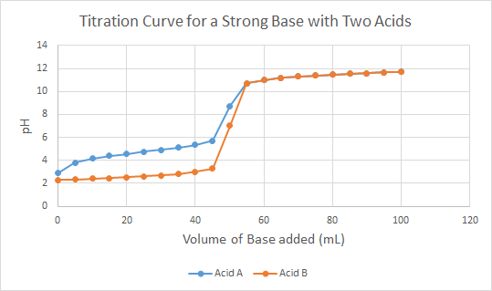

1. Which acid, A or B, is the strong acid? Justify your response.

B is the strong acid. The pH rises more slowly in the beginning and the rise to the endpoint of the titration is sharper/steeper.

1. Based on the graph, estimate the pKa for the weak acid. Describe how you know that is the pKa for the weak acid.

pKa = the pH at the equivalence point of the titration, or the halfway point to the endpoint. pH of acid A after adding 25 mL of base is about 5, so the pKa of the weak acid A is about 5.

1. What is the endpoint of the titration of a strong acid and strong base? Write a net ionic equation for the reaction that occurs between the strong acid and strong base in this titration. Justify why it does not matter the identity of the acid for the net ionic equation.

H+(aq) + OH-(aq) 🡺 H2O(l)

Since the conjugates of a strong acid and base are neutral salts, they will always be spectator ions. All strong acids completely dissociate, so H+ is always the sole ion that participates in the neutralization reaction. Also, there is no equilibrium, so the anion is a spectator ion.

**Scenario #15: Recipe for the Best Buffer**

1. Description: The first model below shows the general net ionic equation form of a buffer. A buffer is composed of a weak acid and its conjugate base. The H+ part represents the acid and the A- part represents the base.

A buffer is defined as a solution that resists change in pH. Below are illustrations of solutions, in net ionic form. Using the illustrations as a model, answer the questions that follow.

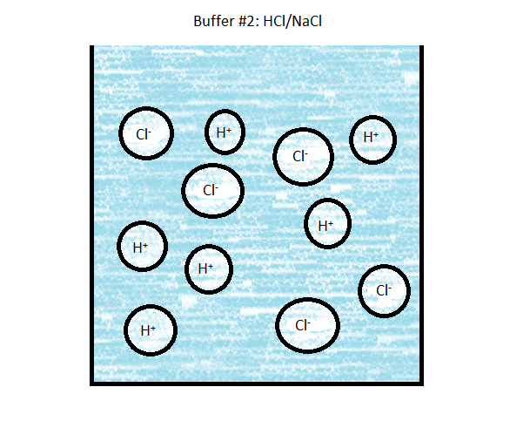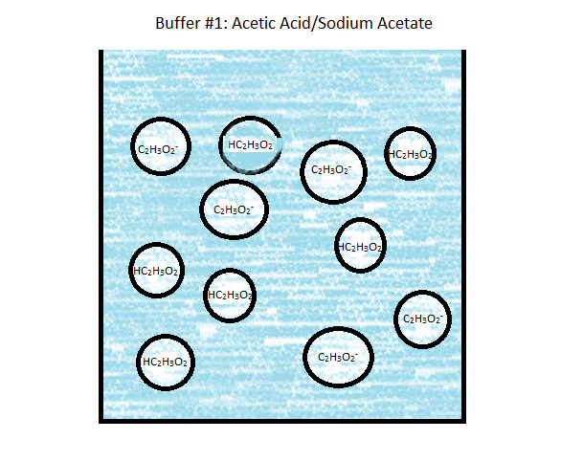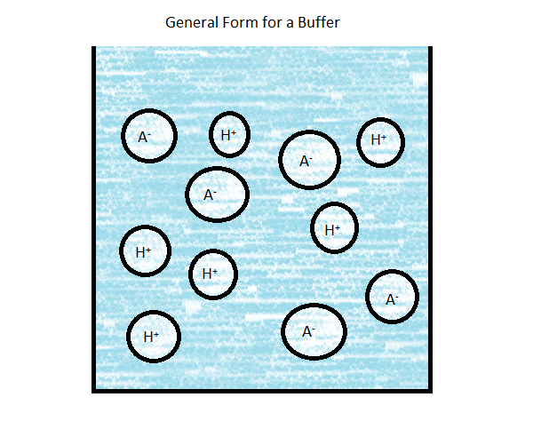

1. Write the net ionic equation for the reaction of a strong acid with both buffers:

Buffer 1: H+(aq) + C2H3O2-(aq) 🡺 HC2H3O2(aq)

Buffer 2: H+(aq) + Cl-(aq) 🡺 HCl(aq)

1. If the pKa for acetic acid is 4.75 and you have a 0.100-M solution of acetic acid, how many grams of sodium acetate would you need to dissolve in the acid to make a buffer with a pH of 4.85? The molar mass of sodium acetate is 82.04 g/mol.

|  |  |  |  |  |
| --- | --- | --- | --- | --- |
| pH = pKa + log | [Base] |  | 4.85 = 4.75 + log | [Base] |
|  | [Acid] |  |  | [0.100] |

.10 = log([Base]/.1)

1.26 =[Base]/.1

.126 M = [Base]

|  |  |  |  |
| --- | --- | --- | --- |
| [Base] = | 0.126 mol | 82.04 g | = 10.3 g NaC2H3O2 |
|  | L | mol |  |

1. If the buffer in part c were titrated with 0.050 mol of strong base, like NaOH, what would the pH of the resulting solution be?

|  |  |  |  |  |
| --- | --- | --- | --- | --- |
| pH = 4.75 + log | [Base] | = 4.75 + log | [0.05] | = 4.75 |
|  | [Acid] |  | [0.05] |  |

**Scenario #16: Buffer Capacity**

|  |  |
| --- | --- |
| **Weak Acid** | **pKa** |
| Acetic Acid  HC2H3O2 | 4.75 |
| Hypochlorous acid  HClO | 7.53 |
| Acetylsalicylic acid  (Aspirin, MM=180g/mol) | 3.50 |

1. Description: You are given the task of preparing the best buffer for a series of situations. The available ingredients include the three weak acids (assume 1.0M solutions of each) listed in the table on the right, with the corresponding pKa values. You also have access to the sodium salts of the weak acids, and you may assume that they are stable in solid and aqueous forms.
2. Determine the recipe for a 1.0-L buffer solution with pH 5.0

You want to choose an acid with a pKa closest to the pH of the desired solution, so acetic acid/sodium acetate will be the chemicals you use for the buffered solution. To determine the concentrations of the acid and conjugate base, use the Henderson-Hasselbalch equation:

|  |  |
| --- | --- |
| pH = pKa + log | [Conj. base] |
|  | [Acid] |

|  |  |
| --- | --- |
| 5.0 = 4.75 + log | [Conj. base] |
|  | [Acid] |

|  |  |  |
| --- | --- | --- |
| log | [Conj. base] | = 0.25 |
|  | [Acid] |  |

Raise both sides to the power of 10:

|  |  |  |
| --- | --- | --- |
| The ratio of | [Conj. base] | = 10.25 =1.78 |
|  | [Acid] |  |

This means you need 1.78:1 moles of sodium acetate to acetate. If you use 1 L of a 1.0-M acetic acid solution, you can dissolve 1.78 mol sodium acetate (MM = 82.03 g/mol) in the solution to create the buffer.

|  |  |  |  |
| --- | --- | --- | --- |
| NaC2H3O2 = | 1.78 mol | 82.03 g | = 146 g NaC2H3O2 |
|  |  | mol |  |

1. With the ingredients listed in the table, would it be practical to make a 1.0 L sample of a buffer with a pH of 2? Justify your response with calculations.

|  |  |  |  |  |  |  |
| --- | --- | --- | --- | --- | --- | --- |
| Acetic acid | 2 = 4.75 + log | [Conj. base] |  | Ratio | [Conj. base] | = 10-2.75 =0.0018 |
|  |  | [Acid] |  |  | [Acid] |  |

This is not practical – a negligible amount of conjugate base is needed. This is not surprising, since the pKa is vastly different from the desired pH of the buffer. So let’s look at aspirin, which has a pKa closer to the desired buffer solution:

|  |  |  |  |  |  |  |
| --- | --- | --- | --- | --- | --- | --- |
| Aspirin | 2 = 3.5 + log | [Conj. base] |  | Ratio | [Conj. base] | = 10-1.5 =0.032 |
|  |  | [Acid] |  |  | [Acid] |  |

Using a 1 L solution of 1-M acetylsalicylic acid, add 0.032 mol of sodium salicylic acid (MM = 160.104 g/mol) to create the desired buffer.

|  |  |  |  |
| --- | --- | --- | --- |
| Sodium salicylic acid = | .032 mol | 160.104 g | = 5.1 g C7H5NaO3 |
|  |  | mol |  |

1. You are asked to prepare 100.0 mL of hypochlorous acid buffer solution using 0.500-M HClO solution and solid sodium hypochlorite. Describe how you would prepare a buffer with a pH of 7.80. The molar mass of sodium hypochlorite is 74.44 g/mol. Support your answer with related calculations.

|  |  |  |  |  |
| --- | --- | --- | --- | --- |
| pH = pKa + log | [Base] |  | 7.80 = 7.53 + log | [Base] |
|  | [Acid] |  |  | [0.500] |

|  |  |  |  |  |  |  |
| --- | --- | --- | --- | --- | --- | --- |
| 0.27 = log | [Base] | 100.27 = | [Base] | = 1.86 | 0.931 M= | [Base] |
|  | [0.500] |  | [0.500] |  |  |  |

|  |  |  |  |  |
| --- | --- | --- | --- | --- |
| [Base] = | 0.931 mol | 74.44 g | 0.100 L | = 6.93 g NaClO |
|  | L | mol |  |  |

Add about 50 mL of 0.500-M HClO to a 100-mL volumetric flask. Use a funnel to add 6.93 grams of NaClO and swirl to dissolve. Add additional 0.500 M HClO so the botto of the meniscus reaches the fill line on the volumetric flask, put a stopper in the flask, and invert several times until the solution is completely mixed. Check on the bench to make sure the bottom of the meniscus is still level with the fill line. If it’s lower, add HClO solution drop-by-drop until it reaches the line.

1. You are given 100 mL of a buffer solution that was prepared using equal volumes of 0.500M HC2H3O2 and NaC2H3O solutions.
2. Calculate the pH of the buffer after the addition of 0.030 mol of strong base.

|  |  |  |
| --- | --- | --- |
| 0.030 mol OH-1 | = 0.300 M OH-1 |  |
| 0.100 L |

Initial concentration of HC2H3O2 and C2H3O-1 is 0.500M

|  |  |  |  |  |
| --- | --- | --- | --- | --- |
| pH = 4.75 + log | [0.500 + 0.300] | = 4.75 + log | [.800] | = 5.35 |
|  | [0.500 - 0.300] |  | [0.200] |  |

1. What will happen to the pH after you exceed 0.050 mol of strong base?

Once you add over 0.050 moles of strong base, you will exceed the buffer capacity of the solution and pH will rise rapidly. The concentration of the excess base solution will be used to calculate pH.

1. Describe how you could increase the buffer capacity of this buffer. You may support your answer with calculations, but it is not required.

Students should say something about increasing the concentrations of the acid and conjugate base, which could be demonstrated with a H-H equation.