**Experimental Evidence Review**

**AP Chemistry**

For each of the following scenarios, review the objectives of the laboratory team, the data collected, and use your knowledge of chemistry to analyze the results and make conclusions.

\**Note: These scenarios are not to be performed in the lab. Safety precautions have not been included.*

|  |
| --- |
| Digital balance (0.1 g) |
| Beakers, various sizes |
| Goggles |
| Volumetric flasks, various sizes (0.5 mL) |
| Gloves |
| Triple Beam Balance (0.01 g) |
| Graduated cylinders (1 mL) |
| Metal scoop |
| Bathroom Scale (1 g) |

**Scenario #1: Using Spectroscopy to Quantify Color**

1. Description: You are given a bottle of chromium(III) nitrate and asked to prepare 100 mL of a 0.20-M solution of the compound. Given the lab equipment listed in the table with the sensitivity of the instrument in parenthesis, describe the process for preparing the sample.
2. When the solution is analyzed in a spectrophotometer, the data below was obtained.

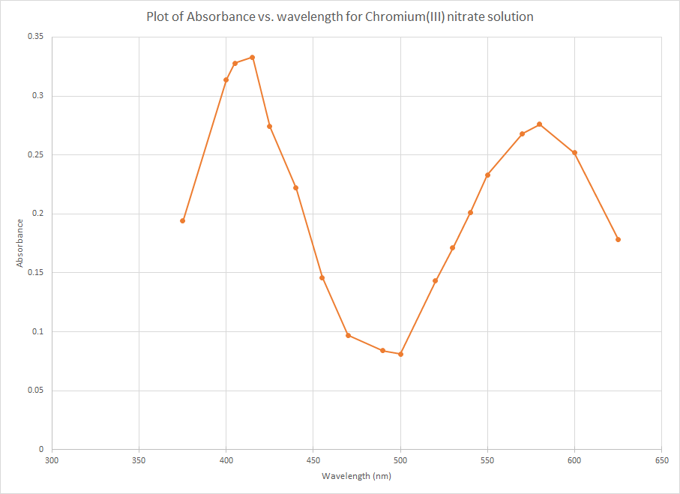

1. What do the peaks at approximately 400 nm and 580 nm represent? Justify your response
2. Would the solution of Cr(NO3)3 be colored? Justify your response.

**Scenario #2: Analysis of an Alloy with Spectroscopy**

1. Description: A chemist is tasked with determining the copper content of a sample of brass. If the content of the copper is above 95%, the brass is considered “Gilding Brass” and it can be used for coins. If it is less than 95% copper, it cannot be used for coins. The other metal alloyed with the copper is zinc. Describe a reaction, or process of reactions, that you can use to separate the alloy.

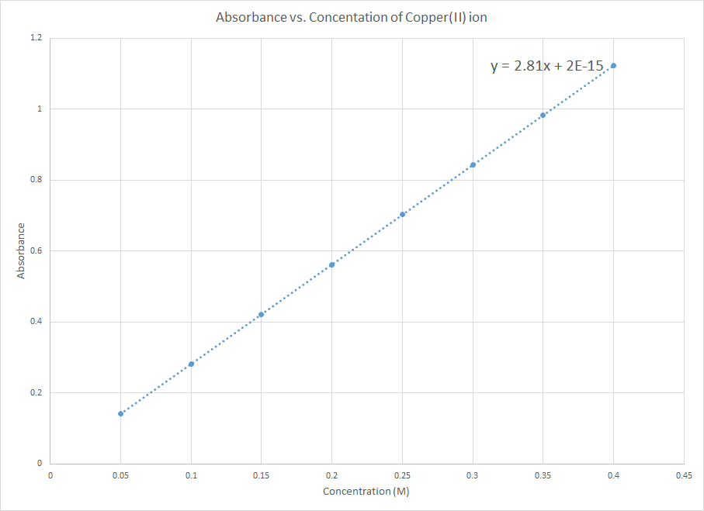

1. Above is a graph of the absorbance of the blue copper(II) ion in solution, made with various concentrations of copper(II) ion. If a 0.5-gram sample of the alloy was dissolved in 100 mL of solution and the absorbance read 0.204, what is the purity of the copper in the brass? Justify your response with calculations.

**Scenario #3: Stoichiometry and Predictive Precipitation**

1. Description: Below is a simulated graph of the titration of a sample of water that is suspected to be “hard water”. The water sample was titrated with 0.10-M sodium carbonate.

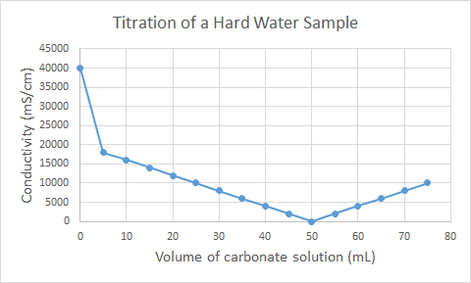

1. What ion makes the water hard?
2. Write a net ionic equation for the reaction of sodium carbonate with the hard water sample.
3. Describe why the titration curve has the shape that it does. Why does the theoretical conductivity go to zero and then rise again?
4. The titration curve does not represent reality. Describe one difference between an actual conductivity titration and the ideal situation shown above.

|  |
| --- |
| beakers, various sizes |
| graduated cylinders |
| PPE |
| Erlenmeyer flasks |
| volumetric flasks |
| glass stir rods |
| 100-mL burets |
| phenolphthalein |
| bromothymol blue |
| phenol red |
| DI wash bottle |
| pH meter |

**Scenario #4: Determination of acid concentration by titration**

1. Description: A student conducts a titration reaction to determine the concentration of an unknown, weak monoprotic acid. The student wants to use a standard sodium hydroxide solution. The available equipment is listed in the table.
2. Describe the process that the student would take to make 100 mL of the standard (0.10 M) sodium hydroxide solution. Include calculations.

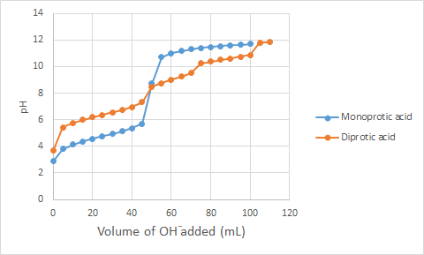

1. The blue line on the graph above represents the titration of 50.0 mL of the mystery weak acid with the standard sodium hydroxide solution. According to the data from the graph, what would you estimate the concentration of the unknown acid to be? Justify your response with an explanation or calculation.
2. The orange line on the graph above represents a different weak acid. Based on the data in the graph, describe the differences in the chemical composition and Ka values of the two different acids (represented in blue and orange on the graph).
3. Another student suggests using an indicator that has a pH range from 9.3-10.5. How would the data found by using this indicator differ from the data gathered when using a titration curve?

**Scenario #5: Components of a Mixture**

1. Description: Paper chromatography is a method of separation that involves a moving phase (the mobile phase, or solvent) and a stationary phase (the paper, in this case). A student sets up a chromatogram to determine the identity of an unknown ink by spotting two known inks next to the unknown ink and running the paper chromatography with water as the mobile phase. The resulting, dried chromatogram is shown below.

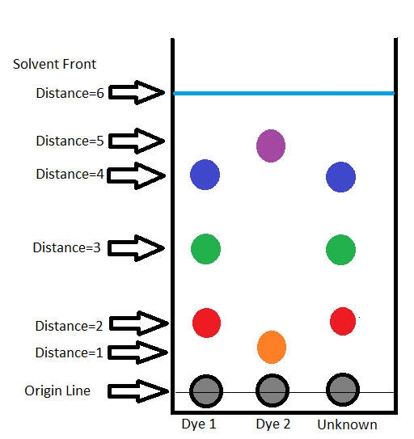

1. In the chromatogram above, the Rf values for the orange spot is ⅙, while the purple is ⅚. What does that tell you about the difference between the molecules of the orange and purple spots, in terms of affinity for the stationary and mobile phases?
2. The student makes the conclusion that the unknown dye is the same as dye 1, because the spots look the same. Describe how the student could be more precise with his/her conclusion, based on the data.

**Scenario #6: Ionic, Covalent, and Metallic Bonding**

1. Description: A student conducts an experiment to determine some of the properties of ionic, covalent, and metallic substances. The student looks at the crystal structure, melting points, solubility, and conductivity of the substances. The results are shown in the table below.

|  |  |  |  |
| --- | --- | --- | --- |
|  | **Ionic Compound** | **Covalent Compound** | **Metallic element** |
| **Crystal Structure** | Crystal structure is an ordered crystal | Crystal structure is an amorphous solid | No crystal structure is evident; the surface is shiny |
| **Melting Point** | 801 0C | 186 0C | 1538 0C |
| **Solubility** | Very soluble in water | Slightly soluble in water | Insoluble in water |
| **Conductivity** | Solid does not conduct electricity, but dissolved solution does conduct. | Neither the solid nor the solution conducts electricity. | Solid conducts electricity. |

1. Describe the intramolecular forces (bonding) in each of the following:
   1. ionic compound
   2. covalent compound
   3. metal
2. Describe how intramolecular forces relate to the structure and melting points of each of the substances.
3. What two things must be true for a substance to conduct electricity? Describe how each substance that is able to conduct electricity fulfills those requirements from the particle-level viewpoint.

**Scenario #7: Formula for a hydrated crystal**

1. Description: A student conducts an experiment to determine the amount of water in a hydrated crystal of magnesium sulfate (Epsom salts). The results of the experiment are shown in the table below:

|  |  |
| --- | --- |
| Mass of Crucible | 10.3 g |
| Mass of Crucible + hydrated magnesium sulfate | 15.3 g |
| Mass of Crucible + product after 1st heating | 12.8 g |
| Mass of Crucible + product after 2nd heating | 12.7 g |
| Mass of Crucible + product after 3rd heating | 12.7 g |

1. According to the data, calculate the number of water molecules in the hydrated magnesium sulfate.
2. Write a chemical equation for the reaction performed in the experiment.
3. Why was the product heated three times? What is shown in the mass of the product?
4. Calculate the percent error for the data in this experiment, knowing that the number of water molecules in Epsom salts is 7.

**Scenario #8: Redox Titration**

1. Description: A student is given the task of determining the mass of iron in a solid sample of ferrous ammonium sulfate. The molar mass of the ferrous ammonium sulfate (Fe(NH4)2(SO4)2●6H2O) is 392.2 g/mol. A 1.235-gram sample of the solid was titrated with a 0.0205-M solution of potassium permanganate and it took 26.01 mL of the solution to reach the endpoint. The net ionic equation for the reaction is shown below.

MnO4-(aq) + 5 Fe2+(aq) + 8 H+(aq) ⇒ 5 Fe3+(aq) + Mn2+(aq) + 4 H2O(l)

(pink) (colorless)

1. In the titration described above, what color is observed at the endpoint of the titration?
2. Write the half-reactions for the reduction and the oxidation.
   1. Reduction:
   2. Oxidation:
3. Using the data provided above, calculate the mass percent of iron in the ferrous ammonium sulfate sample.
4. Calculate the percent yield of the reaction.

**Scenario #9: Separation of Mixtures**

1. Description: A student is given a mixture of ammonium chloride salt, sodium chloride salt, and silicon dioxide (sand). The student is asked to separate the mixture and purify the sand. The procedures used are shown below.

|  |
| --- |
| 1. The student takes the mixture to the fume hood and heats the mixture, where the student notices a smell of window cleaner as the mixture is heated. |
| 1. Once the remaining mixture is cooled, the student adds water to the mixture, stirs, and decants the solution. |
| 1. The student rinses the sand with water two more times. |
| 1. Once the sand is rinsed, the student heats it and observes steam that leaves a white residue on the side of the container. |

1. In step 1 of the process, the mixture is heated. Which component was removed by this process? Justify your response.
2. In step 2 of the process, water is added to the mixture. Would that step have worked to remove more than one component of the mixture? Justify your response in terms of the solute-solvent interactions.
3. In the last step, a white residue is noted on the side of the container. Hypothesize the identity of the white residue and describe an experiment or test you would perform to confirm your hypothesis.
4. Describe why the sand was rinsed three times, then dried. Would it make a difference if tap water or deionized water were used?

**Scenario #10: Factors that affect the rate of a reaction**

1. Description: A student designs an experiment to determine the factors that affect the rate of a reaction. The reaction is conducted at 25 0C, in a 1-L flask. The student collects the following data from the reaction of calcium carbonate and hydrochloric acid:

|  |  |  |  |  |  |
| --- | --- | --- | --- | --- | --- |
| **Trial** | **Form of CaCO3** | **Mass of CaCO3** | **[HCl] M** | **Volume of HCl** | **Initial Pressure of CO2 gas** |
| **1** | chips | 1.0 g | 1.0 M | 10.0 mL | 0.15atm. |
| **2** | chips | 2.0 g | 1.0 M | 20.0 mL | 0.15atm |
| **3** | powder | 2.0 g | 1.0 M | 20.0 mL | 0.22atm |
| **4** | powder | 3.0 g | 2.0 M | 30.0 mL | 0.30atm |

1. Write the net ionic equation for the reaction between the calcium carbonate and hydrochloric acid.
2. According to the data above, what conclusions can be made about the effect of particle size on the rate of a reaction?
3. Between experiment 1 and experiment 2, the mass of the calcium carbonate was changed, but the initial rate of the reaction did not. Describe why, in terms of changing concentrations of reactants and products.
4. Between experiment 3 and 4 the pressure of the CO2 gas changed. Can that change be contributed to a specific change in one parameter of the reactants? Justify your response.

**Scenario #11: Determining Rate Law**

1. 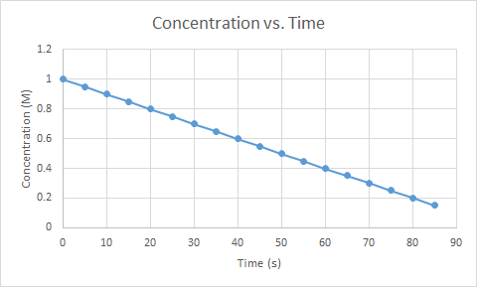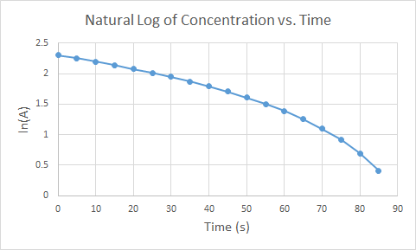Description: A student conducts an experiment to determine the rate law for a reaction with respect to a certain reactant. Below are graphs of the resulting data plotted in three ways. One is with concentration of reactant vs. time, the second with the natural log of the reactant concentration vs. time and the third with the inverse of the reactant concentration vs. time. The generic form for the reaction is:

**A + B ⇔ C**

|  |
| --- |
|  |

1. According to the data above, what is the order of the reaction with respect to A? Justify your response.
2. Can the reaction order of B be inferred from the data above? Why or why not?
3. Calculate the half-life of the reaction, with respect to reactant A, based on the data in the graphs.

[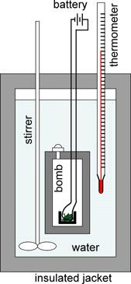](https://commons.wikimedia.org/wiki/File:ChemicalPrinciplesFig2-4.jpg)**Scenario #12: Enthalpy and Calorimetry**

1. Description: In many organisms, glucose is oxidized to carbon dioxide and water, as represented by the following equation:

**C6H12O6(s) + 6 O2(g) → 6 CO2(g) + 6 H2O(l)**

A student conducts an experiment in a bomb calorimeter, where a 2.50 g sample of glucose and an excess of O2(g) were burned. After the reaction proceeded to completion, the total heat released by the reaction was calculated to be 37.5 kJ. The molar mass of glucose is 180.18 g/mol.

1. Calculate the value of ΔH°, in kJ/mol, for the combustion of glucose.

Image: Wikimedia commons CC-BY-3.0

Attribution: [Dickerson, Gray and Haight](https://commons.wikimedia.org/wiki/File:ChemicalPrinciplesFig2-4.jpg)

1. The literature value for the combustion of glucose is -2800 kJ/mol. Calculate the percent error in the experiment.
2. Was the measured amount of heat generated by the reaction too high, too low, or correct? Discuss a possible source of this error in terms of heat flow.

**Scenario #13: Le Châtelier's Principle**

1. Description: A system at equilibrium can be thought of like kids balanced on a seesaw on the playground. The reactants and products have reached a steady state concentration such that balance between reactants and products has been reached. Refer to the illustration below.

|  |
| --- |
|  |

When a system at equilibrium is stressed, or placed out of balance, Le Chatelier’s Principle states that equilibrium will shift to reduce the effect of that stress, or to restore balance. Refer to the series of illustrations below.

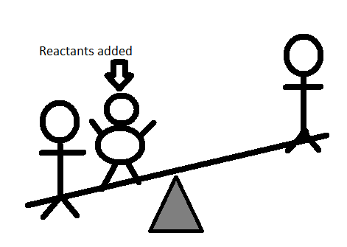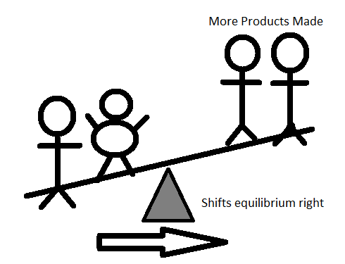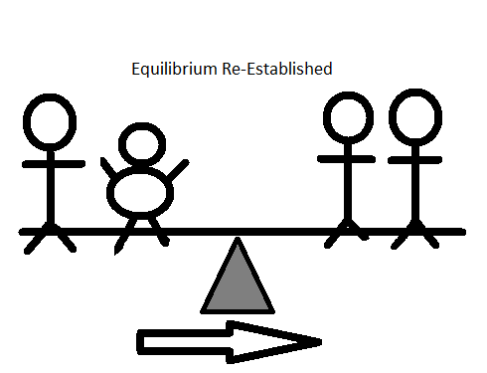

In the first image in the series above, reactants are added to the system, which unbalances the seesaw. In the second image, equilibrium shifts to produce more products, which in the third image, restores equilibrium with a new amount of reactants and products, but the same equilibrium. Use this illustration to answer the questions below.

1. If equilibrium shifts to the right when additional reactants are added to a system, how does equilibrium shift when additional products are added to a system at equilibrium?
2. If a reaction is exothermic, is heat a reactant or product in the reaction?
3. Since a catalyst affects the speed of a reaction only, would adding a catalyst change equilibrium? Justify your response.

**Scenario #14: Strong vs. Weak Acid Titrations**

1. Description: A student conducts a series of titrations with a strong base, NaOH, and two different acids. The student is not told what the identity of the acids are, but one is a strong acid and the other is a weak acid. The student titrates 50-mL of 0.10 M of each acid with 0.10 M sodium hydroxide solution and the pH of the solution is monitored. The resulting graph is shown below.

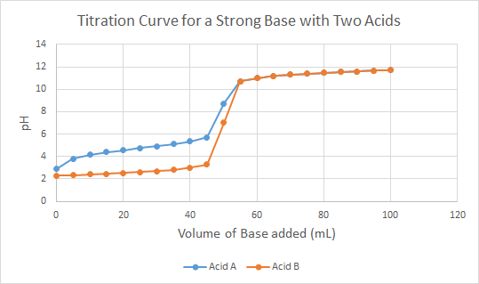

1. Which acid, A or B, is the strong acid? Justify your response.
2. Based on the graph, estimate the pKa for the weak acid. Describe how you know that is the pKa for the weak acid.
3. What is the endpoint of the titration of a strong acid and strong base? Write a net ionic equation for the reaction that occurs between the strong acid and strong base in this titration. Justify why it does not matter the identity of the acid for the net ionic equation.

**Scenario #15: Recipe for the Best Buffer**

1. Description: The first model below shows the general net ionic equation form of a buffer. A buffer is composed of a weak acid and its conjugate base. The H+ part represents the acid and the A- part represents the base.

A buffer is defined as a solution that resists change in pH. Below are illustrations of solutions, in net ionic form. Using the illustrations as a model, answer the questions that follow.

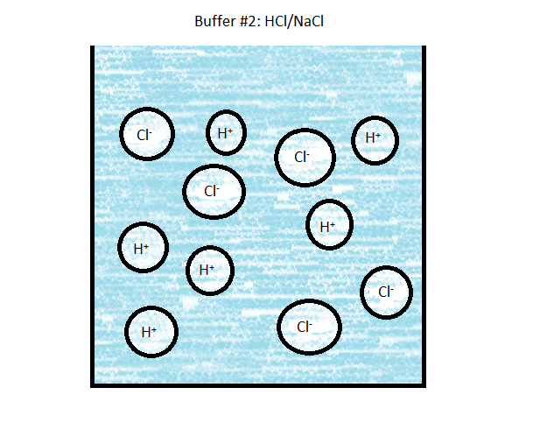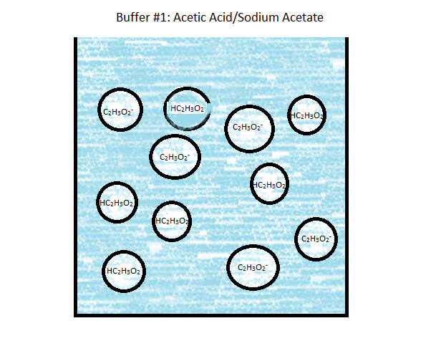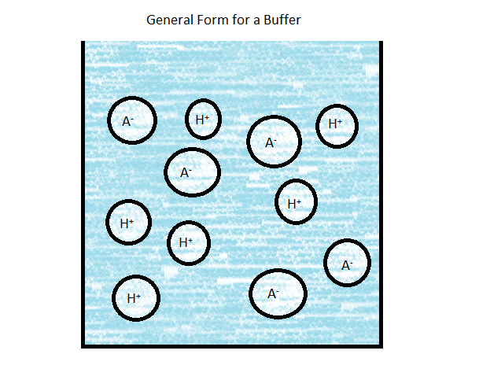

1. Write the net ionic equation for the reaction of a strong acid with both buffers:

Buffer 1:

Buffer 2:

1. If the pKa for acetic acid is 4.75 and you have a 0.100-M solution of acetic acid, how many grams of sodium acetate would you need to dissolve in the acid to make a buffer with a pH of 4.85? The molar mass of sodium acetate is 82.04 g/mol.
2. If the buffer in part c were titrated with 0.050 mol of strong base, like NaOH, what would the pH of the resulting solution be?

**Scenario #16: Buffer Capacity**

|  |  |
| --- | --- |
| **Weak Acid** | **pKa** |
| Acetic Acid  HC2H3O2 | 4.75 |
| Hypochlorous acid  HClO | 7.53 |
| Acetylsalicylic acid  (Aspirin, MM=180g/mol) | 3.50 |

1. Description: You are given the task of preparing the best buffer for a series of situations. The available ingredients include the three weak acids (assume 1.0M solutions of each) listed in the table on the right, with the corresponding pKa values. You also have access to the sodium salts of the weak acids, and you may assume that they are stable in solid and aqueous forms.
2. Determine the recipe for a 1.0-L buffer solution with pH 5.0
3. With the ingredients listed in the table, would it be practical to make a 1.0 L sample of a buffer with a pH of 2? Justify your response with calculations.
4. You are asked to prepare 100.0 mL of hypochlorous acid buffer solution using 0.500-M HClO solution and solid sodium hypochlorite. Describe how you would prepare a buffer with a pH of 7.80. The molar mass of sodium hypochlorite is 74.44 g/mol. Support your answer with related calculations.
5. You are given 100 mL of a buffer solution that was prepared using equal volumes of 0.500M HC2H3O2 and NaC2H3O solutions.
6. Calculate the pH of the buffer after the addition of 0.030 mol of strong base.
7. What will happen to the pH after you exceed 0.050 mol of strong base?
8. Describe how you could increase the buffer capacity of this buffer. You may support your answer with calculations, but it is not required.