**AP Chemistry Daily Videos**

**1.3 Elemental Composition of Pure Substances**

[**Video #1**](https://apclassroom.collegeboard.org/7/home?apd=9e559dc08r)

1. Give an example to illustrate what a “fixed ratio” means.
2. Is sucrose a pure substance? Why or why not?
3. Pause the video at 2:49 and attempt the problem, then evaluate how you did and identify any errors. What is the percent composition by mass of N2O4?



1. Explain the following statement in your own words: **“**If different compounds have the **same smallest whole number ratio of atoms**, the composition by mass of those compounds is **the same**.”

| **Term** | **Definition** | **Example** |
| --- | --- | --- |
| Empirical Formula |  |  |
| Molecular Formula |  |  |

1. Can the empirical and molecular formula be the same?
2. Pause the video at 6:17 and attempt the problem, then evaluate how you did and identify any errors. What are the empirical formulas of H2O2, Na2SO4, and C2H4O2?

[**Video #2**](https://apclassroom.collegeboard.org/7/home?apd=a8b8udp61a)

1. Pause the video at 0:50 and attempt the problem, then evaluate how you did and identify any errors. A compound was analyzed and found to contain 13.5 g Ca, 10.8 g O, and 0.675 g H. What is the empirical formula of the compound?
2. Pause the video at 3:15 and attempt the problem, then evaluate how you did and identify any errors. A compound is determined to be 43.6% P and the remainder oxygen. What is the empirical formula of the compound?
3. Pause the video at 5:25 and attempt the problem, then evaluate how you did and identify any errors. What is the empirical formula of a compound that is 28.7% K, 1.5% H, 22.8% P, and 47.0% O?

[**Video #3**](https://apclassroom.collegeboard.org/7/home?apd=05mfxaw7lr)

1. What is a combustion analysis?
2. Hydrate analysis?

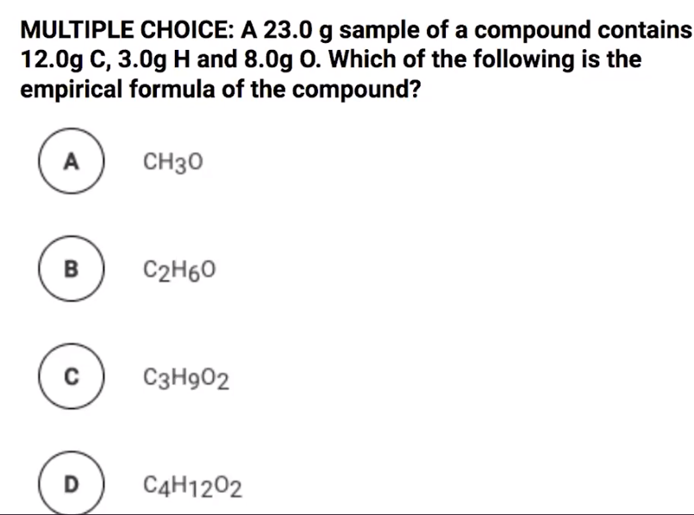

1. Pause the video at 1:25 and attempt the problem, then evaluate how you did and identify any errors.
2. Pause the video at 2:11 and attempt the problem, then evaluate how you did and identify any errors.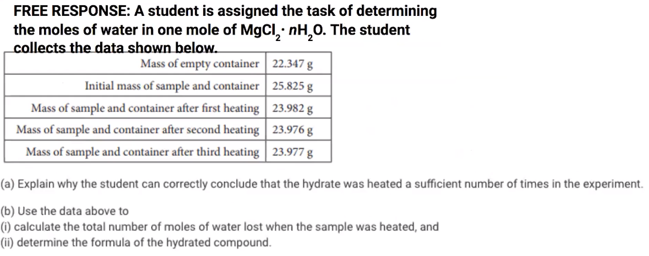

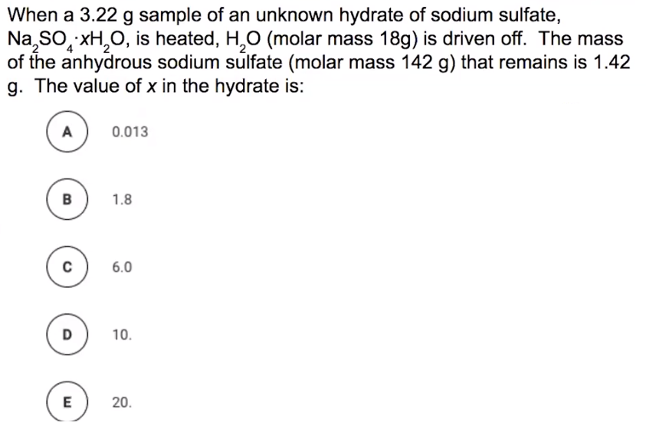

1. Pause the video at 6:14 and attempt the problem, then evaluate how you did and identify any errors.
2. Pause the video at 7:41 and attempt the problem, then evaluate how you did and identify any errors.