**AP Chemistry Daily Videos**

**1.6 Photoelectron Spectroscopy**

[**Video #1**](https://apclassroom.collegeboard.org/7/home?apd=gzuapqin9f)

1. What is Aufbau’s Principle?
2. What is PES?
3. Why are core electrons harder to remove?
4. Write down the important information in a PES.

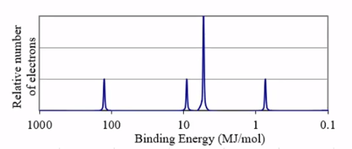

[**Video #2**](https://apclassroom.collegeboard.org/7/home?apd=gpr8ljzu90)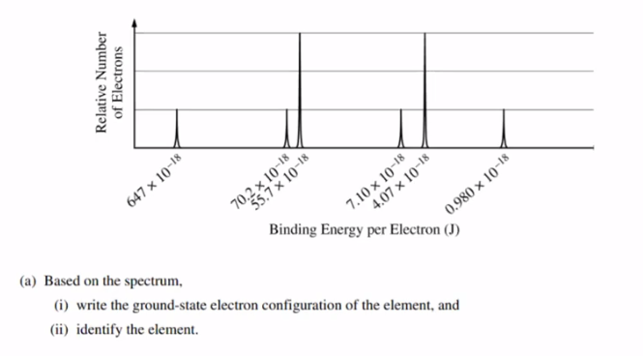

1. Pause the video at 0:44 and attempt the problem, then evaluate how you did and identify any errors.

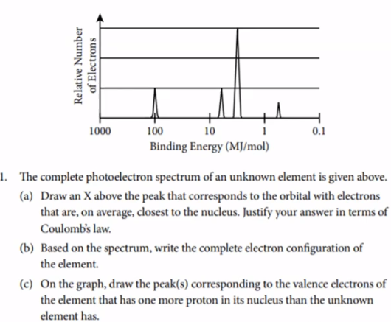

1. Pause the video at 1:40 and attempt the problem, then evaluate how you did and identify any errors.
2. Pause the video at 4:08 and attempt the problem, then evaluate how you did and identify any errors.