**AP Chemistry Daily Videos**

**1.8 Valence Electrons and Ionic Compounds**

[**Video #1**](https://apclassroom.collegeboard.org/7/home?apd=k9ufkry92c)

1. Why are valence electrons the focus of our attention?
2. Pause the video at 2:35 and attempt the problem, then evaluate how you did and identify any errors. 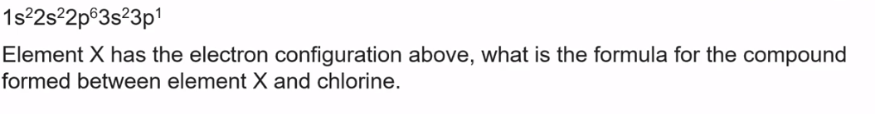
3. Pause the video at 3:40 and attempt the problem, then evaluate how you did and identify any errors. 