**AP Chemistry Daily Videos**

**2.2 Intramolecular Force and Potential Energy**



[**Video #1**](https://apclassroom.collegeboard.org/7/home?apd=maumrkkm1i&unit=2)

1. The image above is of two atoms (green being the nucleus). Mark what charge the nucleus has and what charge the blue electron has. Describe attractive forces and repulsive forces between two atoms and their electrons.

2. The _________ the potential energy the stronger the chemical bond. Anything above 0 kJ/mol is considered unstable.

3. When atoms form a chemical bond, is energy released (neg) or absorbed (pos)?

4. Write notes to understand the effects of internuclear distance, PE, and stability of a chemical bond. What balance must be met in order to form a stable arrangement?

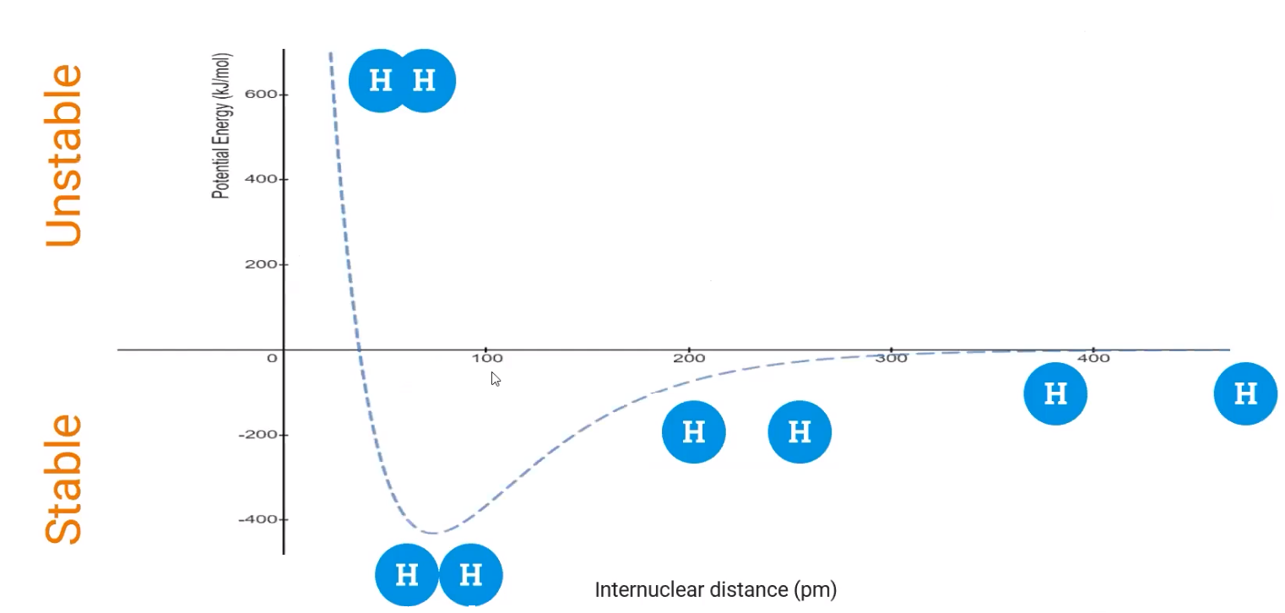

5. How do your notes above relate to Coulomb’s Law?

6. Complete the following table:

| **Bond Order** | **Single Bond** | **Double Bond** | **Triple Bond** |
| --- | --- | --- | --- |
| Bond diagram |  |  |  |
| Lewis Structure Diagram |  |  |  |
| Strength |  |  |  |
| Length |  |  |  |

7. According to Coulomb’s Law, provide an example and explanation of two ions in an ionic chemical bond that forms large electrostatic potential.

[**Video #2**](https://apclassroom.collegeboard.org/7/home?apd=xqwhkjg3vx&unit=2) 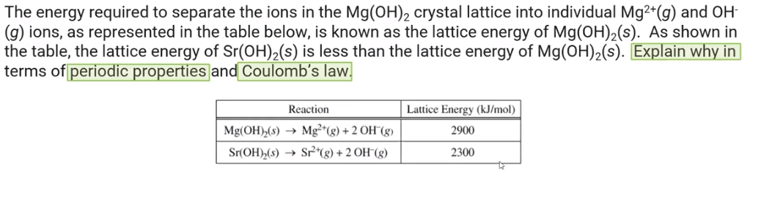

1. Pause the video at 0:53 and attempt the problem, then evaluate how you did and identify any errors.
2. Pause the video at 1:41 and attempt the problem, then evaluate how you did and identify any errors. 