**AP Chemistry Daily Videos**

**2.4 Structure of Metals and Alloys**

[**Video #1**](https://apclassroom.collegeboard.org/7/home?apd=ymkis8vvj8&unit=2)

1. What 3 properties do metals have because of their “sea of electrons”?
2. Ionic compounds that are soluble in water and metals both are good conductors of electricity. Explain why.
3. What are alloys and their two types? Draw a picture and words to describe the types.
4. Pause the video at 2:32 and attempt the problem, then evaluate how you did and identify any errors. 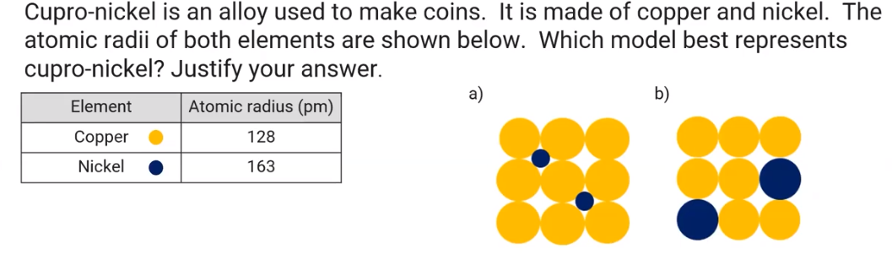

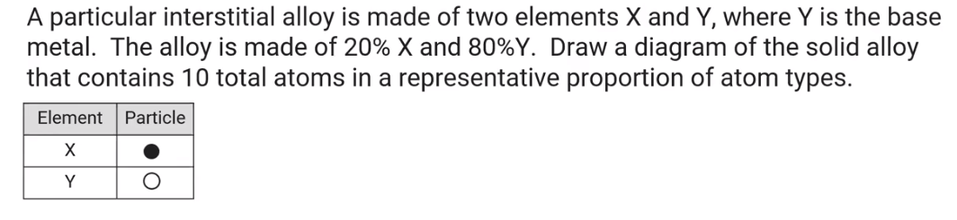

1. Pause the video at 3:13 and attempt the problem, then evaluate how you did and identify any errors.