**AP Chemistry Daily Videos**

**2.5 Lewis Diagrams**

[**Video #1**](https://apclassroom.collegeboard.org/7/home?apd=fn1wddi5jv&unit=2)

1. What are the different ways to represent molecules?
2. Summarize what Lewis Diagrams are trying to communicate. Make sure you include what dashes and dots represent.
3. How do valence electrons and Lewis structures relate to groups/families? Complete the Lewis Diagram for the examples provided in the video

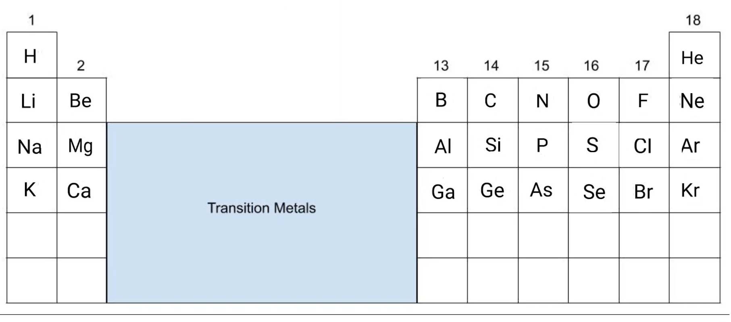

1. Why can carbon form four chemical bonds but nitrogen only three?
2. Using diatomic molecules as examples, how do you represent double and triple bonds?

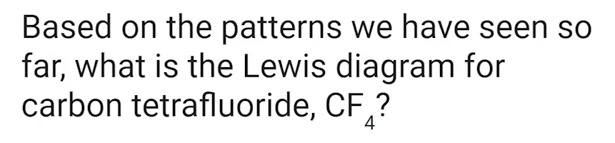

1. Pause the video at 8:22 and attempt the problem, then evaluate how you did and identify any errors.
2. What is the octet rule?

[**Video #2**](https://apclassroom.collegeboard.org/7/home?apd=z00c37ph7e&unit=2)

1. What are the steps in creating Lewis Structures?

1.

2.

3.

4.

1. If the Lewis structure is an ion, what must be included in the structure?
2. Pause the video at 4:24, 5:04, & 5:38 and attempt the problems, evaluate how you did and identify any errors.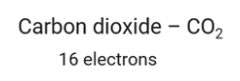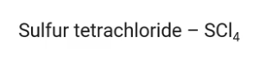
3. What is an expanded octet and give an example? Why do these only occur for element in row three and more?

[**Video #3**](https://apclassroom.collegeboard.org/7/home?apd=ih9tb5k6vl&unit=2)

1. Pause the video at 0:41 and attempt the problem, then evaluate how you did and identify any error.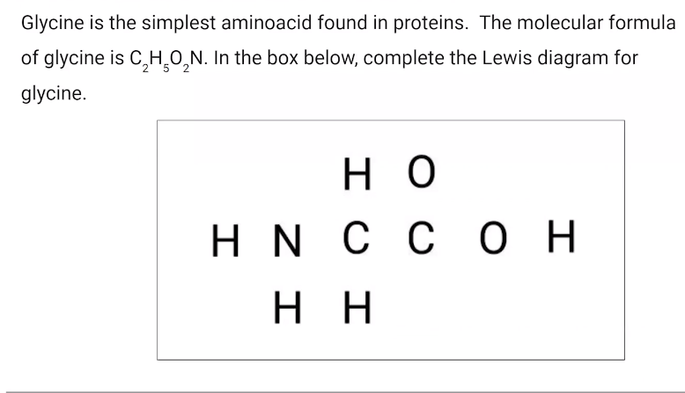
2. Pause the video at 3:00 and attempt the problem, then evaluate how you did and identify any error.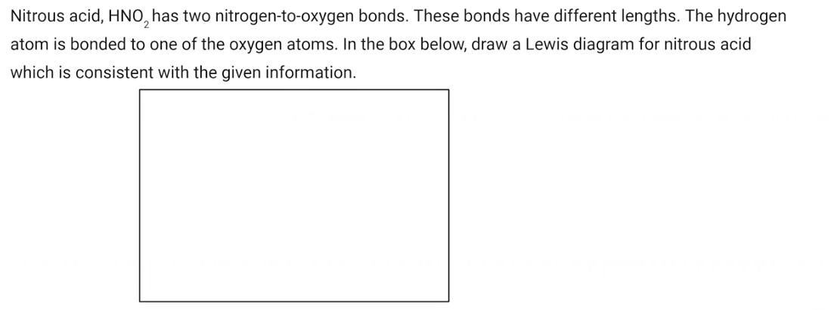

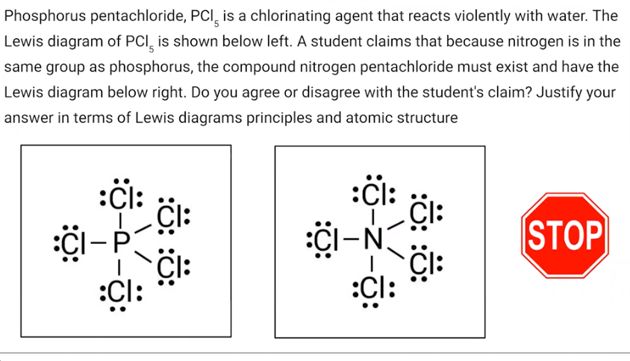

1. Pause the video at 4:15 and attempt the problem, then evaluate how you did and identify any error.