**AP Chemistry Daily Videos**

**2.6 Resonance and Formal Charge**

[**Video #1**](https://apclassroom.collegeboard.org/7/home?apd=5q375eg17v) 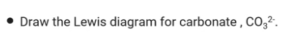

1. Pause the video at :30 and attempt the problem, then evaluate how you did and identify any errors.
2. What do resonance structures show and how do you correctly depict a resonance structure? Make sure you include what the double arrows indict. Describe the bonds in a molecule with resonance.
3. Give an example of how to draw a hybrid resonance structure. Explain what the dotted line represents.

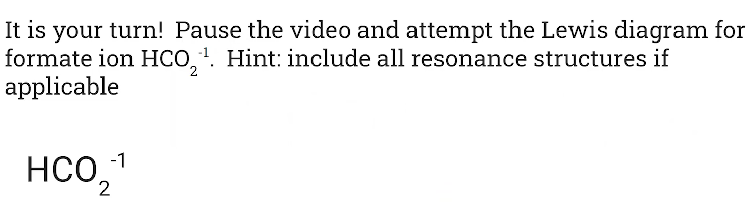

1. Pause the video at 3:20 and attempt the problem, then evaluate how you did and identify any errors.

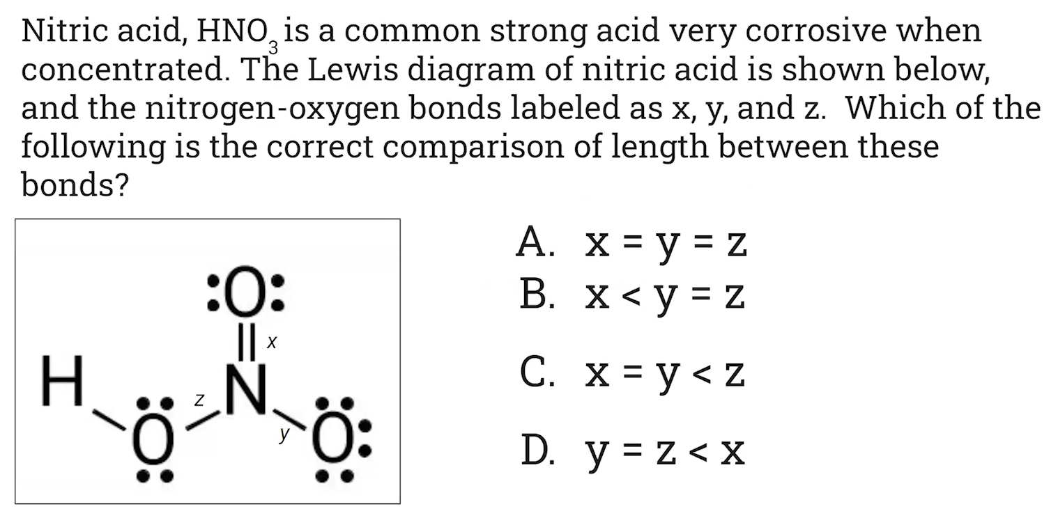

1. Pause the video at 4:28 and attempt the problem, then evaluate how you did and identify any errors.

[**Video #2**](https://apclassroom.collegeboard.org/7/home?apd=mvt88ivwf3)

1. What is formal charge?
2. How do you assign a formal charge to an atom?

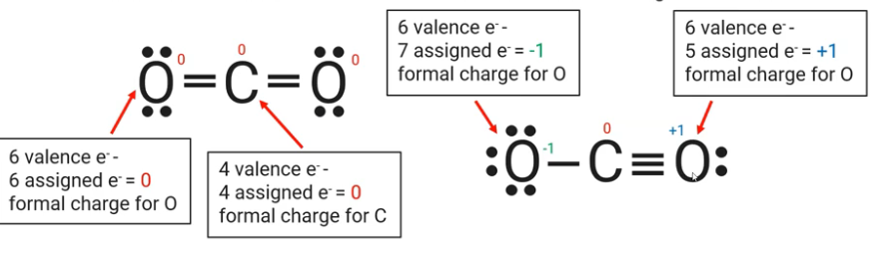

1. How do you use formal charge to determine the best Lewis structure?






1. Pause the video at 4:44 and attempt the problem, then evaluate how you did and identify any errors. 