**AP Chemistry Daily Videos**

**2.7 VSEPR and Bond Hybridization**

[**Video #1**](https://apclassroom.collegeboard.org/7/home?apd=jj3xw6e5lu)

1. What information do Lewis structures leave out?
2. What does VSEPR stand for? Describe the VSEPR Theory.
3. How do electron repulsions impact shape?
4. What are electron domains?
5. Which electron domain impacts the bond angle more than other domains? How does it impact the shape/angles?
6. Write down two important things you learned from using the [Phet simulation for VSEPR](https://phet.colorado.edu/en/simulation/molecule-shapes)?
7. Make sure you know the different shapes based on the number of domains and lone pairs.

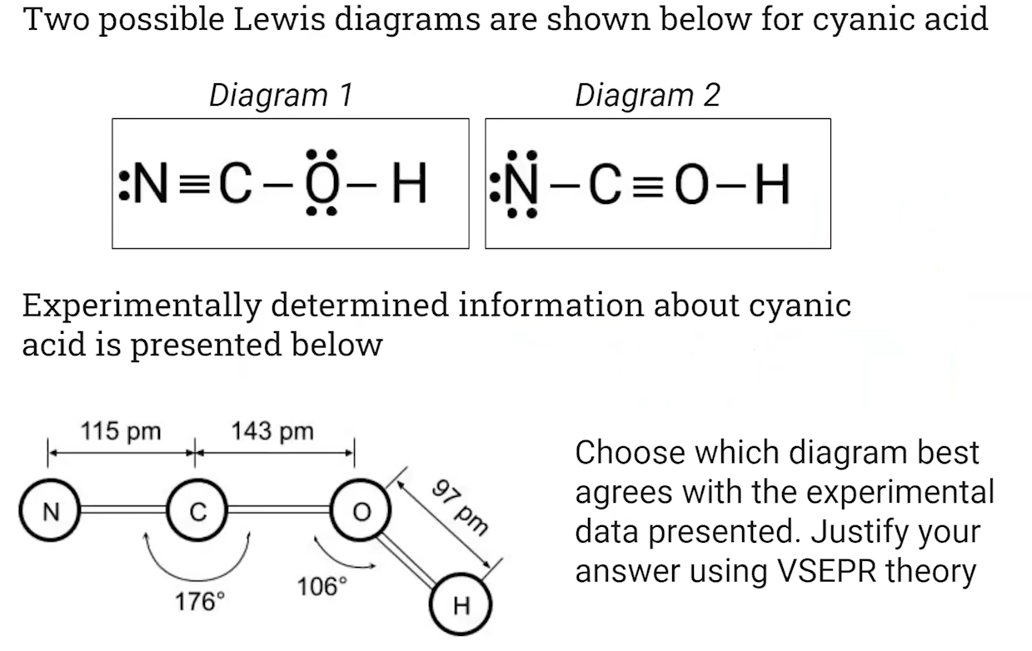

1. Pause the video at 7:21 and attempt the problem, then evaluate how you did and identify any errors.

[**Video #2**](https://apclassroom.collegeboard.org/7/home?apd=occ3p2sgqk)

1. Remind yourself what a polar bond is.
2. How is it possible that a molecule has polar bonds BUT the molecule, overall, is not polar (net dipole is zero)? Give an example.
3. What two things determine if a molecule is nonpolar?
4. What are the symmetrical shapes?
5. What are the asymmetrical shapes?

[**Video #3**](https://apclassroom.collegeboard.org/7/home?apd=fmo6tprqxw)

1. Explain how Carbon, which you know makes four chemical bonds, should only form 2 bonds according to its electron configuration.
2. What are hybrid orbitals?
3. Complete the following table:

| **Hybridized Orbital** | **Energy Diagram** [**Source**](https://chem.libretexts.org/Bookshelves/General_Chemistry/Map%3A_Chemistry_-_The_Central_Science_(Brown_et_al.)/09._Molecular_Geometry_and_Bonding_Theories/9.5%3A_Hybrid_Orbitals) | **Electron Domain Options** | **Molecular Geometry and Angle** |
| --- | --- | --- | --- |
| sp3 | Energy is most similar to 2p.  25% s characteristic and 75% p characteristic. |  |  |
| sp2 | Energy is closer to 2p.  33% s characteristic and 67% p characteristic. |  |  |
| sp | Energy is equidistant between s and p.  50% s characteristic and 50% p characteristic. |  |  |

1. Pause the video at 4:24 and attempt the problem, then evaluate how you did and identify any errors.