**AP Chemistry Daily Videos**

**3.13 Beer-Lambert Law**

[**Video #1**](https://apclassroom.collegeboard.org/7/home?apd=9k5o1apgma&unit=3)

1. Does a highly concentrated solution (which is darker in color) absorb more or less light than a dilute solution?
2. How does absorption of light change as concentration of a solution increases?
3. What units is wavelength of light measured in?
4. How does wavelength change as energy increases?
5. Which color ROYGBIV has the most energy?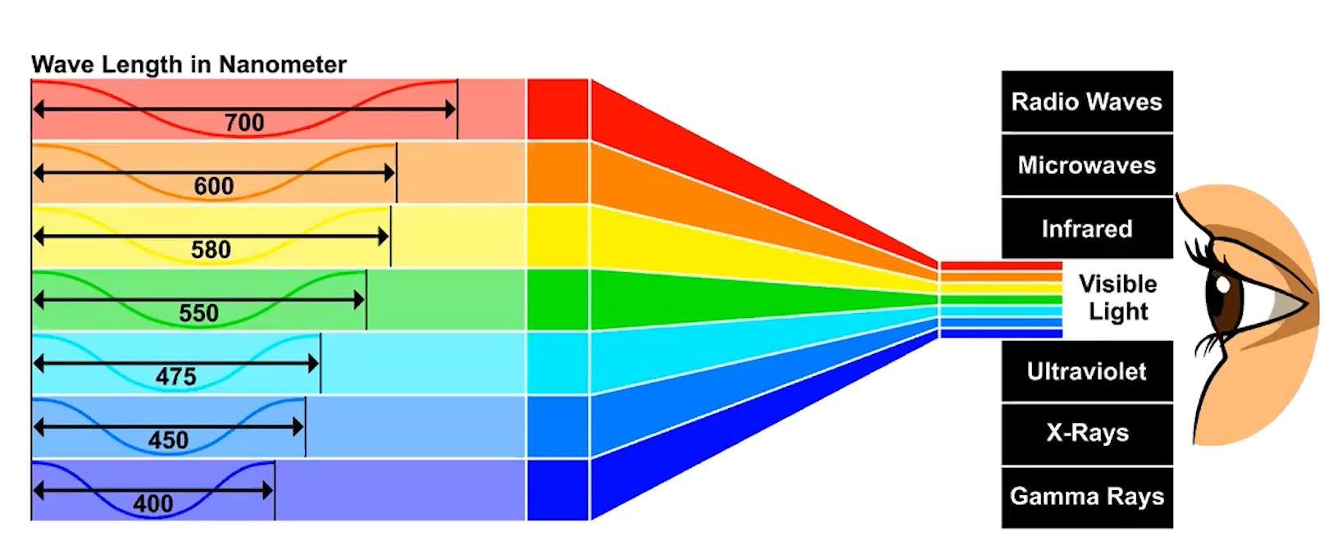
6. When you see a green shirt, what colors/wavelengths are absorbed and which are reflected?
7. Draw a picture to describe how a spectrophotometer or colorimeter works.

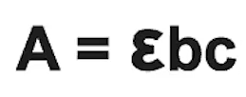

1. Explain each variable in the Beer-Lamber Law.
2. Rewrite this formula if the path length and molar absorptivity are held constant?
3. Does this formula support your answer in #2?
4. Pause the video at 2:35 and attempt the problem, then evaluate how you did and identify any errors. 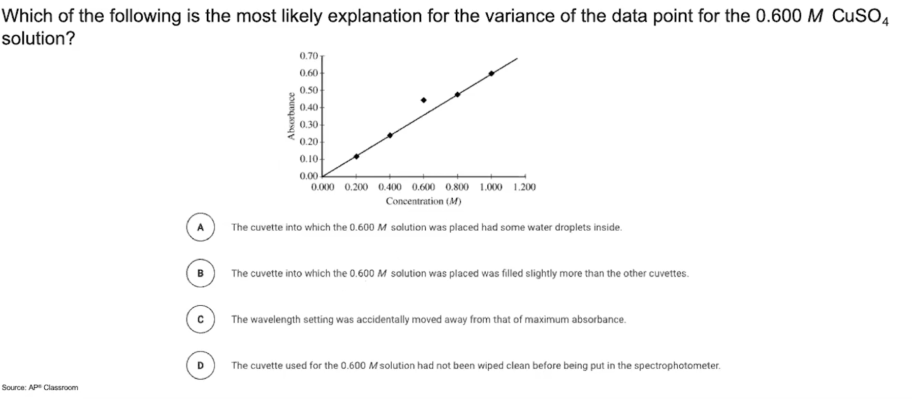

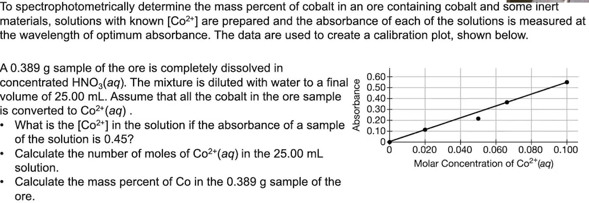

1. Pause the video at 4:28 and attempt the problem, then evaluate how you did and identify any errors.

[**Video #2**](https://apclassroom.collegeboard.org/7/home?apd=6px2o19wge&unit=3)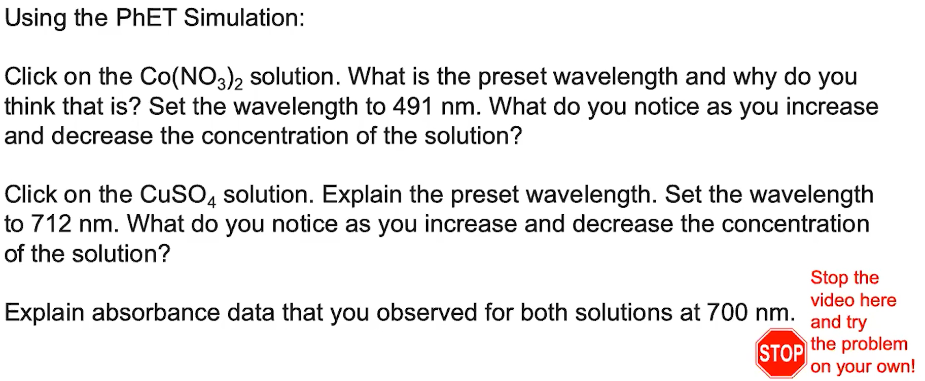

1. Pause the video at 2:45 and attempt the problem, then evaluate how you did and identify any errors. [Phet Simulation link](https://phet.colorado.edu/en/simulations/beers-law-lab).

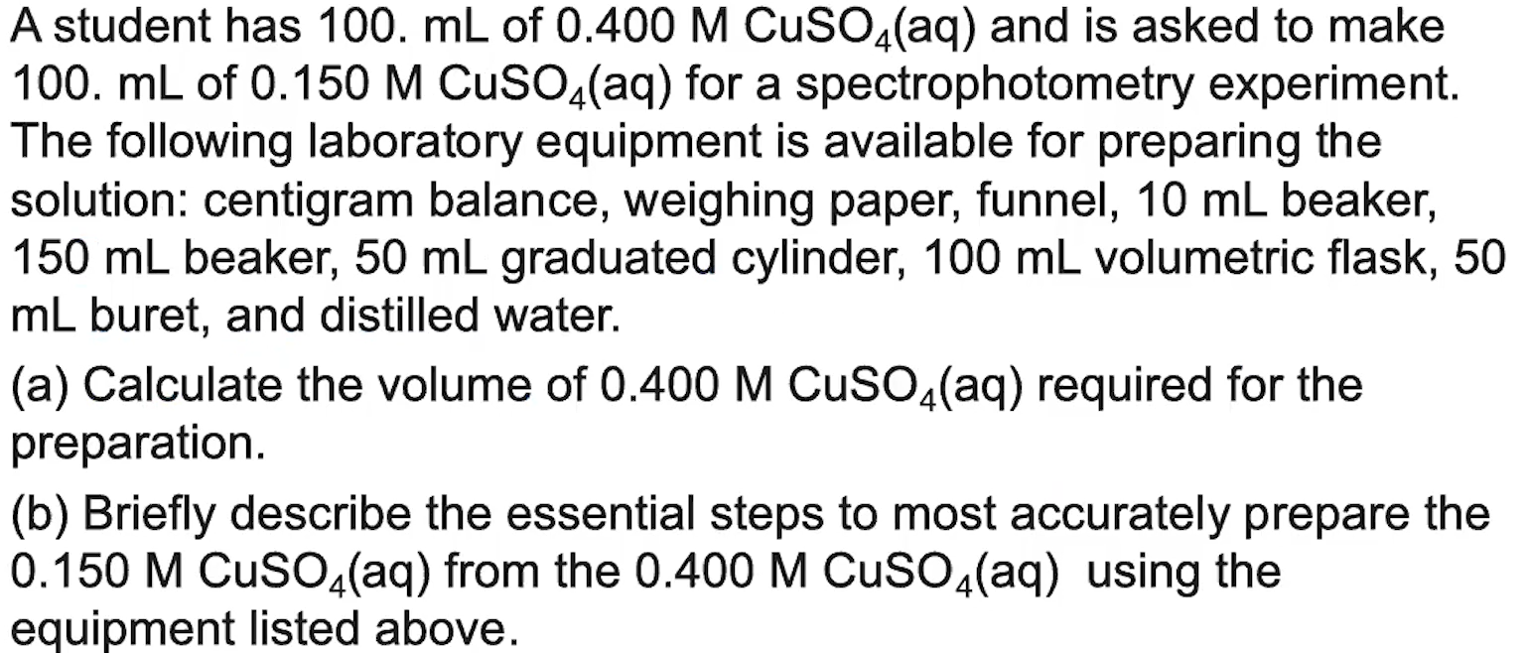

1. Pause the video at 4:40 and attempt the problem, then evaluate how you did and identify any errors. 