**AP Chemistry Daily Videos**

**4.1 Introduction for Reactions**

[**Daily Video #1**](https://apclassroom.collegeboard.org/7/home?apd=sutdgl8s80&unit=4)

1. Describe physical changes. Provide two examples.
2. What are chemical changes?
3. What are the types of evidence of a chemical change?
4. Pause the video at 3:50 attempt the problem, then evaluate how you did and identify any errors.

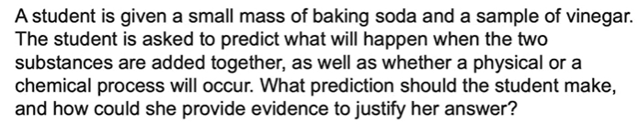

1. What are the big takeaways?