**AP Chemistry Daily Videos**

**4.3 Representations of Reactions**

[**Daily Video #1**](https://apclassroom.collegeboard.org/7/home?apd=500ypu96ah&unit=4)

1. What do the different parts of a balanced chemical equation represent?
2. What are some benefits of a particulate diagram?
3. Pause the video at 5:14 and attempt the problem, then evaluate how you did and identify any errors.

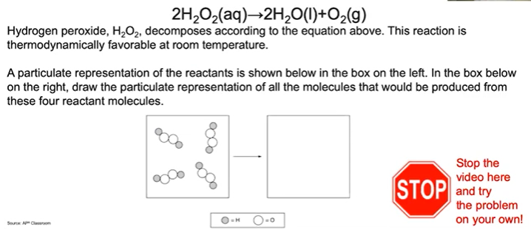

1. What are the takeaways?