**AP Chemistry Daily Videos**

**4.5 Stoichiometry**

[**Daily Video #1**](https://apclassroom.collegeboard.org/7/home?apd=38p2aue9tj)

[**Daily Video #2**](https://apclassroom.collegeboard.org/7/home?apd=nkimiid696)

1. **What is stoichiometry? Explain in your own words.**
2. **Show your work for the following MC question. Be sure to include any formulas. Make any notes of how to solve the problem based on the video’s explanation. (please attempt without a calculator)**

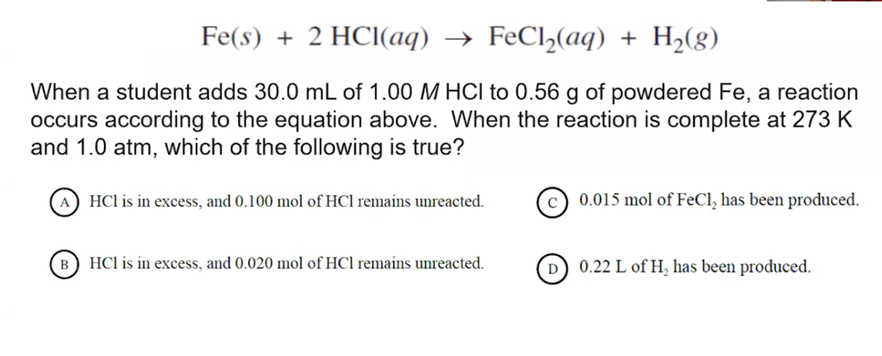

1. **Please show your work for next MC question below.**

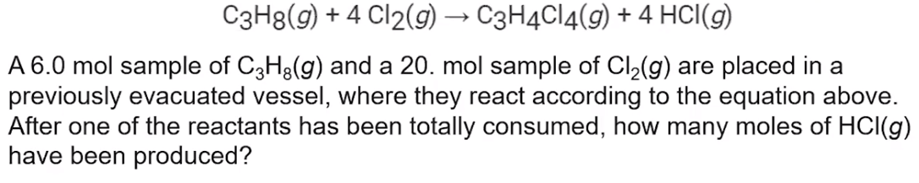

1. **Please show your work for the following MC question below.**

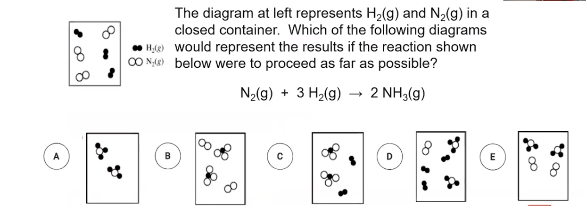

**@ 5:40 in Daily Video #2 What is the take away? Summarize in your own words.**