**AP Chemistry Daily Videos**

**5.1 Reaction Rates**

[**Video #1**](https://apclassroom.collegeboard.org/7/home?apd=xv08dersm1&unit=5)

1. What does kinetics study? How does it relate to rate?
2. How can you use stoichiometry to determine the rate of change of react and product concentrations?

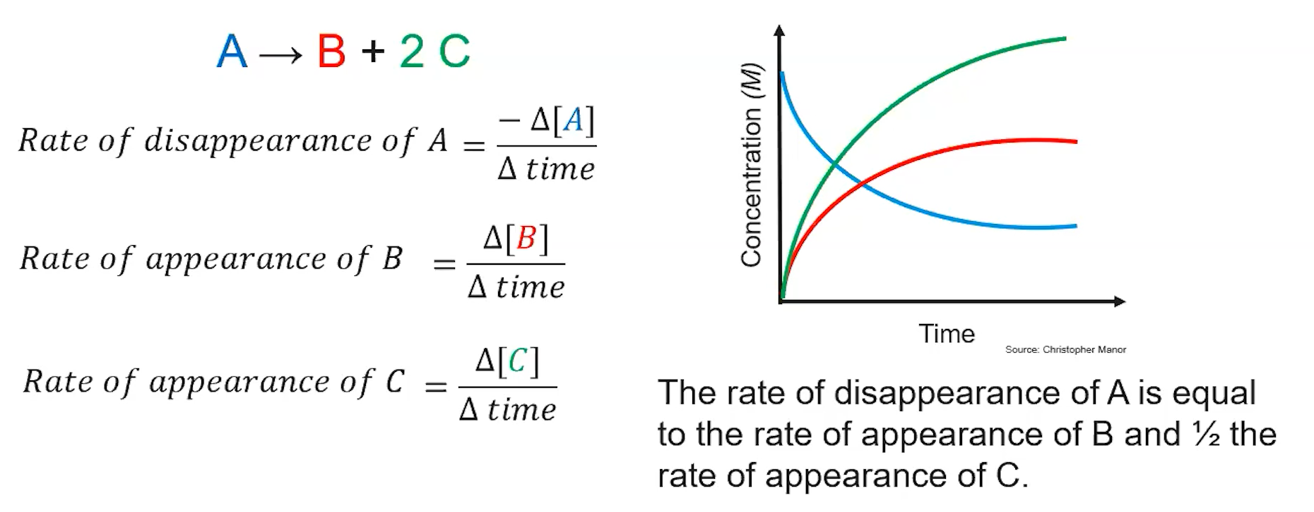

1. What happens to the concentration of reactants and products as a reaction occurs?
2. What is the unit of reaction rate?
3. Pause the video at 2:22 and attempt the problem, then evaluate how you did and identify any errors.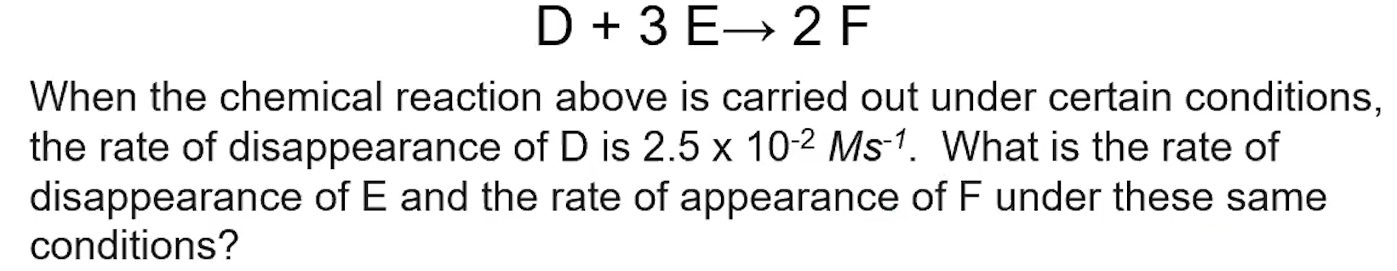

1. Pause the video at 3:25 and attempt the problem, then evaluate how you did and identify any errors.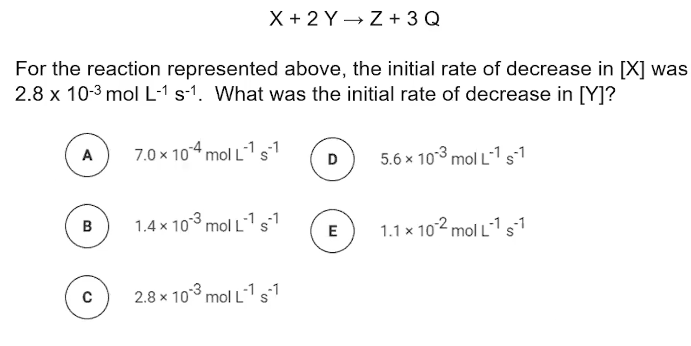

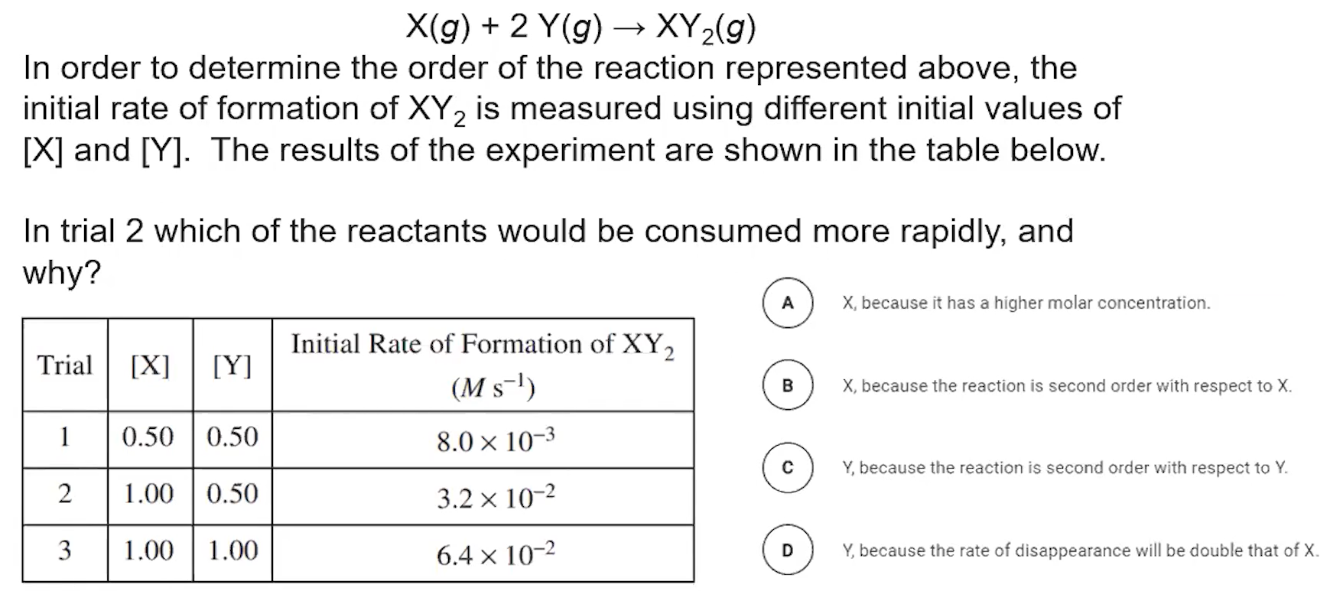

1. Pause the video at 4:12 and attempt the problem, then evaluate how you did and identify any errors.

[**Video #2**](https://apclassroom.collegeboard.org/7/home?apd=j20vzgfca3&unit=5)

1. How does collision theory relate to reaction rates?
2. Explain how increasing aqueous concentration and decreasing volume of gases both increase reaction rates.
3. Why does increasing temperature increase reaction rates?
4. What does increasing surface area increase reaction rates?

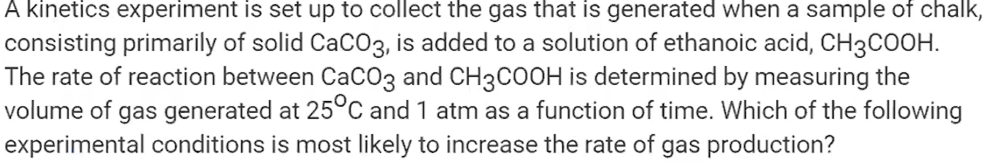

1. Pause the video at 2:07 and attempt the problem, then evaluate how you did and identify any errors.
2. Pause the video at 3:27 and attempt the problem, then evaluate how you did and identify any errors.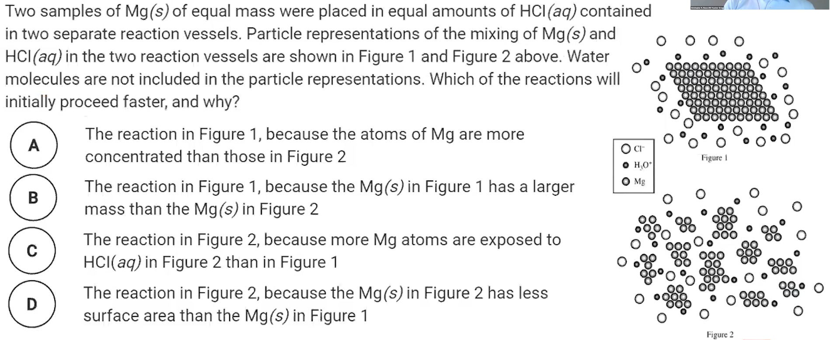
3. **Key Takeaway**: Rate of a reaction is influenced by anything that affects the ____________ of collision or the _________________ of collision.