**AP Chemistry Daily Videos**

**5.10 Multistep Reaction Energy Profile**

[**Video #1**](https://apclassroom.collegeboard.org/7/home?apd=020giusvtg)

1. What is the relationship between slow steps and activation energy?

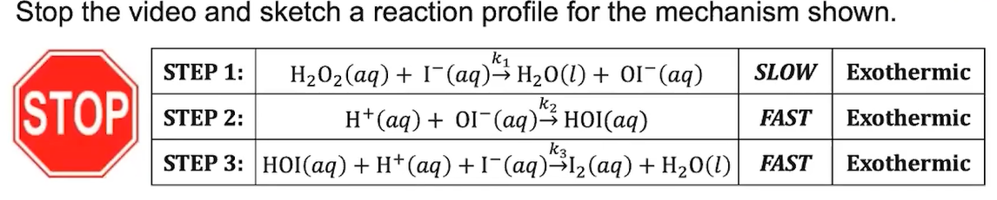

1. Pause the video at 4:25 and attempt the problem, then evaluate how you did and identify any errors.

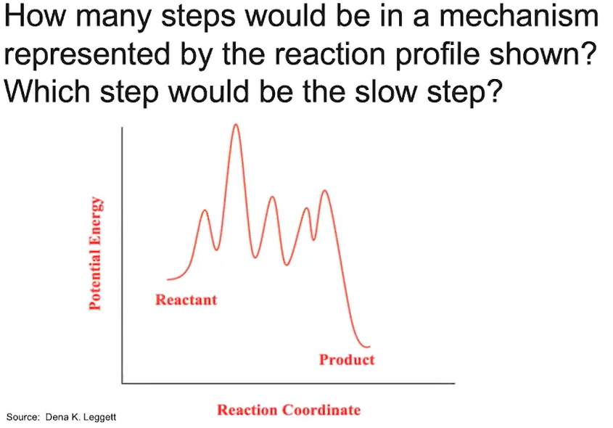

1. Pause the video at 6:13 and attempt the problem, then evaluate how you did and identify any errors. *Before checking your work*, identify each step as endothermic or exothermic. Circle where transition states form and box in where you’d find intermediates.