**AP Chemistry Daily Videos**

**5.3 Concentration Changes Over Times**

[**Video #1**](https://apclassroom.collegeboard.org/7/home?apd=8li3xtygif)

1. Complete the following table:

| **Reaction Order** | **What happens to the rate when the reactant doubles?** | **Generic Rate Law** | **Integrated Rate Law** | **Relationship of k to slope** | **Graphical representation** |
| --- | --- | --- | --- | --- | --- |
| Zero |  |  |  |  |  |
| First |  |  |  |  |  |
| Second |  |  |  |  |  |

1. What is the purpose of the integrated rate law? What does [A]t and [A]0 represent?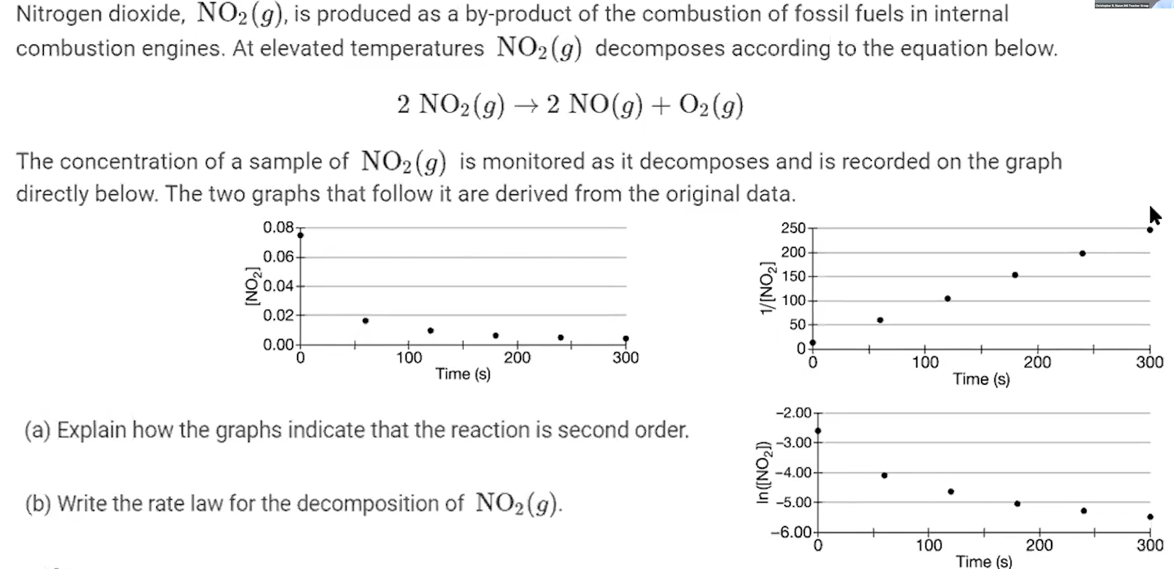
2. Pause the video at 3:16 and attempt the problem, then evaluate how you did and identify any errors.
3. Pause the video at 4:08 and attempt the problem, then evaluate how you did and identify any errors. 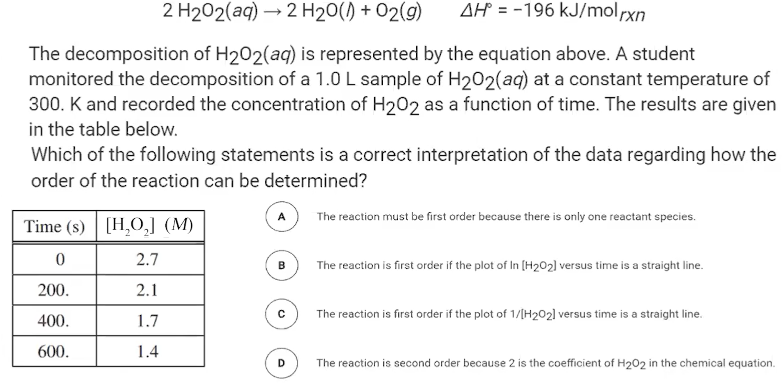
4. Pause the video at 5:11 and attempt the problem, then evaluate how you did and identify any errors. 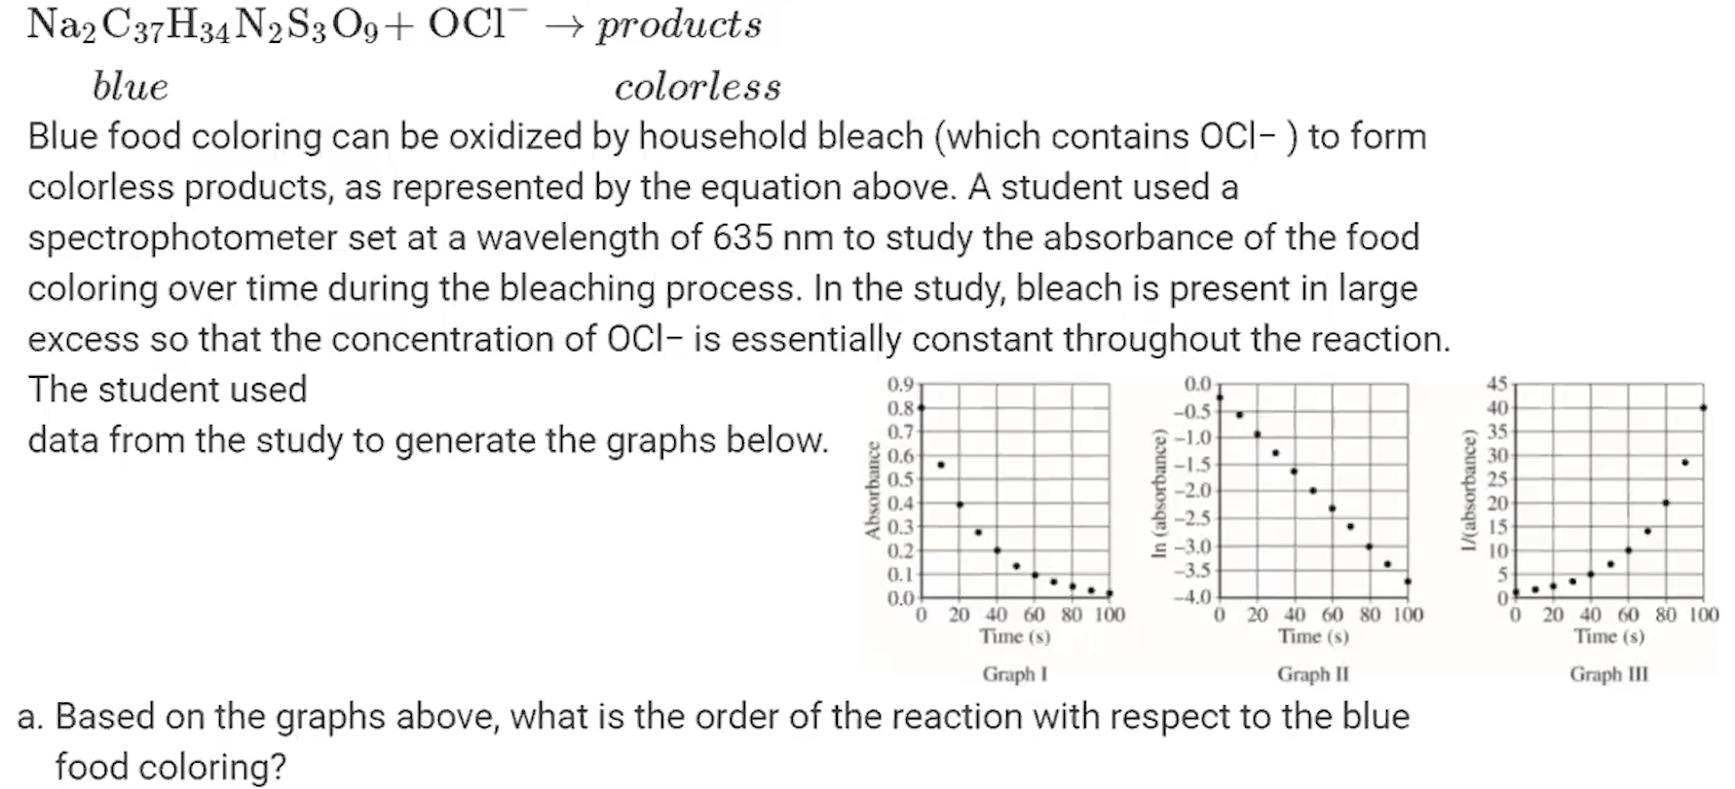

[**Video #2**](https://apclassroom.collegeboard.org/7/home?apd=g2ayjfb2un)

1. Explain in your own words and using this picture what half-life is.



Note that for first order reactions, the concentration of the reactant is decreased by half at a constant rate. You might see this information in a data table or graph. The key is recognizing what is occurring and the rate. The value of t1/2 (half-life) can be determined from the graph or data table.

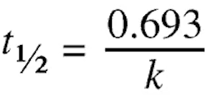

1. Explain how to use this equation to calculate half-life.
2. Pause the video at 1:20 and attempt the problem, then evaluate how you did and identify any errors. 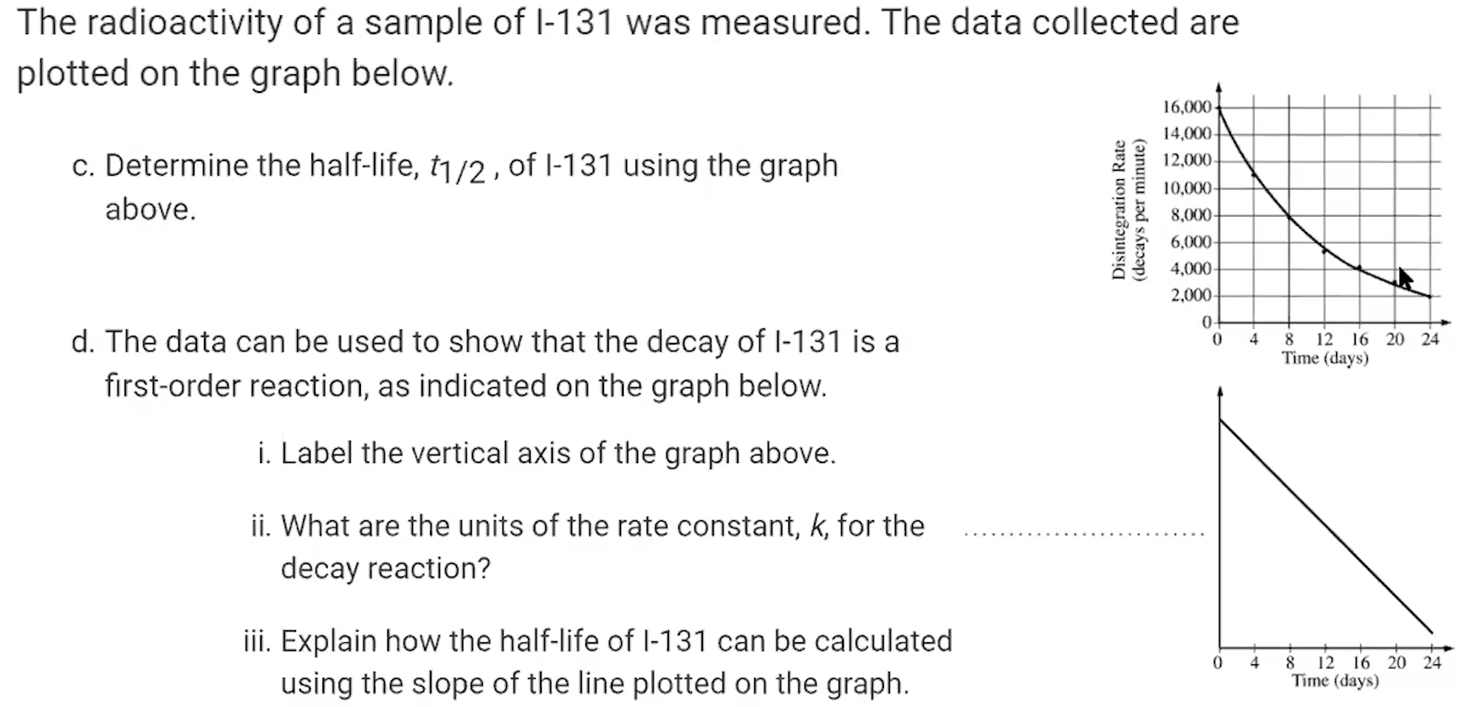

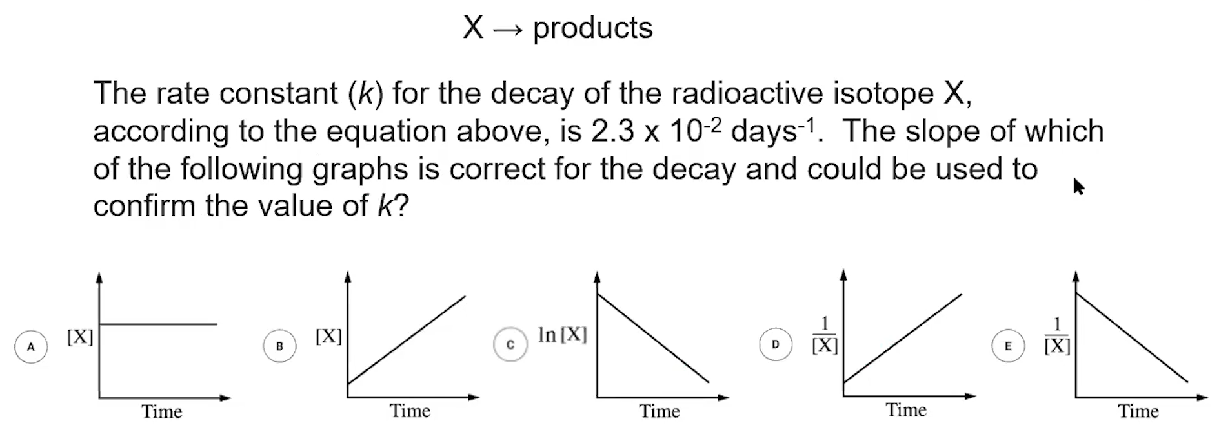

1. Pause the video at 2:52 and attempt the problem, then evaluate how you did and identify any errors.
2. Pause the video at 3:34 and attempt the problem, then evaluate how you did and identify any errors. 