**AP Chemistry Daily Videos**

**5.4 Elementary Reactions**

[**Video #1**](https://apclassroom.collegeboard.org/7/home?apd=99fbehpmk6)

1. Relate reaction mechanism to walk directly to class versus a circuitous route.
2. Why are intermediates not included in the overall reaction?
3. *Note, unlike typical rate laws, a rate law from a reaction mechanism can be derived based on the elementary step’s coefficients.
4. Pause the video at 1:20 and attempt the problem, then evaluate how you did and identify any errors. 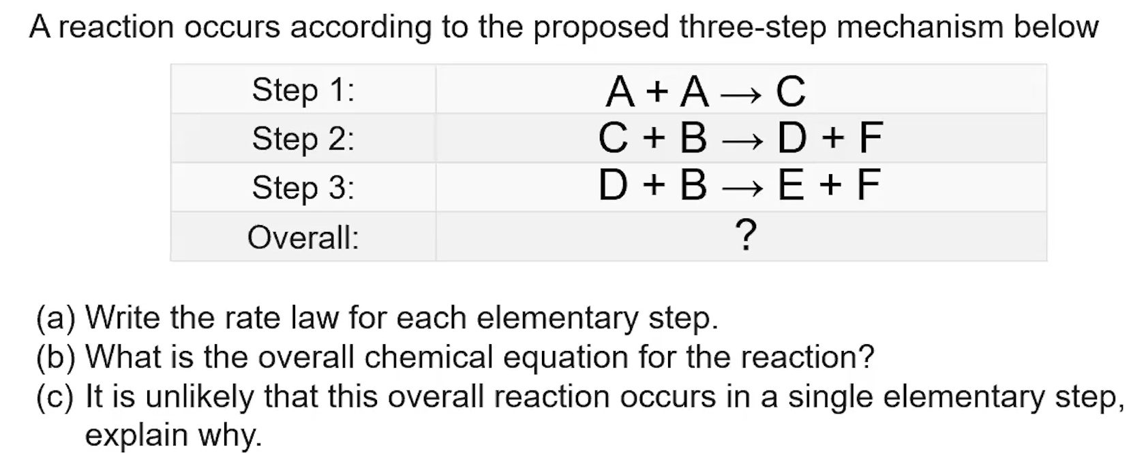

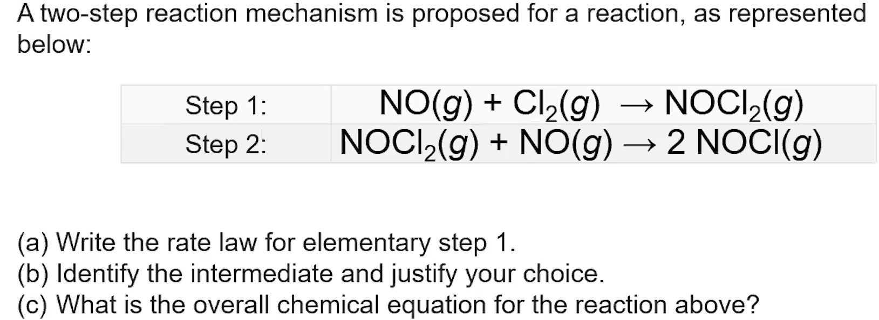

1. Pause the video at 3:06 and attempt the problem, then evaluate how you did and identify any errors.