**AP Chemistry Daily Videos**

**5.5 Collision Model**

[**Video #1**](https://apclassroom.collegeboard.org/7/home?apd=rmzuby5k7c)

1. Why don’t all collisions produce a reaction? State three factors that need to be considered.

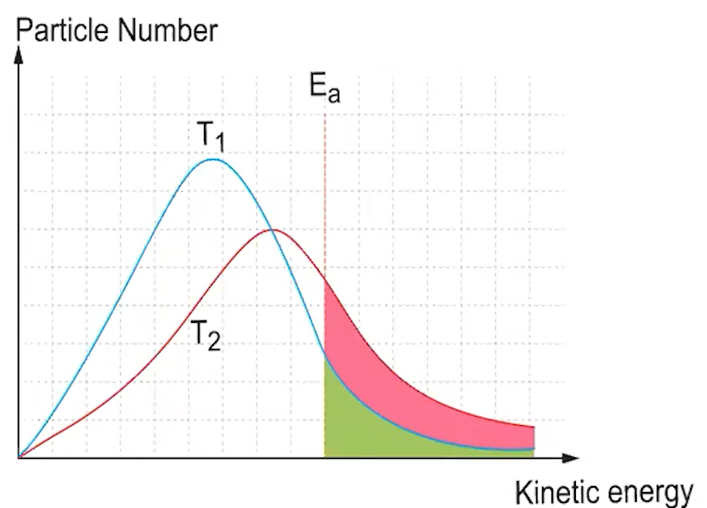

1. Explain what the Maxwell-Boltzmann curve communicates. Note, Ea= Activation Energy.
2. Why do all reactions (exothermic or endothermic) require energy to get started (activation energy)? Consider what chemical bonds must be broken for the reaction to proceed.
3. Pause the video at 1:26 and attempt the problem, then evaluate how you did and identify any errors. 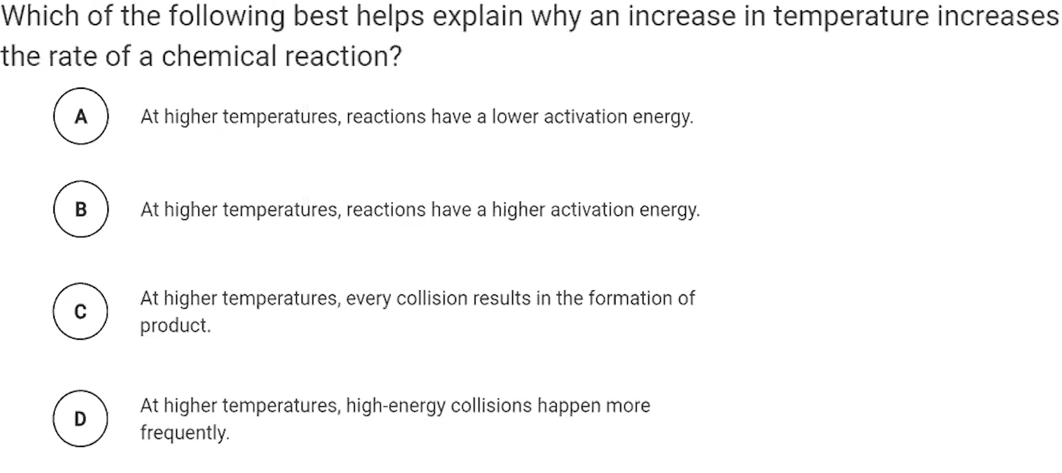
4. Pause the video at 2:37 and attempt the problem, then evaluate how you did and identify any errors. 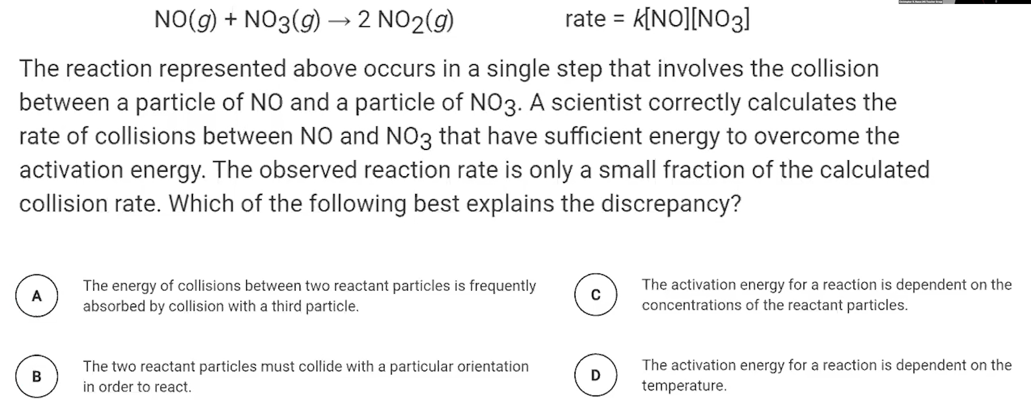
5. Pause the video at 3:23 and attempt the problem, then evaluate how you did and identify any errors.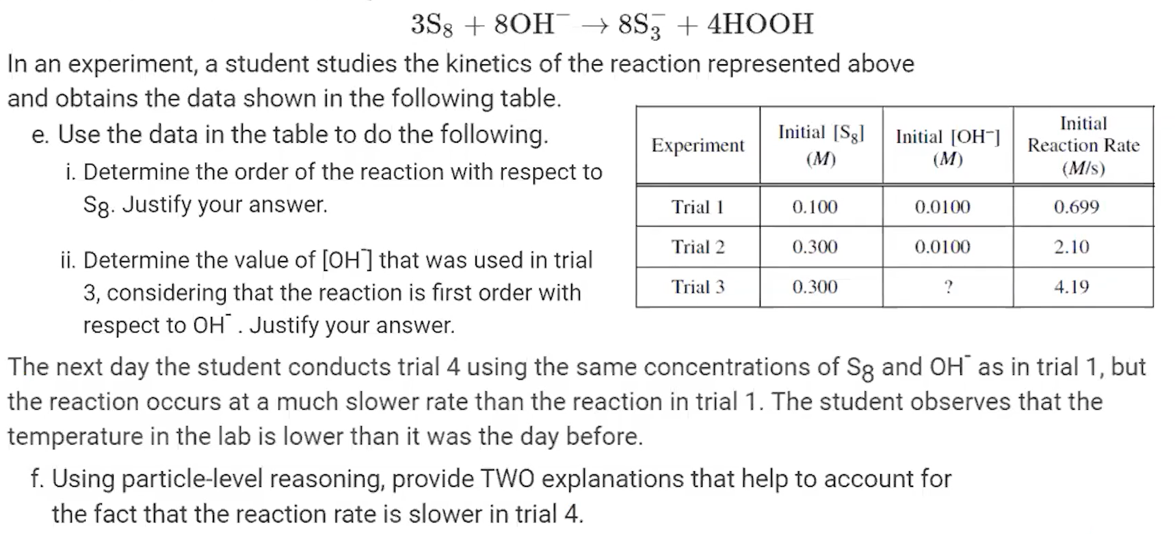
6. Pause the video at 5:52 and attempt the problem, then evaluate how you did and identify any errors.