**AP Chemistry Daily Videos**

**5.7 Introduction to Reaction Mechanisms**

[**Video #1**](https://apclassroom.collegeboard.org/7/home?apd=z16qwg3wbx&unit=5)

1. Describe in your own words what a reaction mechanism is.
2. What are elementary steps?
3. If a product is formed in one step and then consumed in another step it is called an _______________.
4. How do you know if a substance is acting as a catalyst or an intermediate in a reaction mechanism?

|  | Catalysts (Yes/No) | Intermediates (Yes/No) |
| --- | --- | --- |
| Present at the beginning and end of a reaction? |  |  |
| Shows up in a rate law? |  |  |
| Consumed in the reaction? |  |  |
| Temporary product? |  |  |

1. Identify the catalysts and the intermediates in the following reaction mechanisms: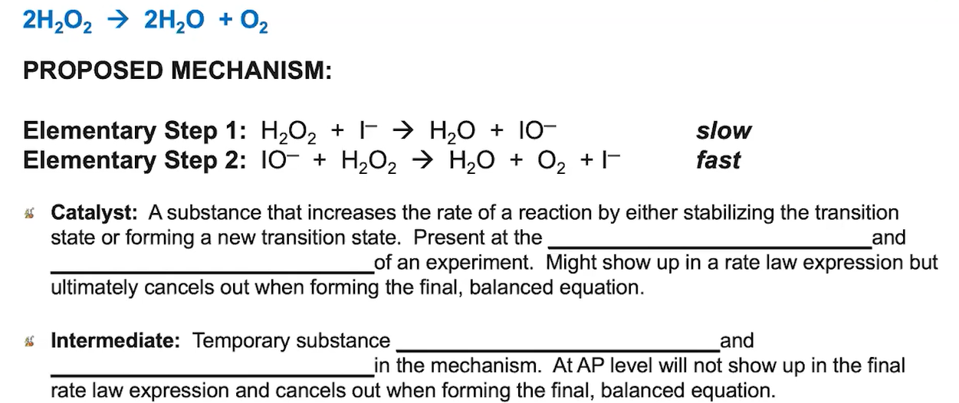

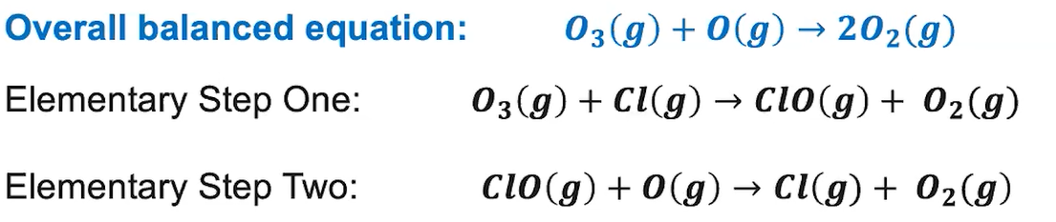

[**Video #2**](https://apclassroom.collegeboard.org/7/home?apd=qedd93dk2x&unit=5)

1. What are two criteria we consider when judging if a reaction mechanism is plausible?
2. Pause the video at 1:55 and notice each elementary step has a rate law, activation energy, and rate constant.
3. Write down how you add elementary steps together to generate the overall reaction.

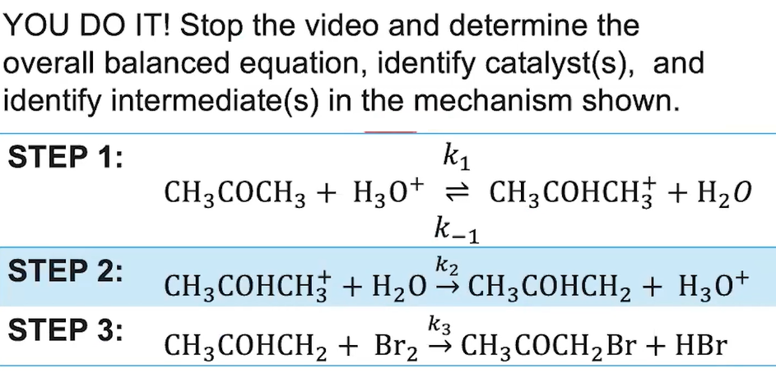

1. Pause the video at 4:30 and attempt the problem, then evaluate how you did and identify any errors.