**AP Chemistry Daily Videos: 6.5 Energy of Phase Changes**

**[Video #1](https://apclassroom.collegeboard.org/7/home?apd=v26aalicdb)**

**1. Discuss the attractions and energy associated with the various phase changes that can take place with water.**

**2. What is taking place at the plateaus during the graphical representation of the phase changes? Discuss temperature and states of matter in your answer.**

**3. Discuss the difference of the line segments, angled vs. flat. Include the different equation for the different line segments.**

**4. Why is the line segment for vaporization longer than the line segment for melting?**

**AP Chemistry Daily Videos: 6.5 Energy of Phase Changes**

**[Video #2](https://apclassroom.collegeboard.org/7/home?apd=xe2hcwqmlm)**

**1. Follow along with Dr. Leggett to complete the following problem!**

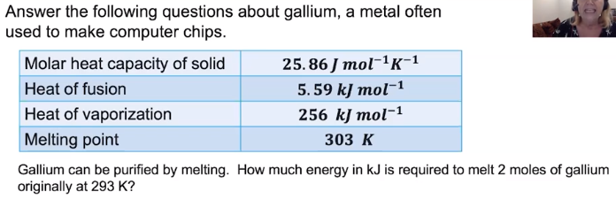





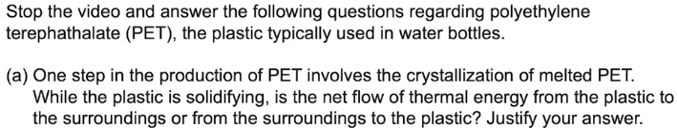2. **Pause the video at 4:35 to read and to read and attempt the problem, then evaluate how you did and identify any errors.**

