**AP Chemistry Daily Videos: 6.7 Bond Enthalpies**

**Daily Video #1**

1. Give a brief explanation of the difference between endothermic and exothermic processes in regards to bonds and energy. (She has a really good analogy for the difference, write them down if it helps you!)

2. What is bond energy? When is it negative vs. positive?

3. What is different about the H-H bond energy when they are broken vs. formed? What is the same?

4. When you look at the average bond energy chart, what happens as you move from C-C to C=C to CΞC bonds?

5. What is ΔHrxn? Give the equation for calculating ΔH and label it in regards to signs.

6. Looking at this data, first calculate ΔH, thinking carefully about if bonds are broken/formed and how many bonds you have. After you have calculated, determine the best graph and sketch it below. Is it endo or exothermic? How do you know?

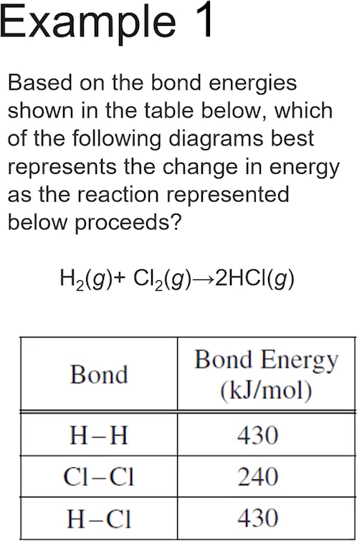

7. Big takeaways?

**AP Chemistry Daily Videos: 6.7 Bond Enthalpies**

**Daily Video #2**

1. Given CH4­ + 2 O­2 🡪 CO­2­ + 2 H2O and the general Lewis Structures below, determine what type of bonds and how many of each type you have, if the bonds are broken or formed (+ or -) and calculate the enthalpy of the reaction.

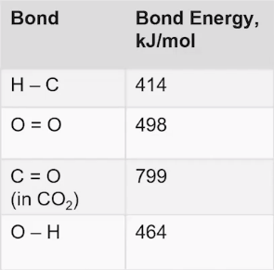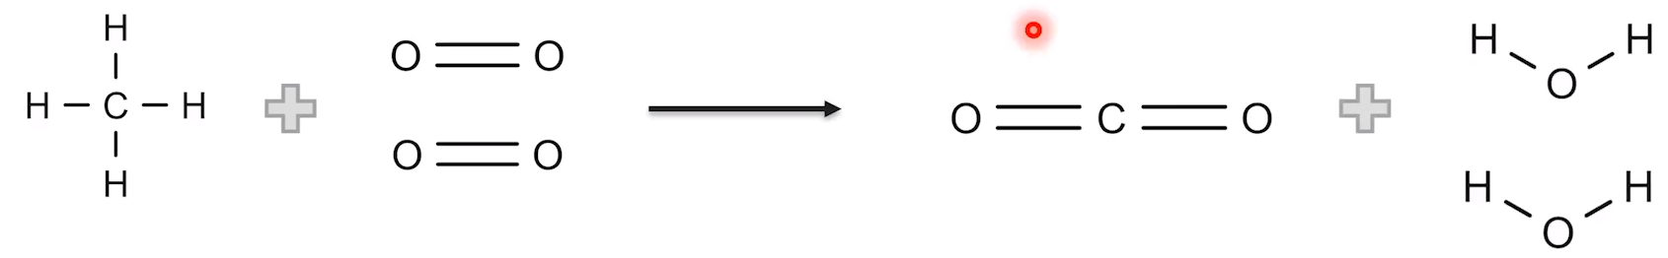

2. Pause the video at 3:42, attempt the problem, then evaluate how you did and identify any errors. Hint!! Draw the Lewis Structures of your reactants and products for yourself first!

