**AP Chemistry Daily Videos: 6.8 Enthalpy of Formation**

**Daily Video #1**

1. Review: What is the Enthalpy of Reaction, ΔHrxn?

2. What is the standard enthalpy of formation, ΔH˚f?

3. What does the ˚ refer to or tell us?

4. What is standard state? Give a few examples?

5. When you are given CO2 and ΔH˚f = -393.5 kJ/mol, what does that mean?

6. What is the ΔH˚f value for an element in its pure state? ΔH˚f  = _____

7. Given the following values, sketch a diagram to help you explain the difference of enthalpy formations for the following substances using the sea level analogy.

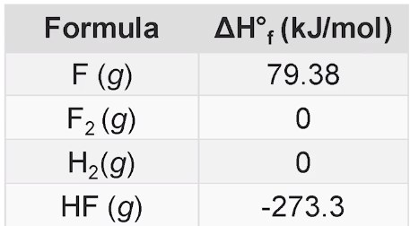

8. Big takeaways?

**AP Chemistry Daily Videos: 6.8 Enthalpy of Formation**

**Daily Video #2**

1. What is the equation for calculating the ΔH˚rxn?

2. What are the two key things to keep in mind when calculating ΔH˚rxn?

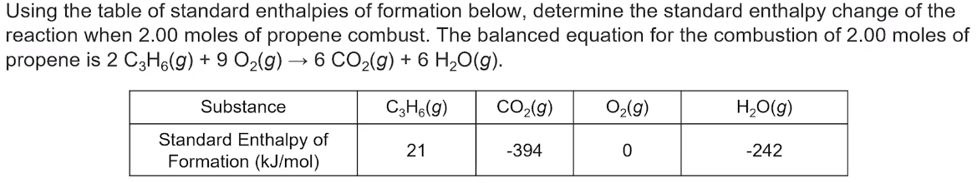3. Complete this practice problem along with Ms. Scimeca.

4. Pause the video at 3:30, attempt the problem, then evaluate how you did and identify any errors.

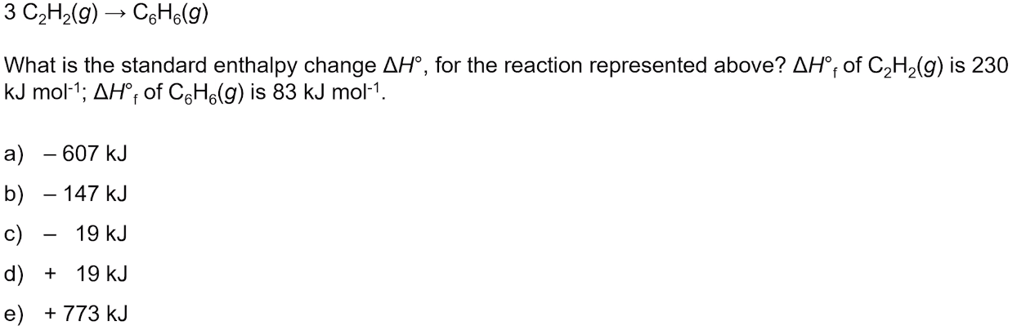

5. Pause the video at 4:38, attempt the problem, then evaluate how you did and identify any errors.

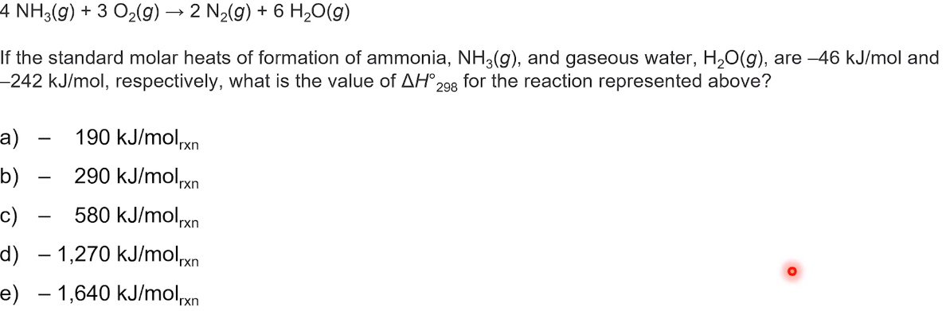

6. Key takeaways?